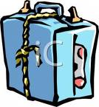
Suggested Kit List

- Sturdy suitcase or travel bag with name and address clearly marked on it
- 3 (at least) pairs of trousers/jeans/shorts/skirts
- 3 Shirts/blouses
- 2/3 sweaters/fleece
- 4 T-shirts
- Trainers – comfortable shoes
- Slippers
- Numerous pairs of socks and underwear
- 1 plastic bin liner for dirty washing
- Pyjamas/nightdress
- 1 towel
- Washing kit- flannel, soap, toothbrush, hairbrush, comb etc
- Waterproof jacket
- Sensible walking shoes
- Outfit for bowling
- Sun cream and red school cap

HAND LUGGAGE
- A stamped self-addressed postcard- extra stamps are useful
- Needed on outward journey and therefore not packed in the suitcase
- Small rucksack suitable for walking
- Packed lunch for Monday
- Water bottle - not glass
- Named purse/wallet
- Medicines to be clearly marked and handed into staff
- Cameras and extra film
- Waterproof jacket with hood
- Travel sickness tablets
- Pencil case
- Pocket money to be handed in- £20.00 in £1 coins
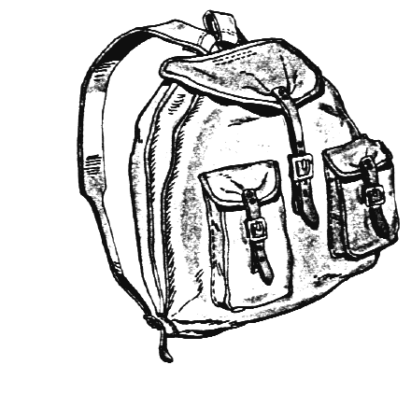
- NOT REQUIRED: Items of sentimental value. Electronic items, mobile phones, i-pods, stereos, aerosol deodorants, chewing gum , hoards of sweets
- Sun cream

