Senses
All animals, including humans, have senses. Without them, you would not be able to see, hear, smell, taste or touch.
The information below will tell you more about your senses. The words in bold are explained in the glossary.
Animals and their senses.  Some animals have fewer senses than humans. They develop the senses which suit their way of life best. Cats and owls, which hunt at night, can see well in the dark. It is thought that whales and dolphins can hear each other over hundreds of miles of ocean. Dogs, lions and wolves use their sense of smell to track down their prey. Snakes use their tongues to collect smells from the air. Many insect have well-developed senses to help protect them from other animals. | 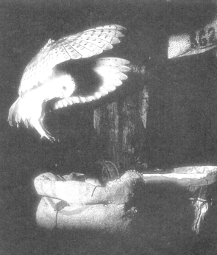
All animals need their senses to find food and escape their enemies. We use our senses to keep us safe and to enjoy life.
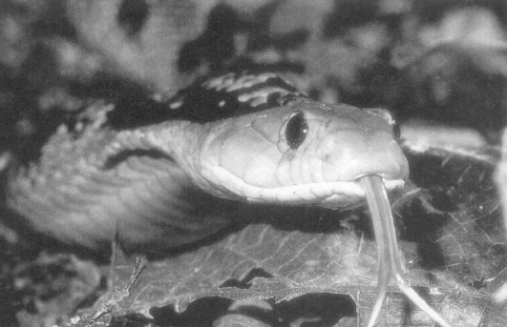
Tasting
ng
It is easier to taste food if you can smell it too. Have you noticed that food doesn't taste as good when you have a cold?
There are four different types of taste. These tastes are sweet, salty, sour and bitter. The tongue can also sense when things are hot or cold.  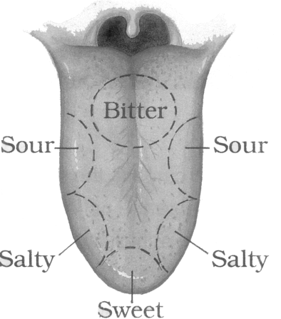 | 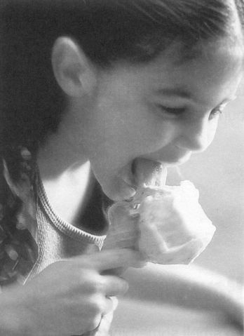
How your taste sense works
If you look at you tongue in the mirror, you can see lots of little bumps. Inside each bump there are over a hundred taste buds which pick up different tastes in food. Inside the taste buds there are taste cells which have tiny hairs on the end. The taste cells send messages to the nerves in the tongue. These nerves then send messages to the brain and the brain decides what the taste is.

Smelling
Smells
How many smells can you think of? Which do you like? Which do you dislike? Believe it or not, your brain can pick out over 10,000 different smells!

Some smells make you feel happy, others sad. Some make you feel hungry. others make you feel sick. Smells can warn you not to eat bad food, or tell you that something is burning. | 
How your smell sense works
To smell something properly, you sniff, This pulls the air carrying the smell up to a space at the top of your nose. In this space there are sense cells with millions of tiny hairs at the end. The hairs are rooted in a think, sticky liquid - like reeds in a pond. When you breath in, the sense cells send a message to the brain. The brain then interprets this message as a particular smell.
Glossary
sense cells These are areas where information is collected from inside your body.
taste buds The small bumps on your tongue.
taste cells These are inside the taste buds on your tongue and detect taste.
nerves These carry information around your body and to and from your brain.

These questions are about the information on Senses.
1. Tick five boxes to show what our senses help us to do.
walk smell
taste touch
hear jump
sleep see
1 mark
Animals and their senses
2. Dogs, lions and wolves are able to
.
1 mark
3. Give two reasons why all animals need their senses.
1) ................................................................................................................
2) ................................................................................................................
2 marks

Tasting
4. As well as different types of taste, what else can your tongue sense?
......................................................................................................................
1 mark
5. Why is there a diagram of the tongue?
......................................................................................................................
1 mark
6. Look at the diagram of the tongue
Use the information to complete the table.
Type of Taste | Part of Tongue
 | back
 | sides
sour
 | tip
1 mark

Smelling
7. Look at the information on Smelling.
Why do you think it begins with three short questions?
......................................................................................................................
......................................................................................................................
......................................................................................................................
2 marks
8. How does the writer describe the tiny hairs at the end of the sense cells?
like ...............................................................................................................
1 mark
Thinking about Senses
9. What is the link between the story of Sanji and the information on the Senses section?
......................................................................................................................
1 mark

10. Where would you find this information on senses?
1 mark
11. Why do you think there is a glossary?
......................................................................................................................
......................................................................................................................
1 mark
12a. The information on senses has a main heading Senses and some sub-headings, such as
Animals and their senses
Smelling
How your smell sense works
Find and copy one other sub-heading.
......................................................................................................................
1 mark
12b. Explain why you think the author has used these headings and
sub-headings.
......................................................................................................................
......................................................................................................................
......................................................................................................................
2 marks

