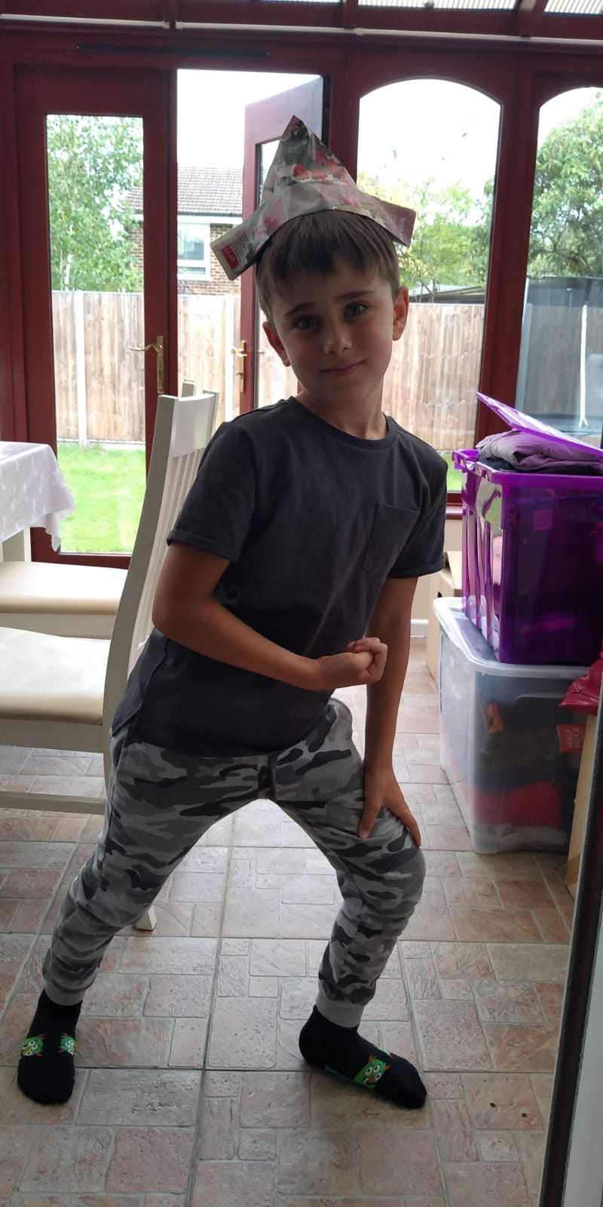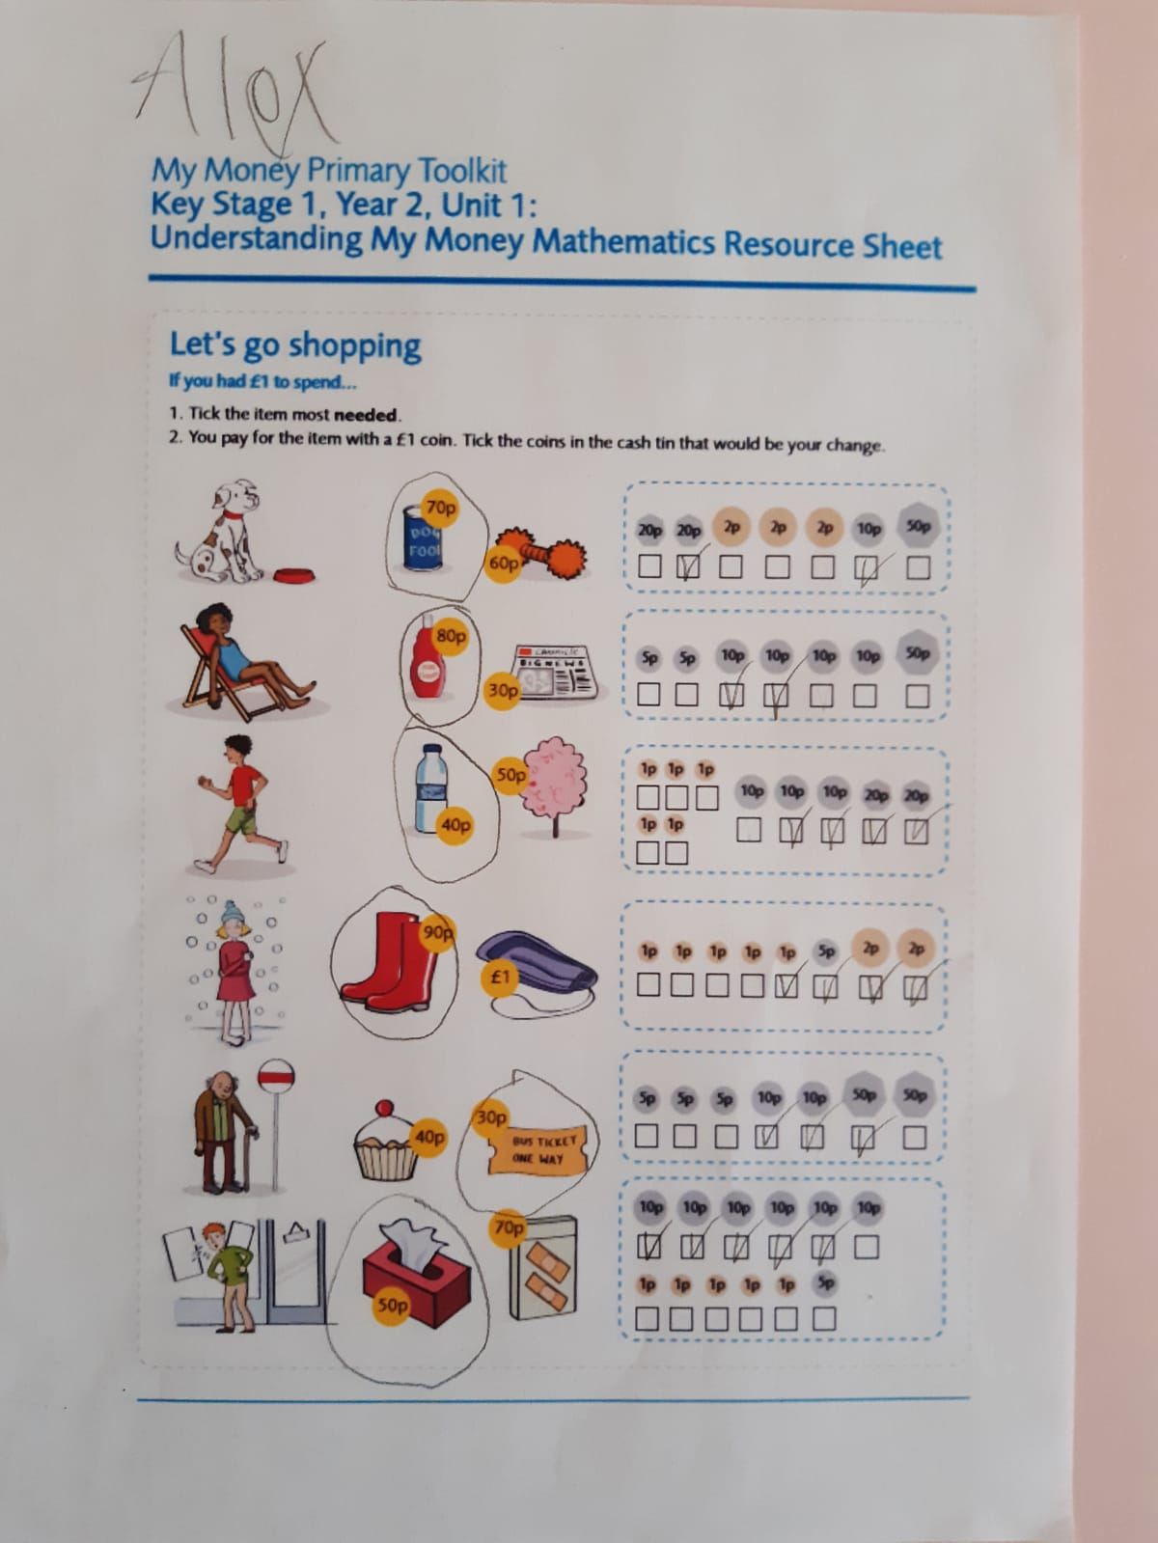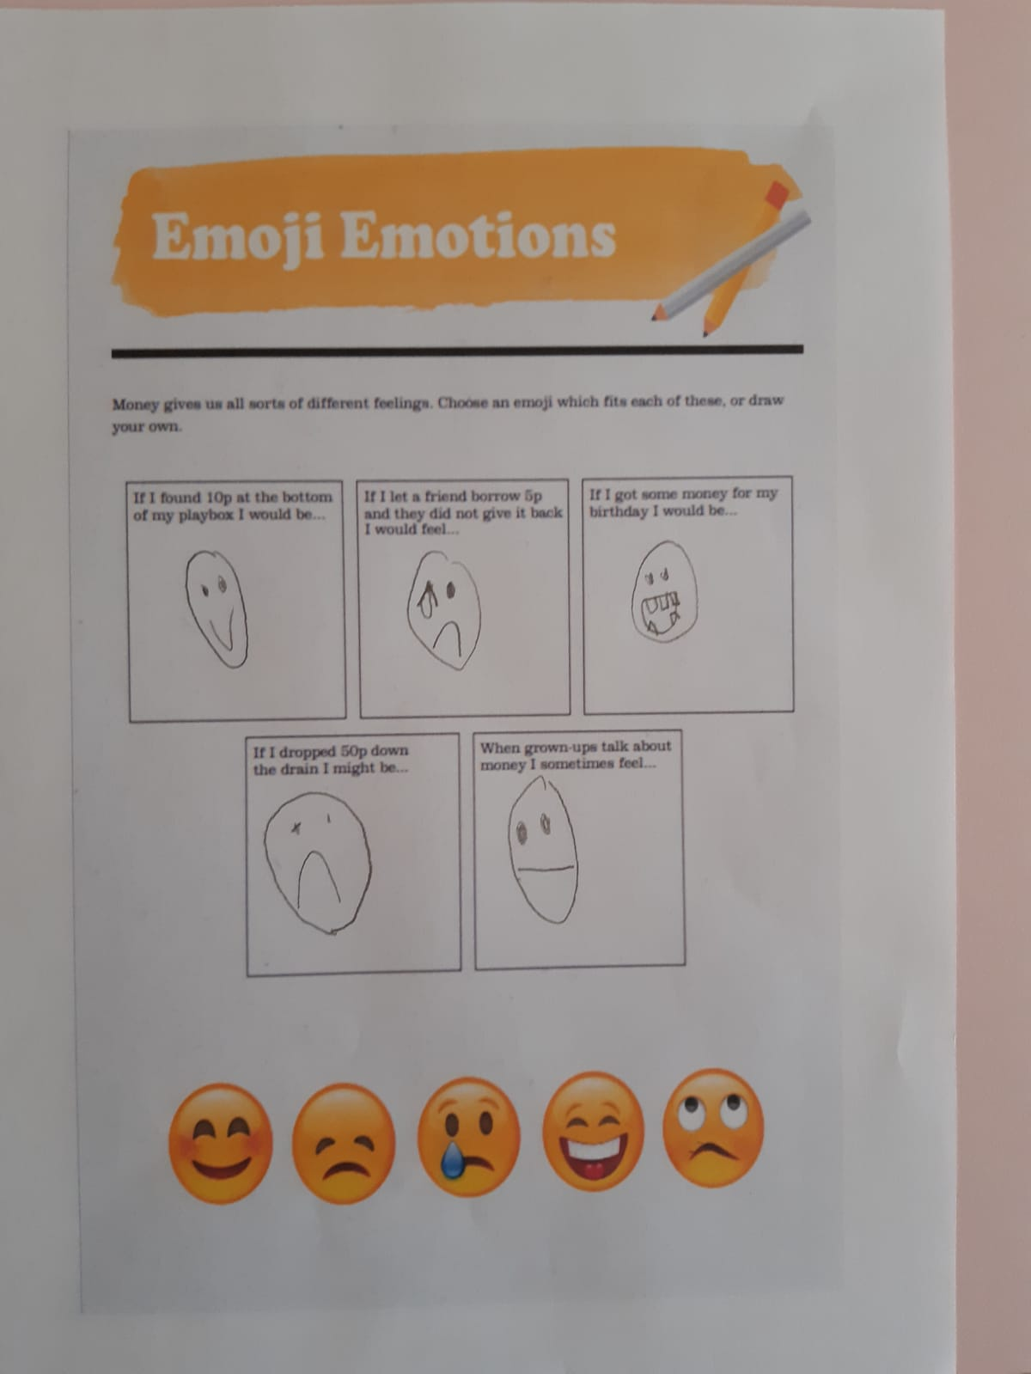

Alex has clearly been very busy this week at home. Not only he was able to complete his Maths work on Money, but also he has done some Science investigation and involved his younger brother in cooking activity. What a STAR!

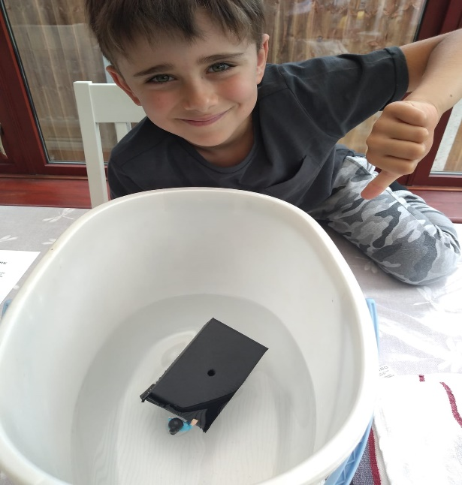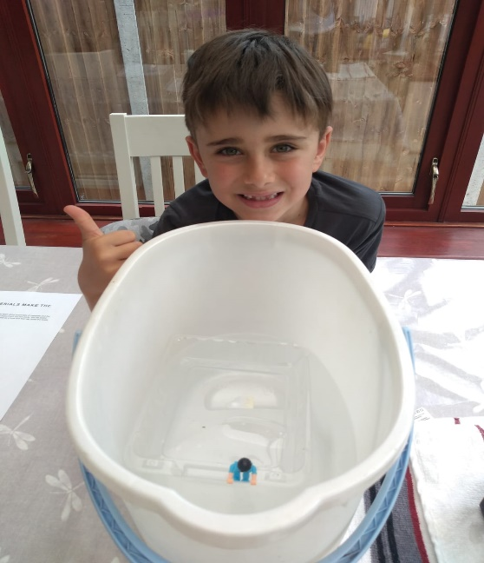

Science investigation: floating and sinking

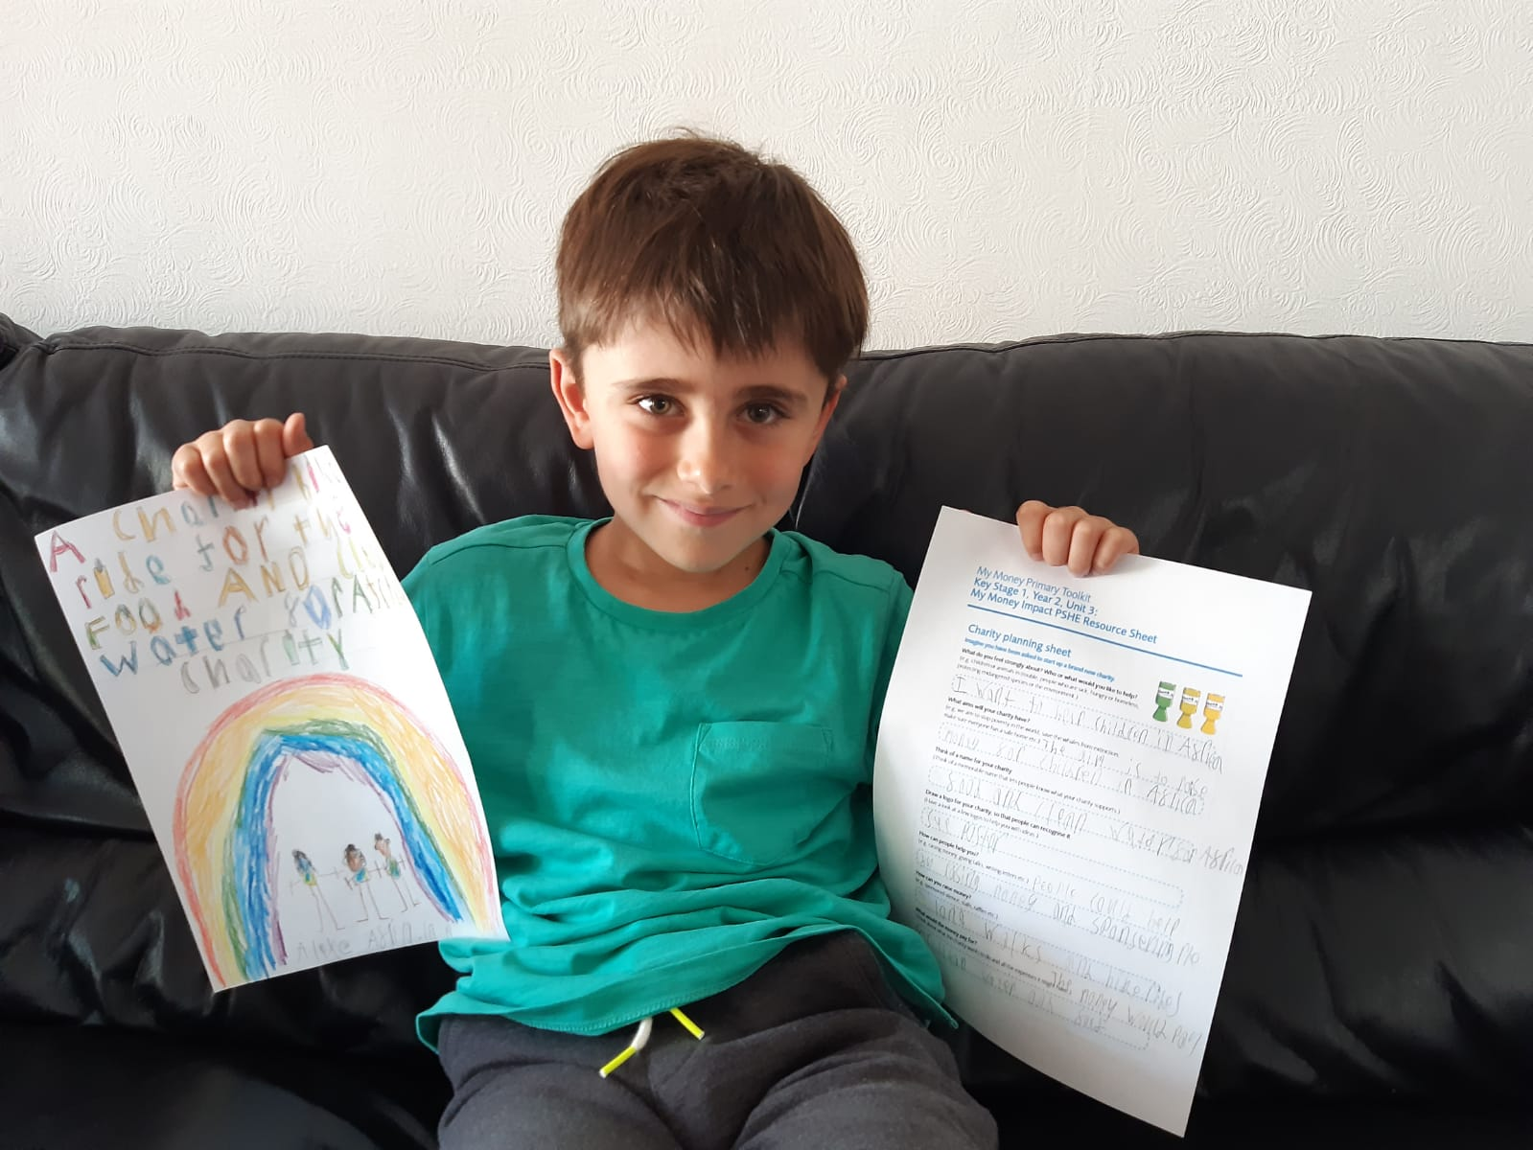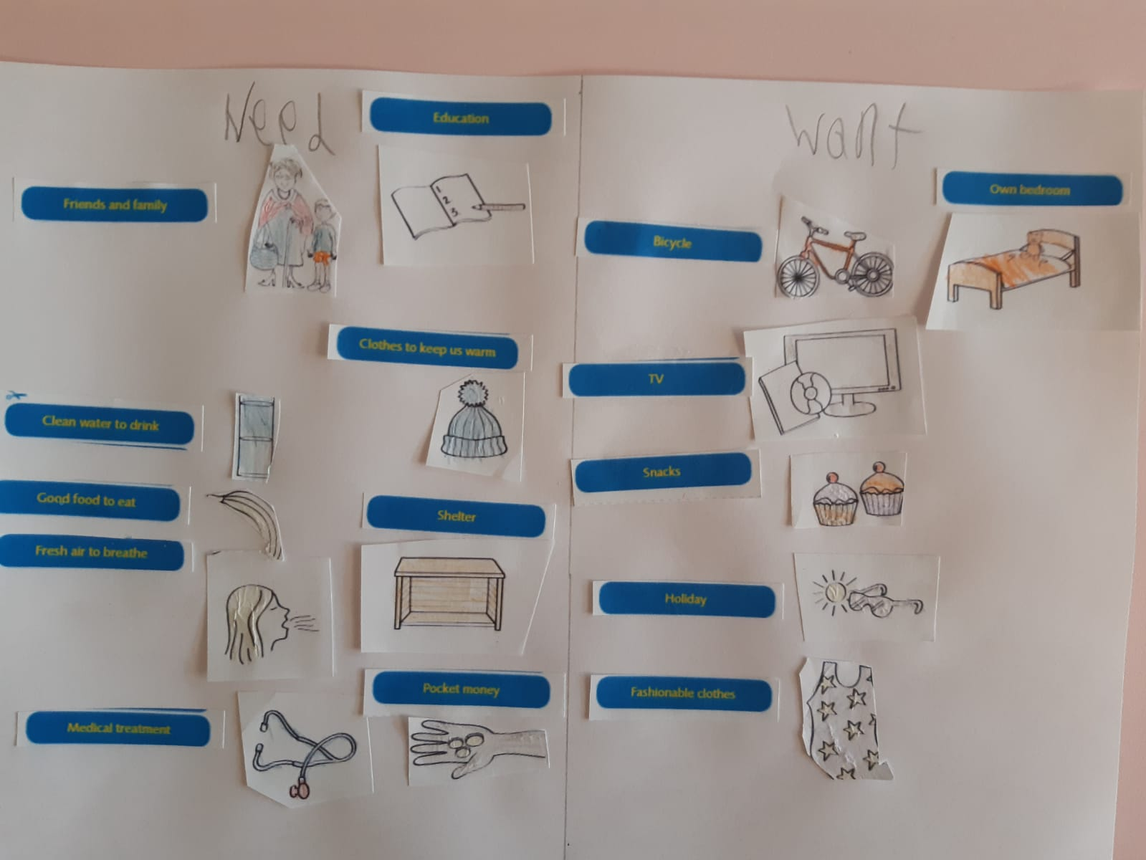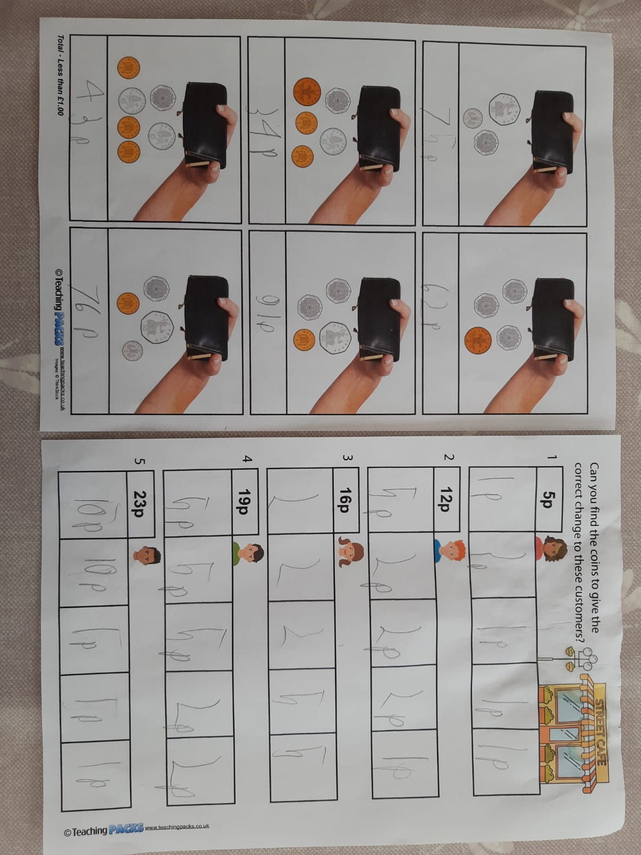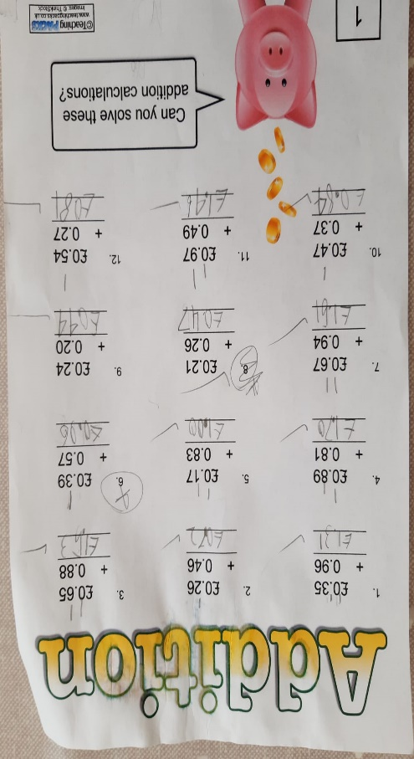

This is my favourite activity!

What a lovely aim, Alex!

Well planned.

You can distinguish between needs and wants. 😊

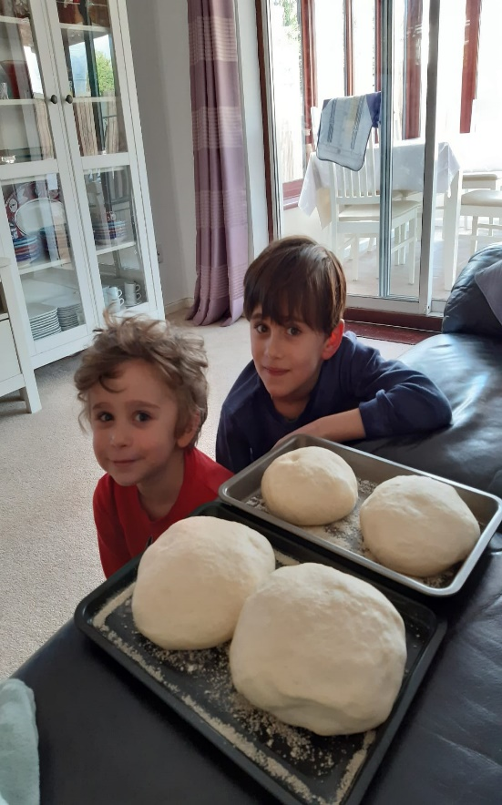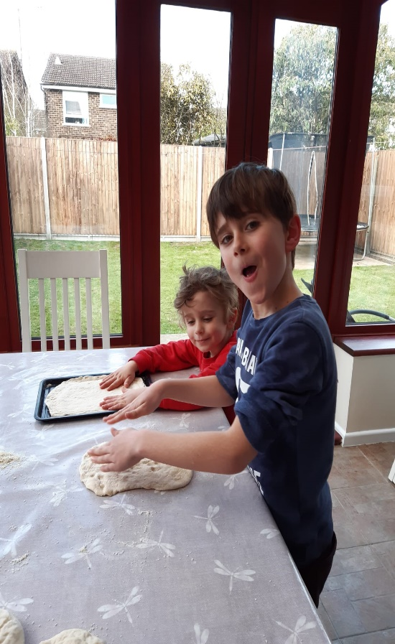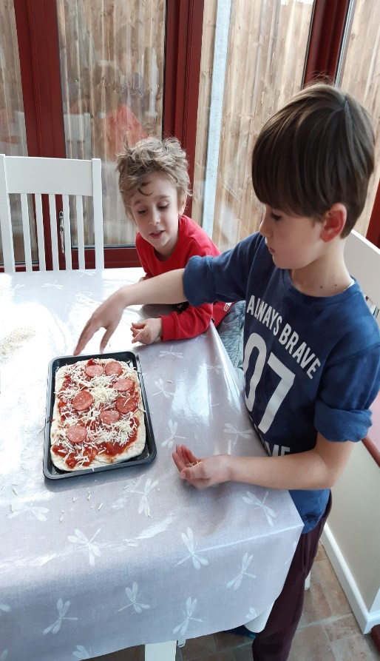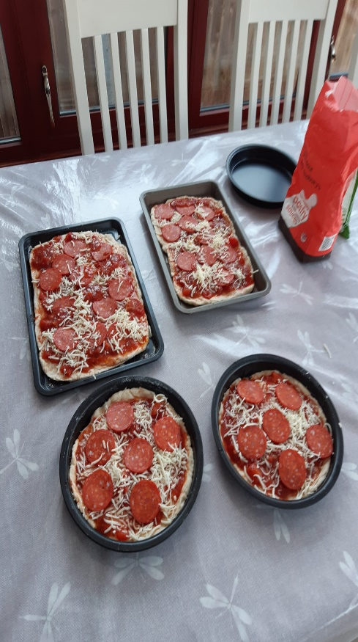

I can see that you are a good team player, allowing Christian to help you.

Pepperoni Pizza! This looks wonderful. Alex, what a lovely way to learn a list of valuable cooking skills!

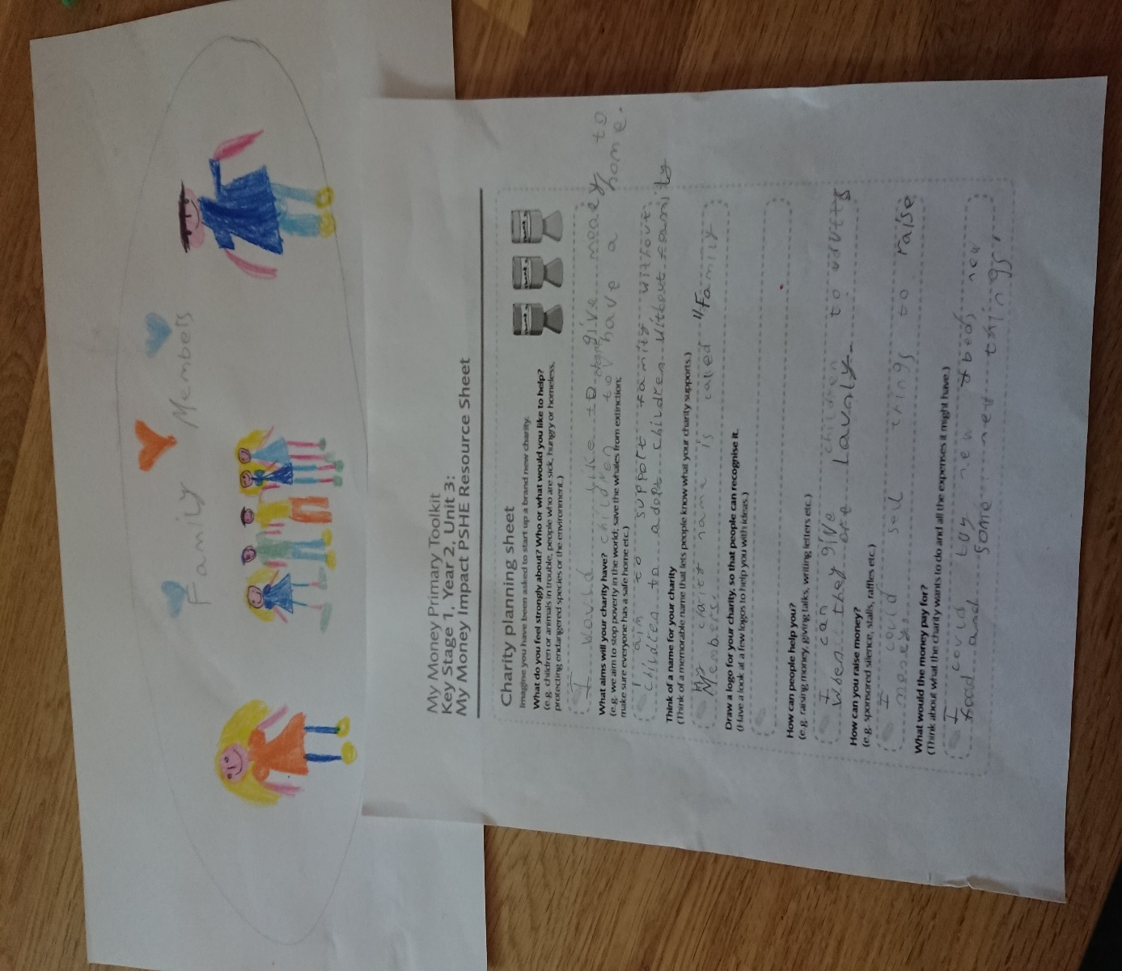

Olivia wishes to support families/children who need roof over their heads.

She came up with a good name and some lovely ideas for raising money.

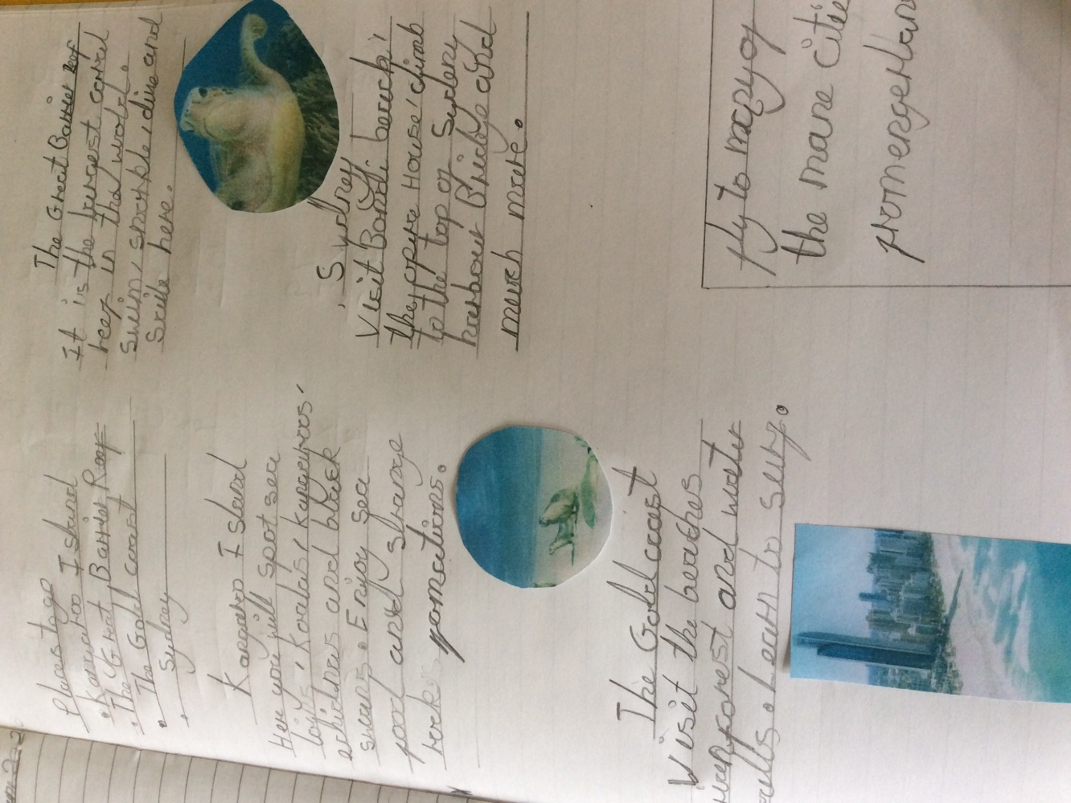

Thank you so much for sending your recorded voice about Australia Day. You sounded so confident and mature.

Great work!

Florence is working hard and is finding a lot of interesting information about Australia.

Keep it up!

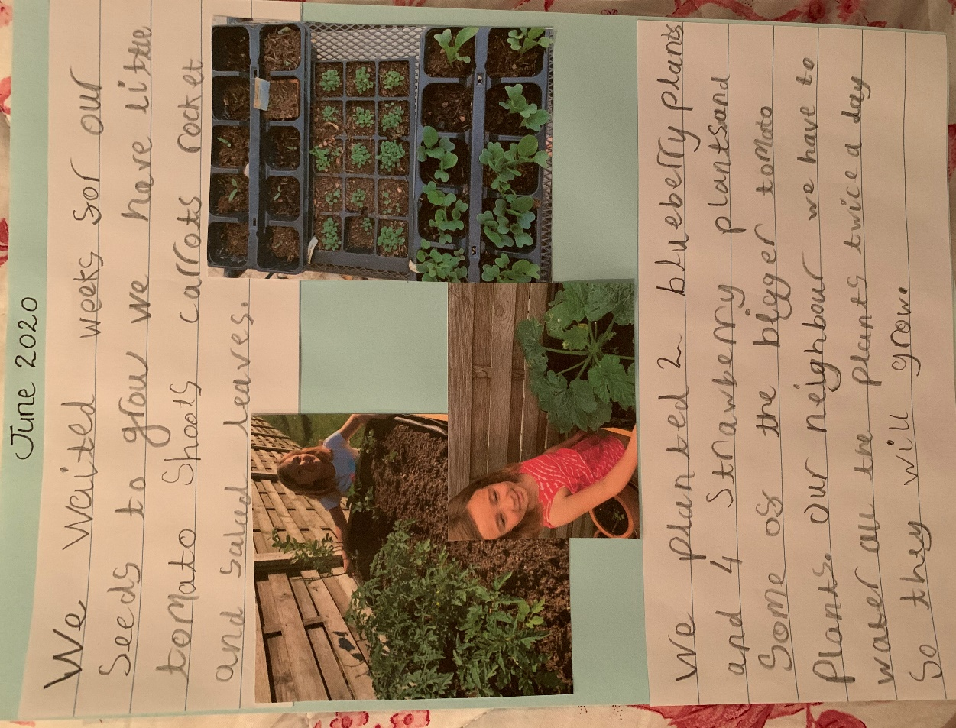 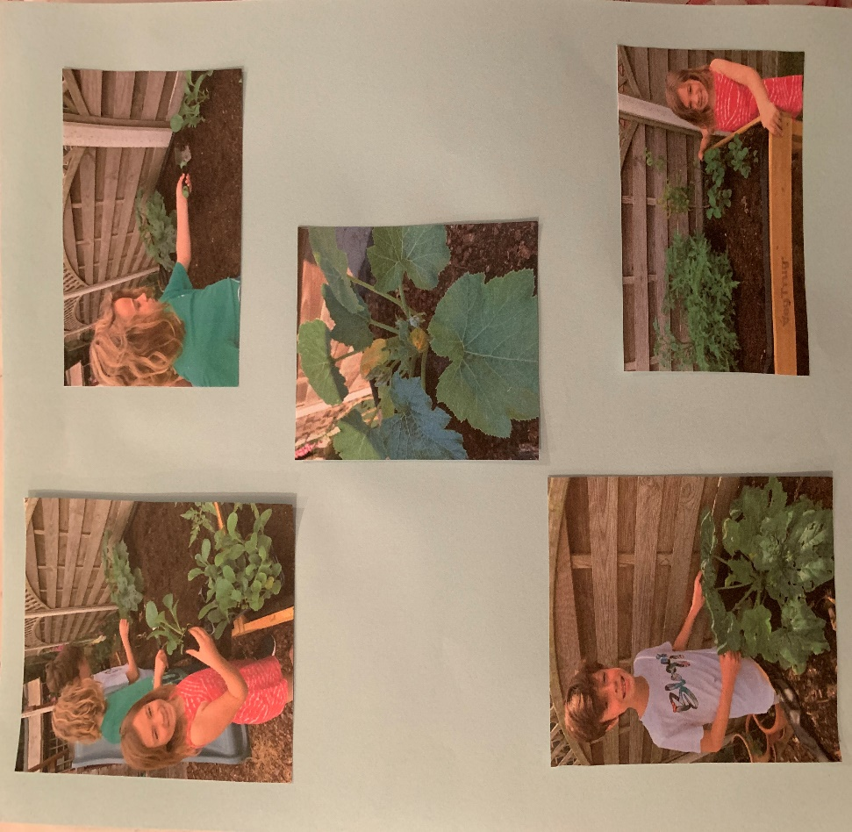

Erin, this looks amazing. Let me know when the blueberries are ready!:)

Oliver and Sebastian, it is great to see you being involved in a family project. Your vegetable patch looks impressive!

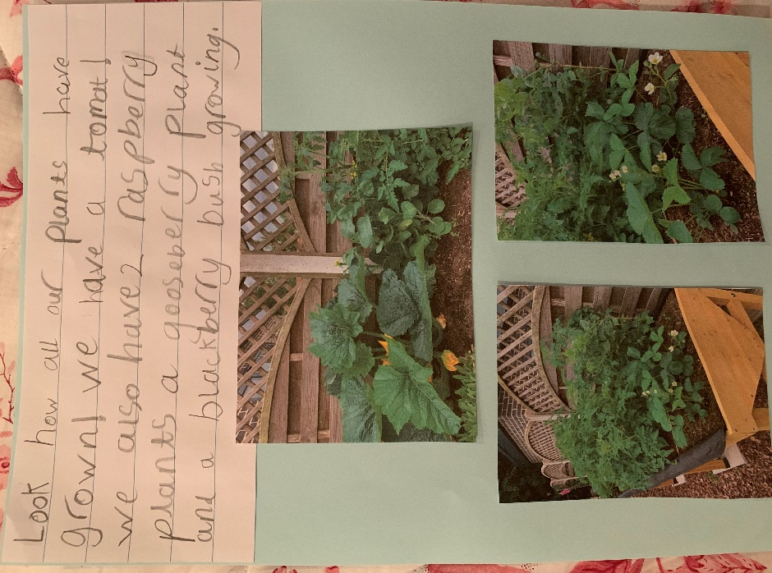 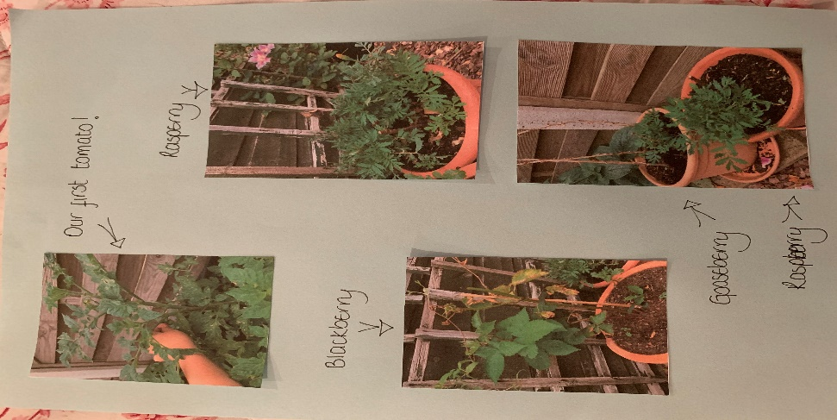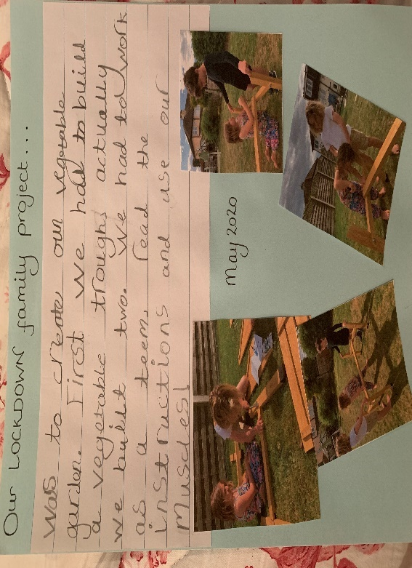

What can I say? I wish this could be mine! 😊

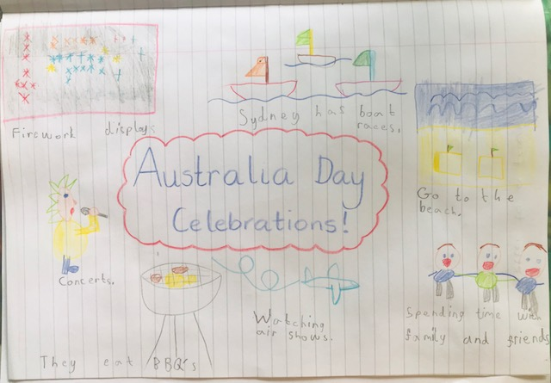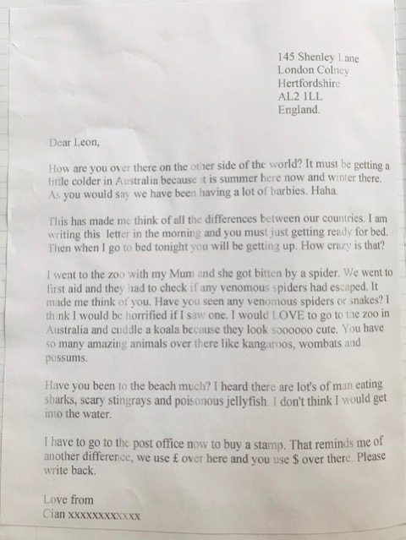

Lovely to see your ICT skills!

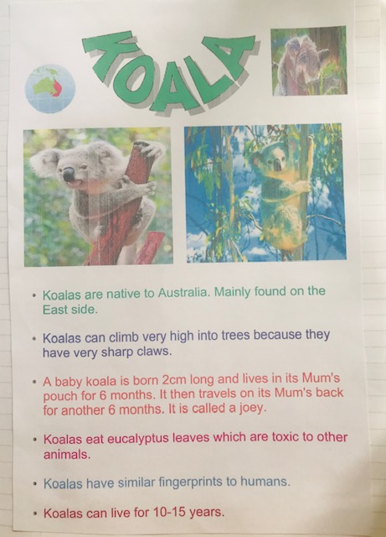 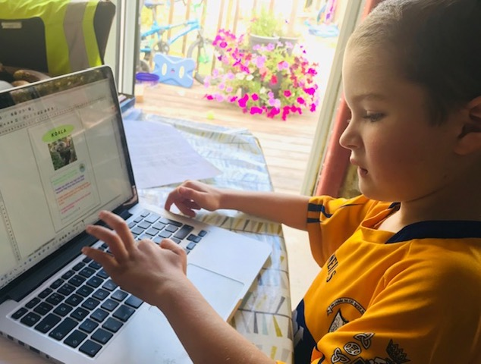 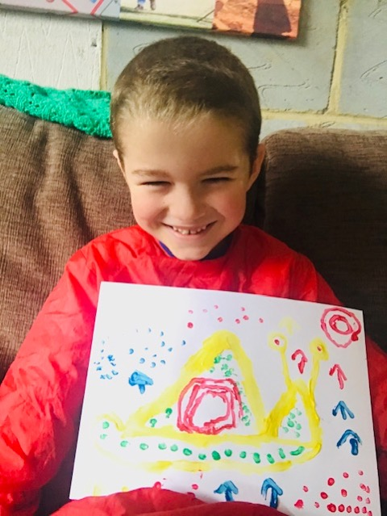

Great dot painting Cian.

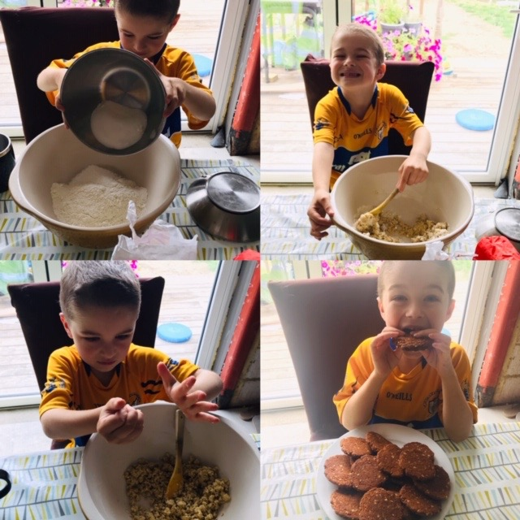

The biscuits look fantastic. I hope you have saved one for ME! 😊

Here is what Cian thinks about our Topic: Australia

I really enjoyed this week learning about Australia.

 The aboriginal painting and making the Anzac biscuits were really fun. I painted a snail because that is what I would find in my environment. Anzac biscuits are what the Australian soldiers used to eat in World War One.

I loved learning about the koalas.

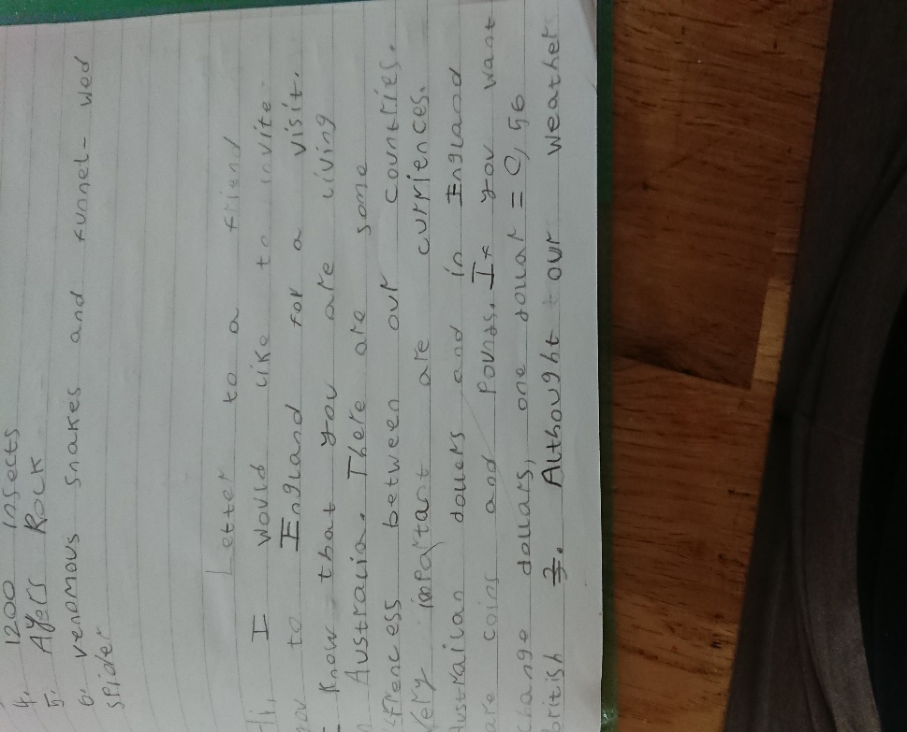 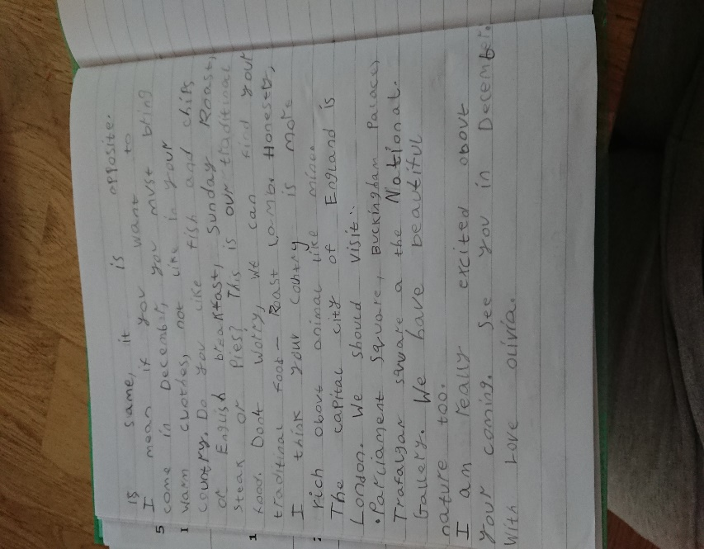

Olivia has written a letter to her pen pal comparing their two countries.

Good work Olivia!