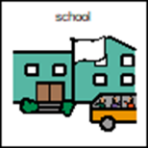
What is a School ‘Bubble’?
When I go back to school I will be with a special group of people.
This will be called a Bubble
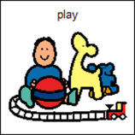
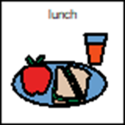
This means at school I am going to work, play and eat my snacks and lunch with the people in my bubble.

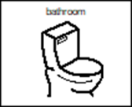
I will use the same toilets and sink as the people in my group.

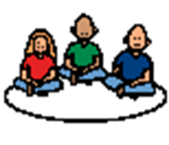
It is called a ‘Bubble’ because at school I am doing things with my small group.
Other children will do things with their small group.
This is ok.
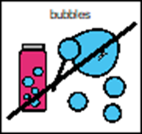
At school ‘Bubble’ is the word that is used to mean ‘small group’. I will not be in a in a real bubble.
It is ok to be part of a school ‘bubble’

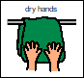
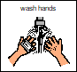
It is good to remember that
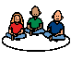
- washing my hands,

- trying to stay with my special group
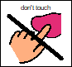
- trying not to touch other people

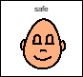
will help to keep me and my friends and teachers safe.

