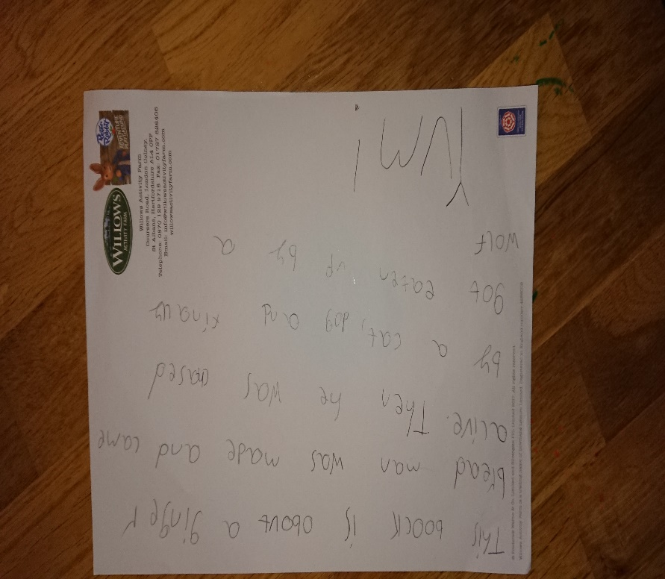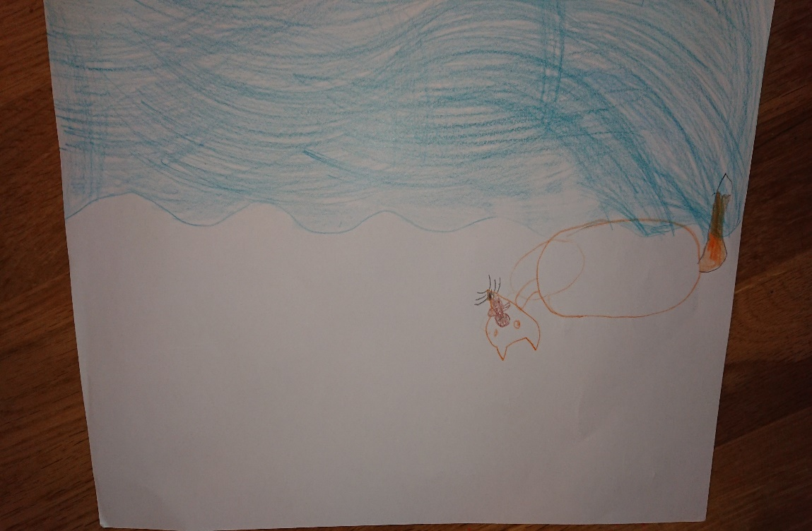

Olivia reads a lot at home and then writes short stories. Here are some examples. Good work, Olivia!

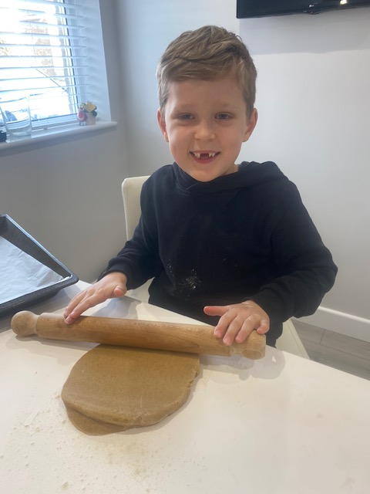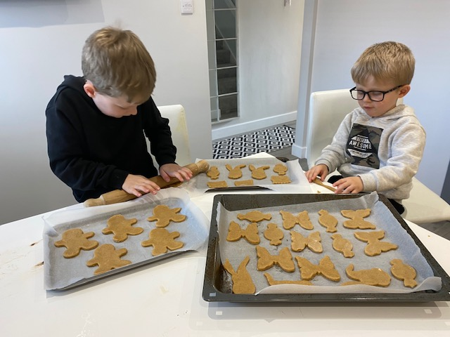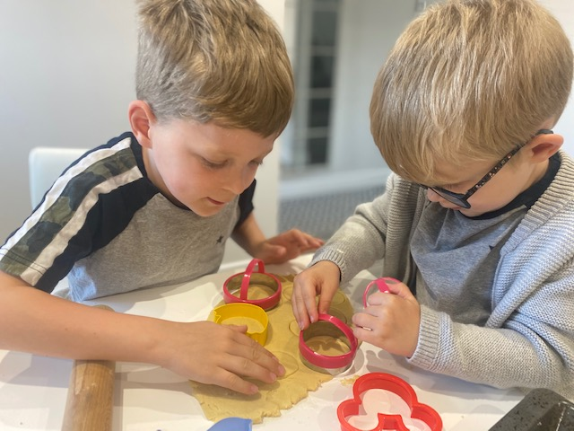
We have been doing a lot of cooking since lockdown. Lots of baking cakes/biscuits making homemade pizza. We have been measuring out the ingredients and helping with the preparation and baking. I am really enjoying it.

Here is what Mason has sent me.

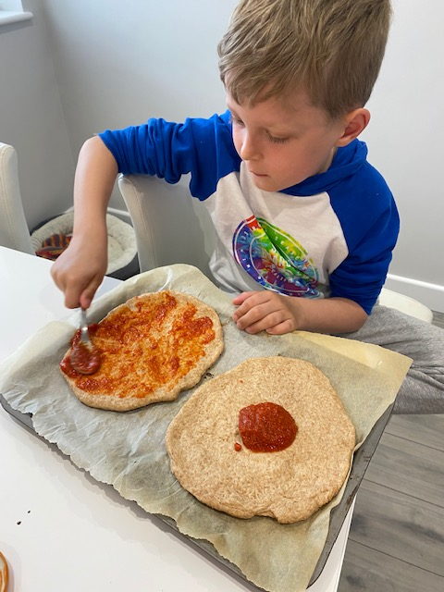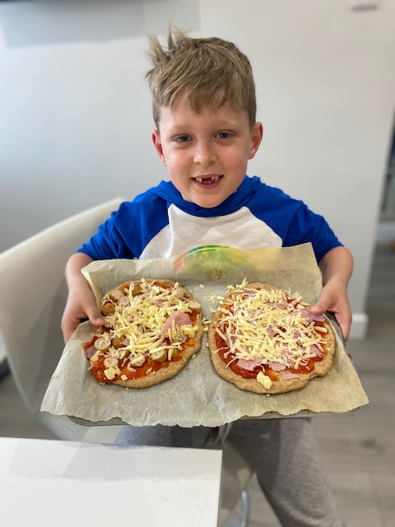
Mason, I must say, from what I am seeing, you are much better at cooking than I am!
WOW, superb work! Keep it up!

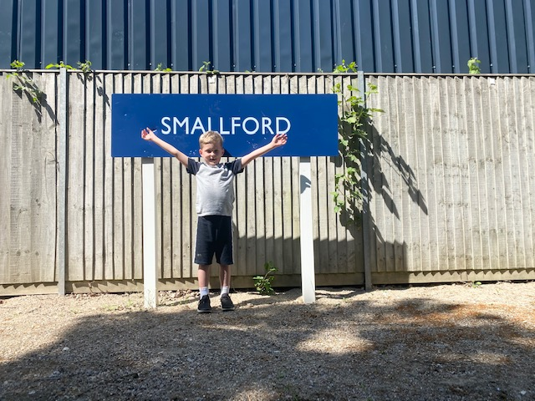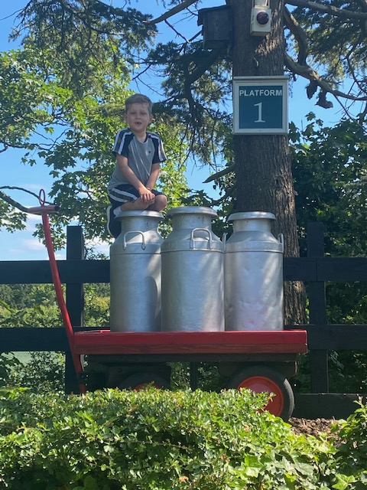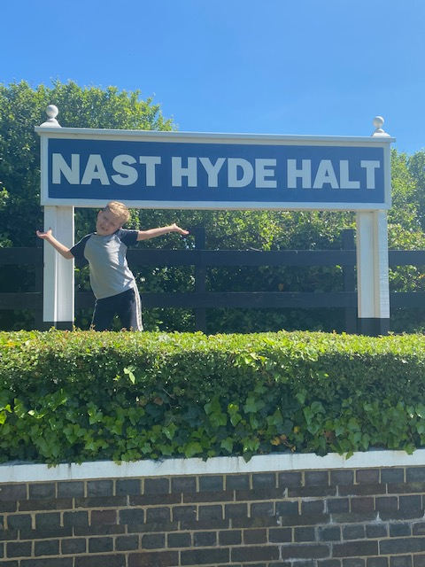
Mason and his family went along the Albany way cycle path and read all the history about the rail line. They found it very interesting. He used this as a history lesson.
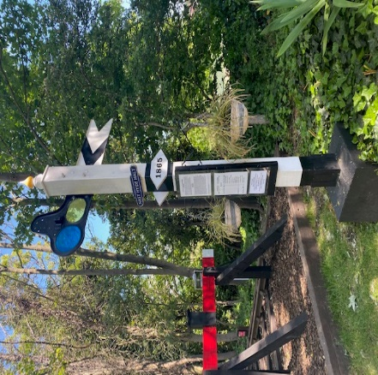
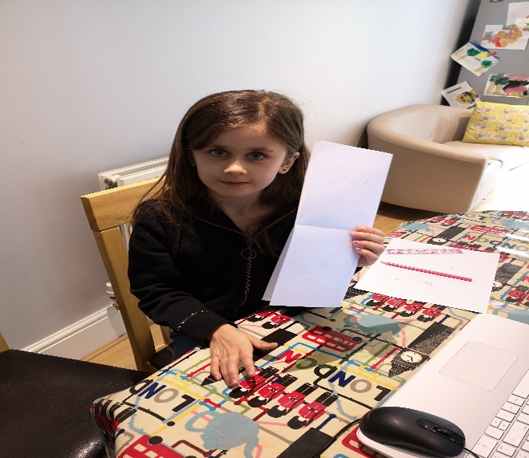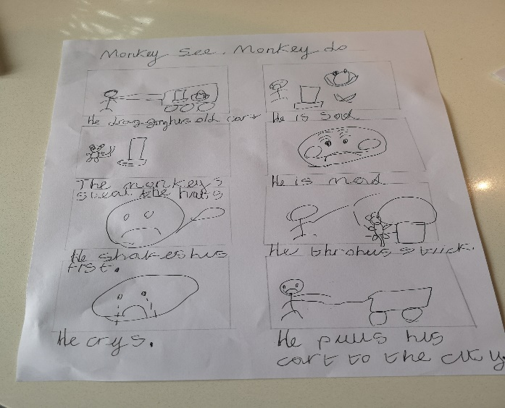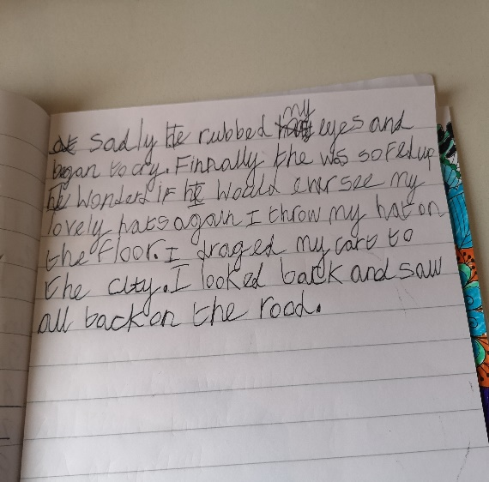
Sofia working on fractions.

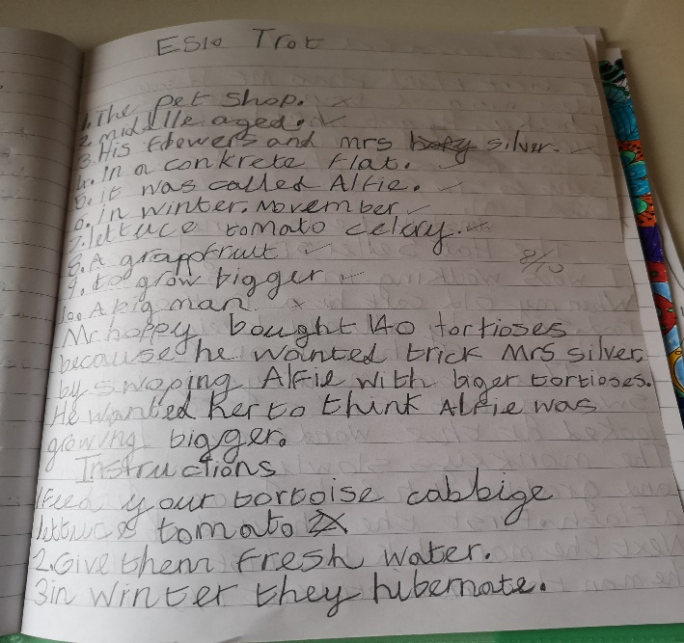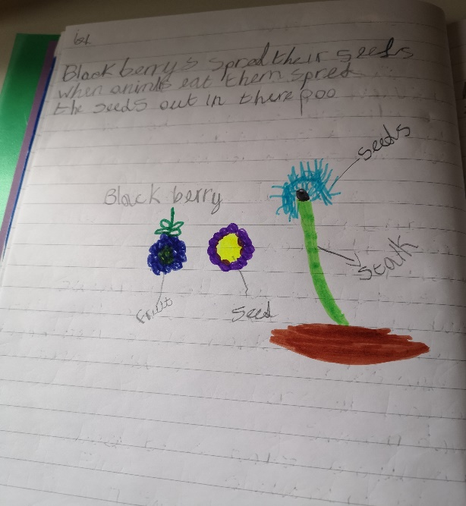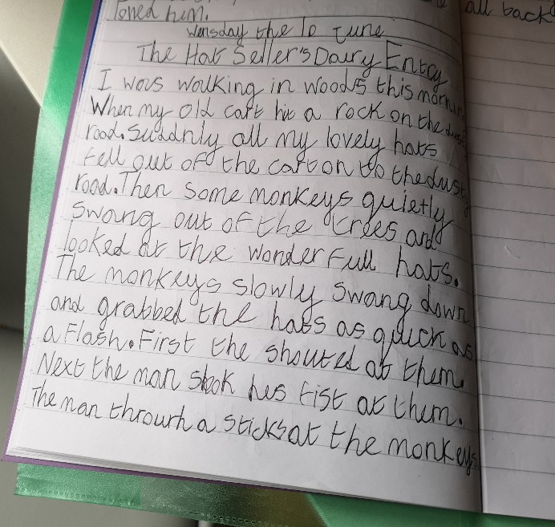
Marvellous story, fantastic handwriting.
Great Science
Project
Sofia worked hard finishing her Maths, English and Science activities.
I liked them all, but my favourite one must be the POSTER.
Fantastic work Sofia!
Thank you for sharing it with me.

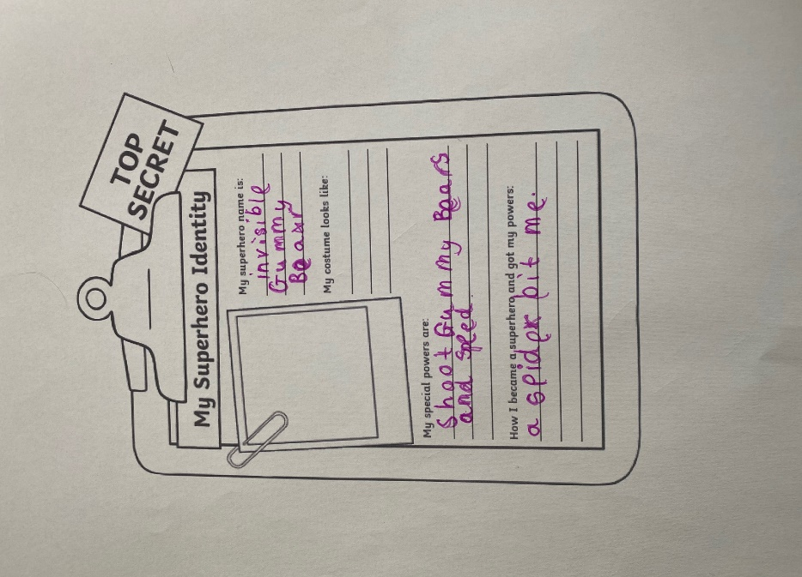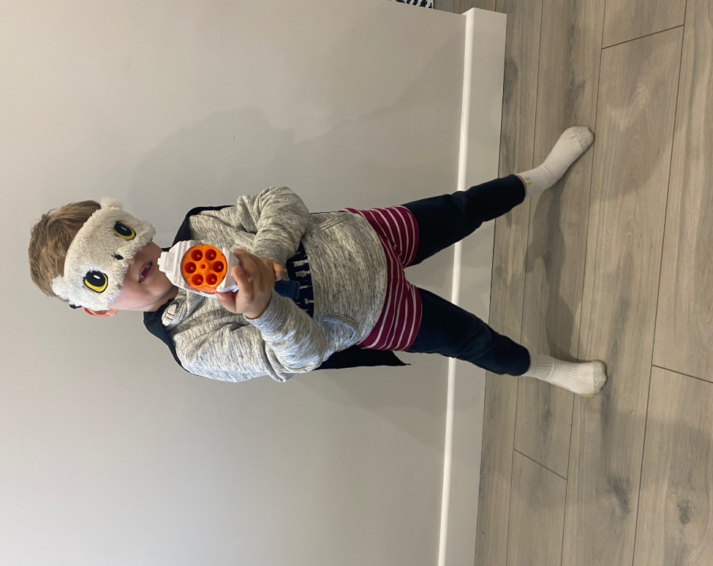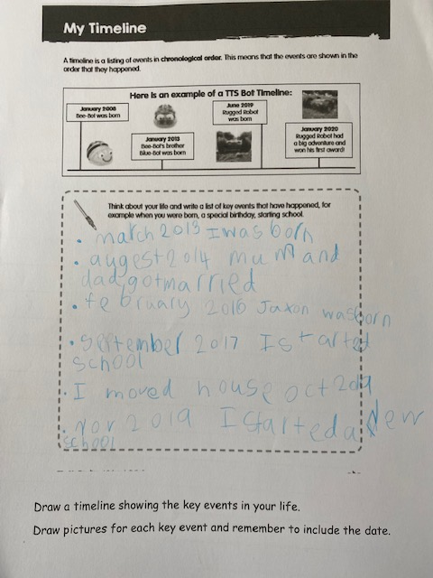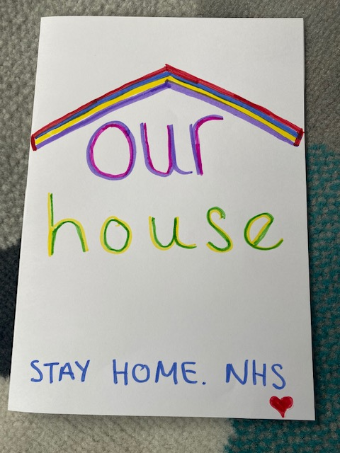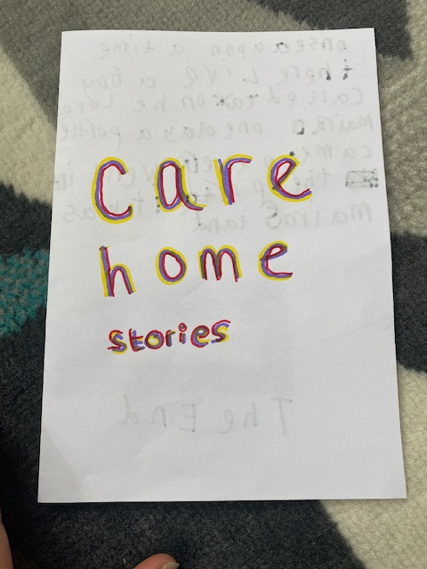
What a cute Gummy Bear!
Mason, I read your house rules and I can see how they can create structure.
Mason sharing some important moments in his life .

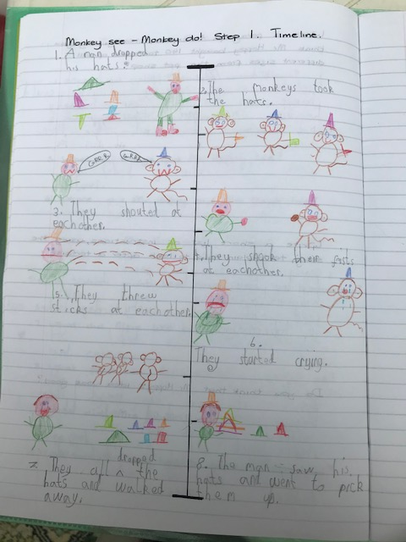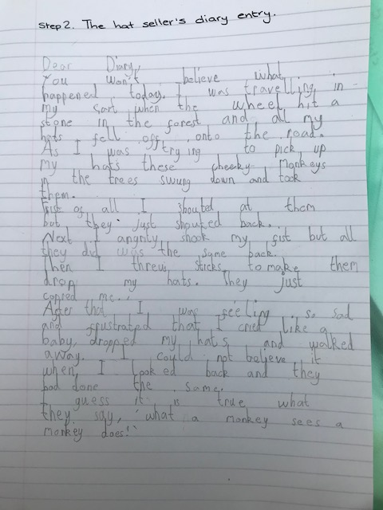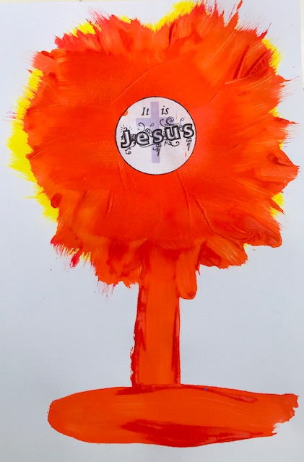
Dear Cian,
I have enjoyed reading your diary and your timeline. But the real surprise came when I saw that you finished the Art activity and beautifully painted the Monstrance, using straight lines.
Wonderful work!

BY ALI ZIEGLER-SMITH.
>
> The clumsy elephant
>
> Once upon a time there was a elephant called Trunky.
> Trunky was a very clumsy elephant.
> One day when it was sunny and hot Trunky went for a walk and bumped into a giraffe, but before she could say sorry the giraffe ran away, kicking up a cloud of dust which made Trunky sneeze an enormous, snotty sneeze.
> Cucadidledooooo! Came a noise from somewhere within the dust cloud.
> Trunky looked up, down, left and right, but couldn’t see where the sound came from, all she could see was dust.
> Cucadidledooooo! Came the noise again.
> And as the dust settled, Trunky spotted a small hen, sat just under her trunk..... covered from head to toe in snot.
> Hello said Trunky.
> Hello Trunky said the hen.
> Trunky tried to hug her and wipe the snot away but instead hurt her beak so the hen ran home in tears.
> Trunky was very sad.
> She cried and cried .
> She cried because she was clumsy and bumpy a lot. The reason was she lost her glasses. She shouted out loud so the others could here, WHERE ARE MY GLASSES!
> Trunky lost her glasses that morning and that’s why she asked every animal to help her find them.
> All the animals kept looking when suddenly, Trunky started to remember were she left them.
> Hmmmmm she thought, thinking and thinking.
>
> She remembered!
> She told all the animals to stop looking and told them that she remembered where the glasses were.
> She run home to look in the mud were she lived and she found the glasses.
> I found them, shouted Trunky happily.
> She told and told and told everyone that she found her glasses.
> Her glasses were purple with sparkling jewels on.
> They were round like a circle.
>
>
> The next day Trunky had a rest from all the walking she did.
>
> The third day Trunky went out for a walk again but remembered to put her glasses on. She didn’t want to be clumsy again bumping into animals, doors,trees,her friends and everyone.
> That would be very clumsy.
> Her family were impressed that she found the glasses all by herself in her house in the slimy mud and gave her big hug.
>
> The End!
I can see how much effort you have put in.
It really paid off. I love your story. Keep it up!

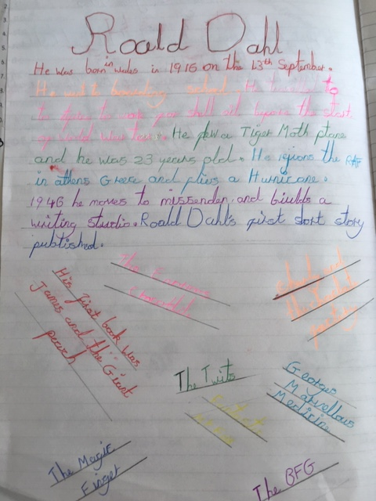
Here are just some highlights from Florence.
She’s loving junk modelling and her latest creation is a marble run!
Her baking highlight is making Battenberg last week!
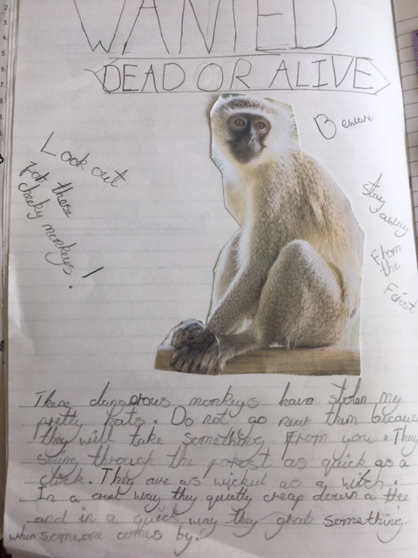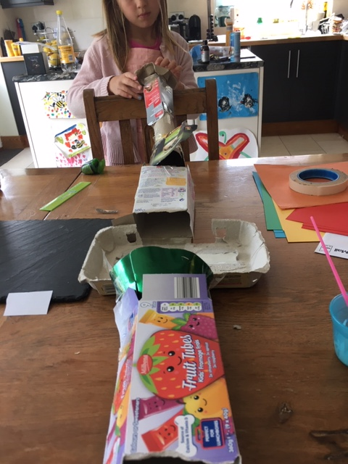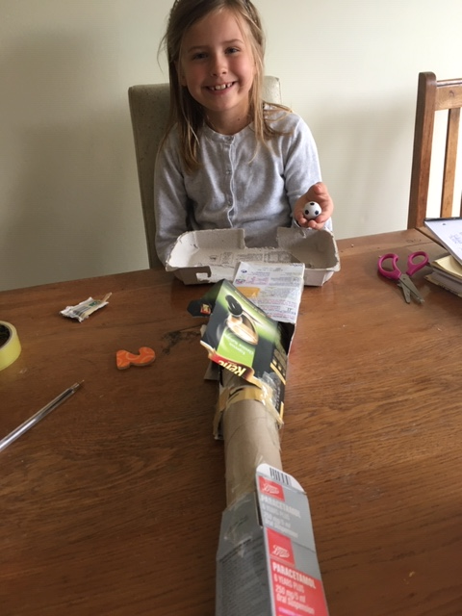
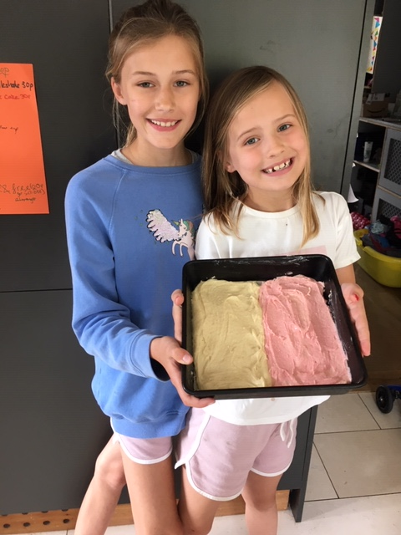
Congratulations GIRLS!
It looks delicious, yum, yum!

