1. A shop sells flowers.
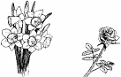
John buys 3 bunches of daffodils.
How much does he pay altogether?
1 mark
Karpal has £4.00 to spend on roses.
How many roses can she buy for £4.00?
1 mark
2. Here is the cost of pizzas.
Jill orders one small cheese pizza with extra tomato.
What is the total cost?
1 mark
Ben buys one small pizza and one medium pizza.
They cost him £10.
Which two could they be?
one small ........................................................................................... pizza
and one medium ............................................................................... pizza
1 mark
3. A shop sells greetings cards.
Each card has a price code on it.
These are the codes.
Tina buys two cards.
One card has code AA on it.
The other card has code DD on it.
How much does Tina pay?
£
1 mark
Omar buys a card. He pays with a £2 coin.
He gets 45p change.
What is the code on his card?
...............................
1 mark
4. A shop sells batteries in packs of four and packs of two.
Simon and Nick want two batteries each.
They buy a pack of four and share the cost equally.
How much does each pay?
2 marks
Mary buys 2 packs of two batteries.
Hamid buys 1 pack of four.
How much more does Mary pay than Hamid?
2 marks
5. Lewis makes a call from a telephone box.
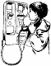
He has £2 in coins.
He uses these five coins to make the call.
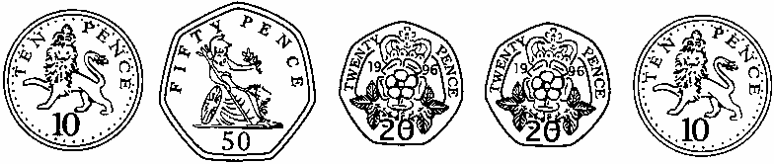
How much money has he got left from the £2?
1 mark
6.
Write these amounts of money in order of size, starting with the smallest amount.
1 mark
7. Chen has £9.10
He wants to buy a game which costs £11.50
How much more does he need to save?
£
1 mark
8. Asif, Vicky and Nita go to town by bus.
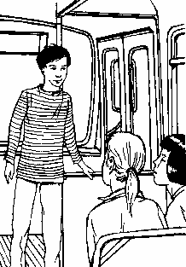
This is what they pay.
How much more does Nita pay than Asif?
1 mark
Vicky then takes another bus from town to visit her auntie.
She pays 90p on this bus.
How much has Vicky paid altogether for her two bus tickets?
1 mark
9. These are the prices of coconuts and bananas.
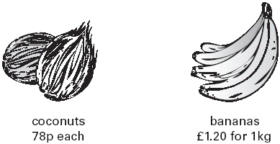
Josh buys one coconut and half a kilogram of bananas.
How much does he spend altogether?
2 marks

Oranges cost 25p each.

How many oranges can Josh buy for £1.50?
1 mark
10. Ben saved twenty-four 10p coins and ten 20p coins.
How much money has Ben saved?
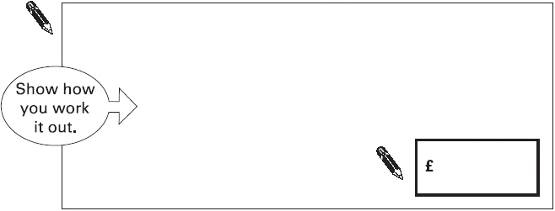
2 marks
11. There are 5 balloons in a packet.
There are 18 packets in a box.
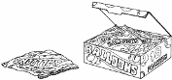
How many balloons are there altogether in a box?
1 mark
There are 5 balloons in a packet.
Kofi needs 65 balloons.
How many packets does he need?
1 mark
12. Cinema tickets cost £3.65 each.
Hannah buys 4 tickets.

How much does Hannah pay?
£
1 mark

Nico buys a box of popcorn and two milkshakes.
How much does Nico spend altogether?
2 marks
13. Write these prices in order from smallest to largest.
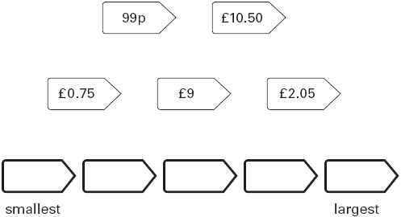
1 mark

14. A shop sells candles.
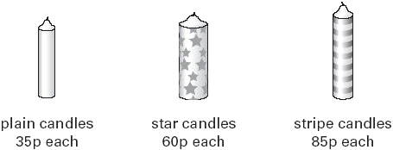
Sapna buys 4 star candles and 2 stripe candles.
How much does she pay altogether?
2 marks
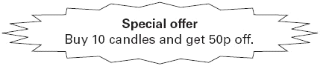
Josh buys 10 plain candles in the special offer.
How much does he pay for the 10 candles?
£
1 mark
15. These are the prices in a shoe shop.
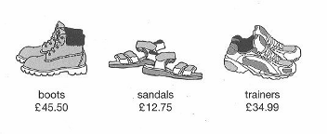
How much more do the boots cost than the trainers?
ml
1 mark
Rosie buys a pair of trainers and a pair of sandals.
How much change she gets from £50?
2 marks

16.
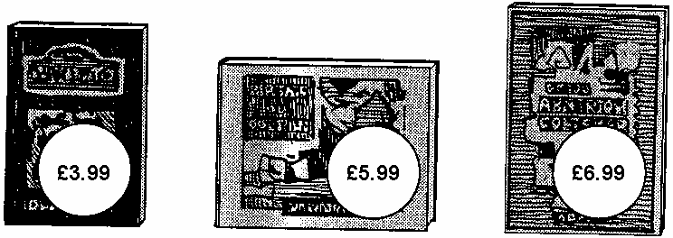
Lee bought these three books in the sale for £14.50
How much money did he save altogether compared to the full price of the books?
2 marks

17.
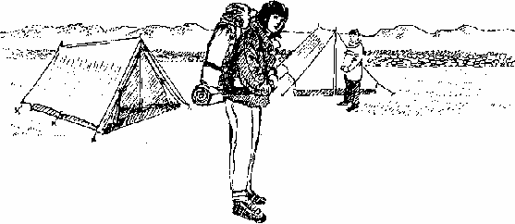
Some children go camping.
It costs £2.20 for each child to camp each night.
They go for 6 nights.
How much will each child have to pay for the 6 nights?
2 marks
There are 70 children.
Each tent takes up to 6 children.
What is the least number of tents they will need?
2 marks
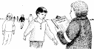
18. Some children do a sponsored walk.
Jason is sponsored for £3.45 for each lap.
He does 23 laps.
How much money does he raise?
£
1 mark
Lynne wants to raise £100.
She is sponsored for £6.50 for each lap.
What is the least number of whole laps she must do?
1 mark
19.
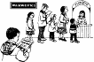
This is the cost to visit the waxworks.
On Friday morning 12 adults and 20 children visit the waxworks.
How much do they pay altogether?
2 marks
Guide books cost £1.50 each.
The waxworks sells £24 worth of guide books.
How many guide books is this?
1 mark
20.
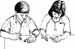
Chris saves 50p coins.
He has saved 45 of them.
How much money has Chris saved?
1 mark
Michelle has saved £8.40 in 20p coins.
How many 20p coins does Michelle have?
2 marks

21. Parveen buys 3 small bags of peanuts.
She gives the shopkeeper £2 and gets 80p change.

What is the cost in pence of one bag of peanuts?
2 marks
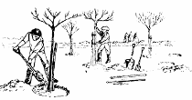
22. Five children collect money to plant trees.

Here is a bar chart of the amounts they have raised so far.

Their target is £40 altogether.
How much more money do they need to reach the target?
2 marks
23. Two children take part in a sponsored silence.
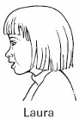
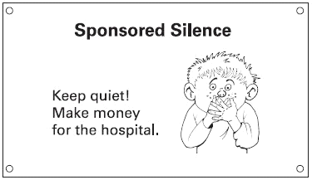
‘I kept quiet from 10:30 to 10:35 in the morning. I got £3.42 a minute.’
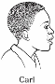

‘I kept quiet for half an hour. I got 35p a minute.’
How much money did each child get?
Laura | £

Carl | £
2 marks
24.
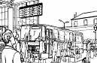
The table shows the cost of coach tickets to different cities.

What is the total cost for a return journey to York for one adult and two children?
£
1 mark
How much more does it cost for two adults to make a single journey to Hull than to Leeds?
£
1 mark
25. Mr Singh buys paving slabs to go around his pond.
He buys 4 rectangular slabs and 4 square slabs.
What is the total cost of the slabs he buys?
2 marks

Mr Singh says,
'It would cost more to use square slabs all
the way round.'
Explain why he is correct.
...............................................................................................................................
...............................................................................................................................
1 mark

26. This graph shows the cost of phone calls in the daytime and in the evening.

How much does it cost to make a 9 minute call in the daytime?
p
1 mark
How much more does it cost to make a 6 minute call in the daytime than in the evening?
p
1 mark
27.
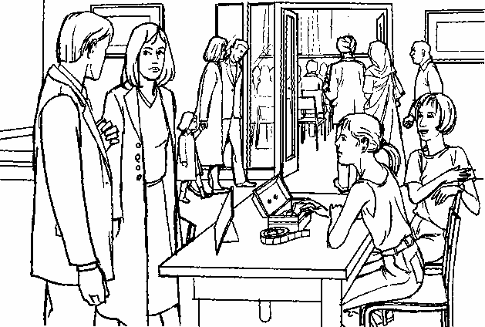
185 people go to the school concert.
They pay £l.35 each.
How much ticket money is collected?
£
1 mark

Programmes cost 15p each.
Selling programmes raises £12.30
How many programmes are sold?
2 marks
28. These are the prices in a fish and chip shop.
Luke has £3
He wants to buy one fish, peas and two large bags of chips.
How much more money does he need?
2 marks
29. Asim and Mike both buy 12 cans of lemonade.
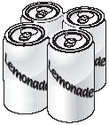
pack of 4 cans
£1.20

Asim buys 3 packs of 4 cans.
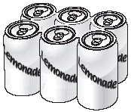
pack of 6 cans
£1.70
Mike buys 2 packs of 6 cans.
Mike says to Asim,
‘You paid 50p more than me’.
Is Mike correct?
Circle Yes or No. Yes / No
Explain how you know.
...............................................................................................................................
...............................................................................................................................
1 mark
30. Calculate of £15
£
1 mark

31. Here are three supermarket bills.
Tom rounds each bill to the nearest £10 and then adds them up.
What is the total amount that Tom gets?
£
1 mark
Mary adds up the three bills exactly.
What is the total difference between her total and Tom’s total?
2 marks

32. A shop sells three types of sunglasses.
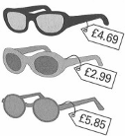
What is the difference in price between the most expensive and least expensive sunglasses?
£
1 mark
The shop also sells sun hats.
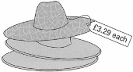
Ryan buys the £4.69 sunglasses and a sun hat.
How much change does he get from £10?
2 marks

33. Forest School sells badges for charity.
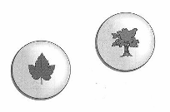
For each badge sold, £1.20 is given to a charity.
How much does the charity get when 12 badges are sold?
£
1 mark
If the charity got £24, how many badges were sold?
1 mark

34.
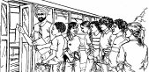
30 children are going on a trip.
It costs £5 including lunch.
Some children take their own packed lunch.
They pay only £3
The 30 children pay a total of £110
How many children are taking their own packed lunch?
2 marks
35.
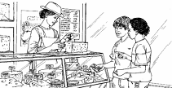
Cheddar cheese costs £7.50 for 1kg.
Marie buys 200 grams of cheddar cheese.
How much does she pay?
£
1 mark
Cream cheese costs £3.60 for 1kg.
Robbie buys a pot of cream cheese for 90p.
How many grams of cream cheese does he buy?
2 marks
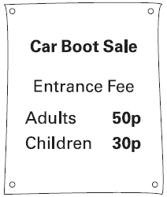
36.
100 adults and 80 children pay to go in.
How much money do they pay altogether?
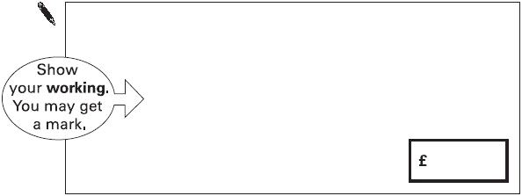
2 marks
37.
6 green apples for 75p 10 red apples for 90p
Jason bought some bags of green apples and some bags of red apples.
He spent £4.20
How many bags of each type of apples did he buy?
2 marks
Nika and Hassan bought some bags of apples.
Nika says,
‘I bought more apples than Hassan, but I spent
less money.’
Explain how this is possible.
...............................................................................................................................
...............................................................................................................................
1 mark
38.
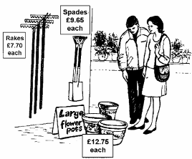
Nicola has £50.
She buys 3 flowerpots and a spade.
How much money does she have left?
2 marks
Seeds are £1.45 for a packet. 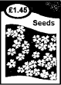
Steffan has £10 to spend on seeds.
What is the greatest number of packets he can buy?
1 mark
39. Shenaz buys a pack of 24 cans of cola for £6.00
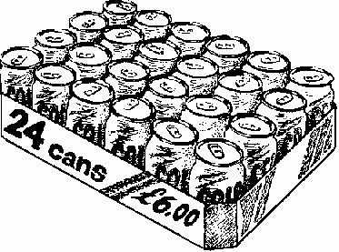
What is the cost of each can?
2 marks
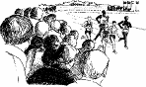
40.
2753 people go to a sports event.
Each person pays £2.30 for a ticket.
What is the total amount of ticket money collected?
£
1 mark
Programmes cost 65p each.
The total money from programme sales is £612.95
How many programmes are sold?
2 marks
41. A drink and a box of popcorn together cost 90p.
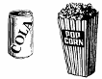
2 drinks and a box of popcorn together costs £1.45.
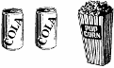
What does a box of popcorn cost?
1 mark
Explain how you got your answer.
...............................................................................................................................
...............................................................................................................................
1 mark
42. 427 children visit a castle.
They go in groups of 15. One group has less than 15.
Every group of children has one adult with them.
How many adults will need to go?
1 mark
Mr Todd buys 7 drinks at 48p each and 8 drinks at 52p each.
What is the total cost of the 15 drinks?
You must show your working.
2 marks

