Handwriting
The letter formations displayed below are what we are working towards in Year Two.
If your child is writing at home please encourage them to try cursive! (Some children are working on separated letter formation and know who they are!)
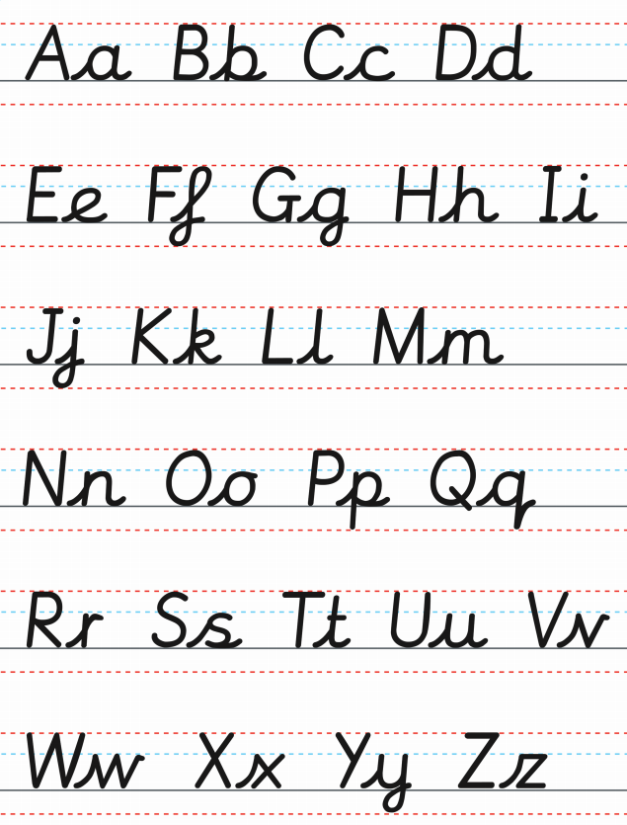
I hope this is helpful!

