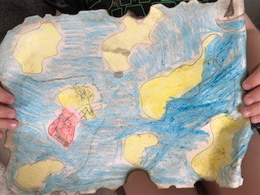 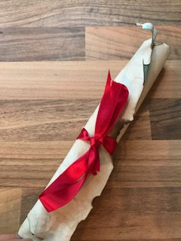

Jem enjoyed “The pirates” task and made a treasure map. He especially liked staining it with a tea bag and burning the edges!

Jem is also doing a football course with 3 of his friends from Year 2. They have a coach who gives them socially distanced skills to do for an hour on a Tuesday.

Wow! That’s great, Jem. Keep it up. I am very happy for you.

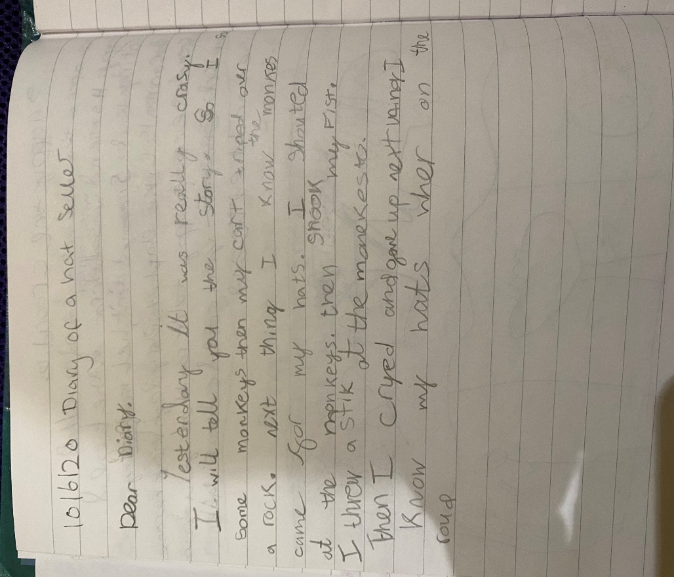 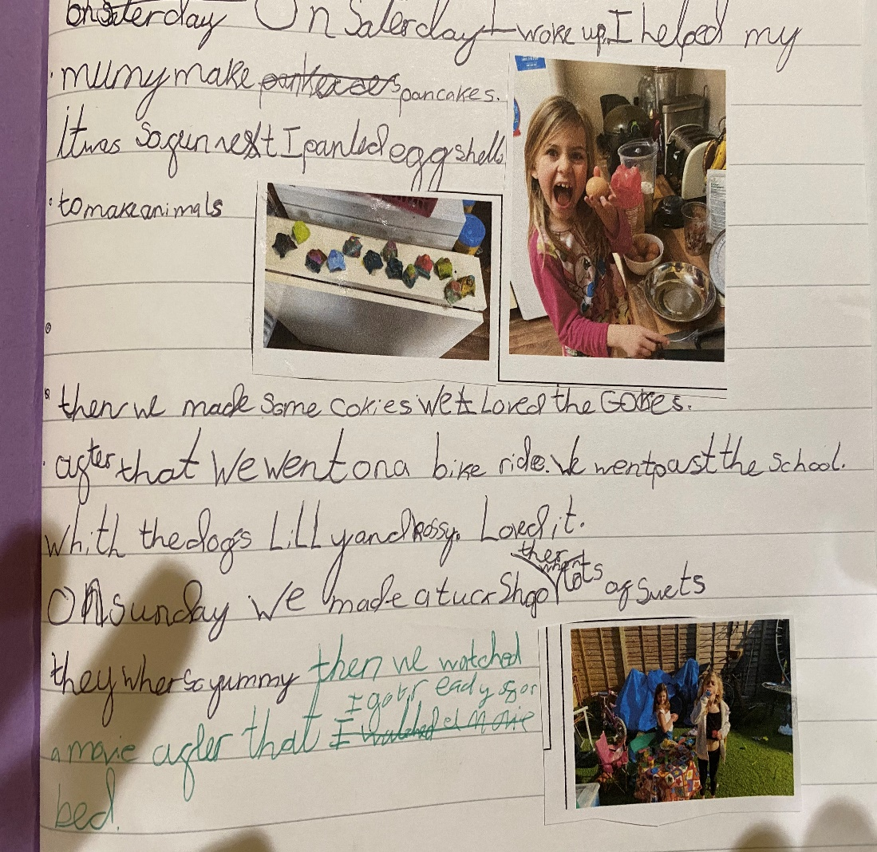

Scarlett has sent a copy of her diary, where she pretended to be the Hal Seller. The second work is showing Scarlett working hard in the kitchen and her garden.

It is so lovely to see your smile. You are a very busy lady. Keep it up!

Oh, Alex, you have made me very, very happy. This is my first entry for the Month of Music competition. Superb work. 😊

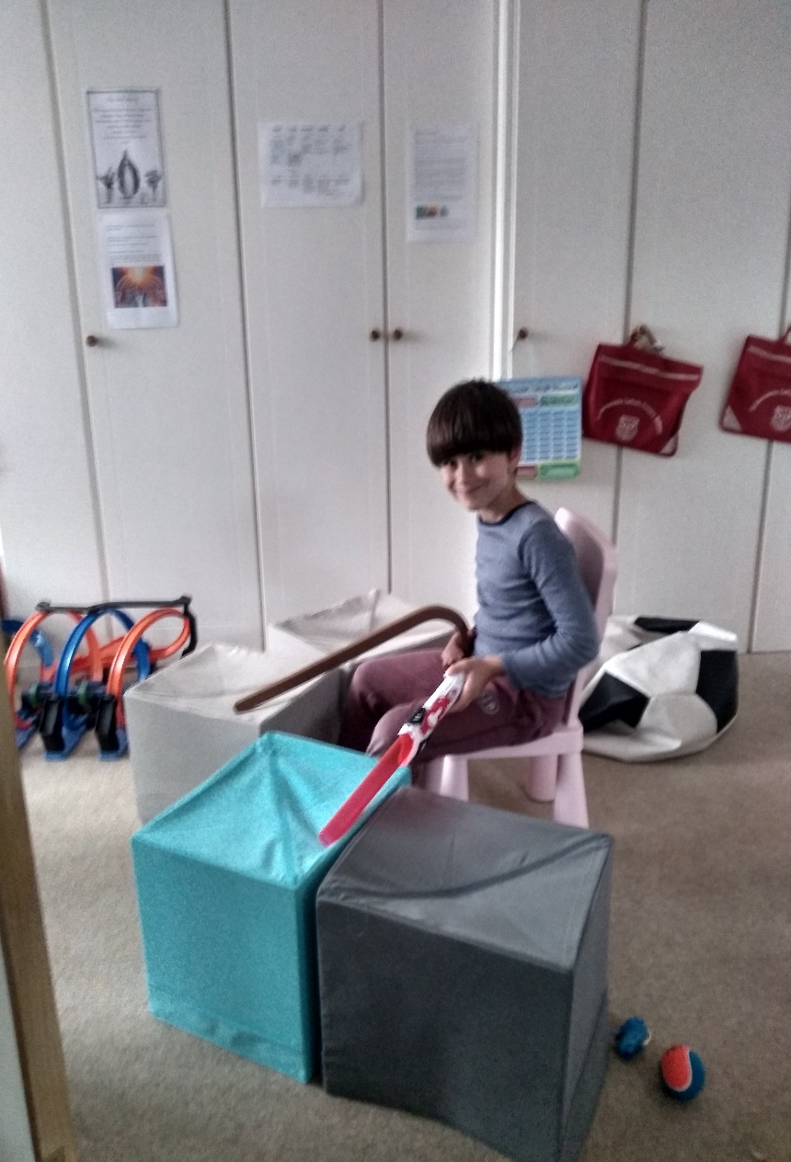Month of Music Competition- Alex making a set of drums.

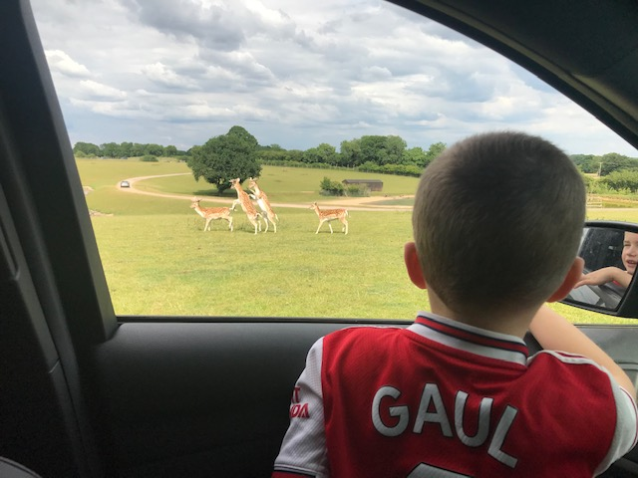 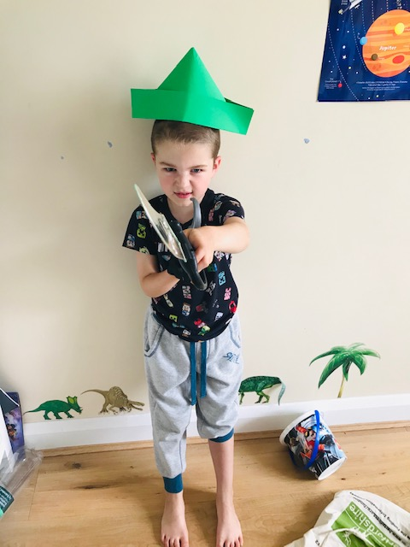

Cian said, “I really enjoyed the science experiment. We tested many materials and picked the best ones for the boats and put Lego people on them. I like “The Pirates” week. We also had a trip to the zoo. I loved it”.

.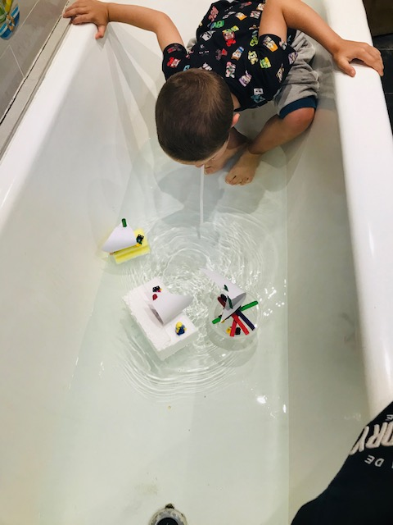 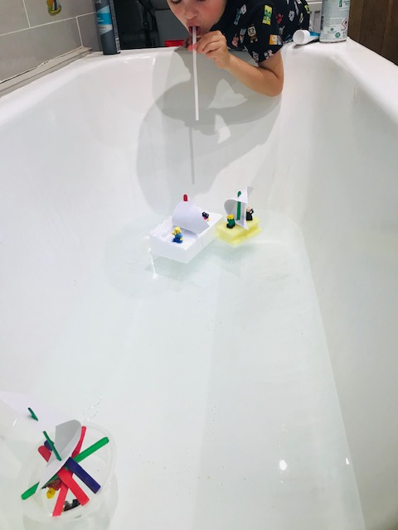

I like your football SHIRT! 😊

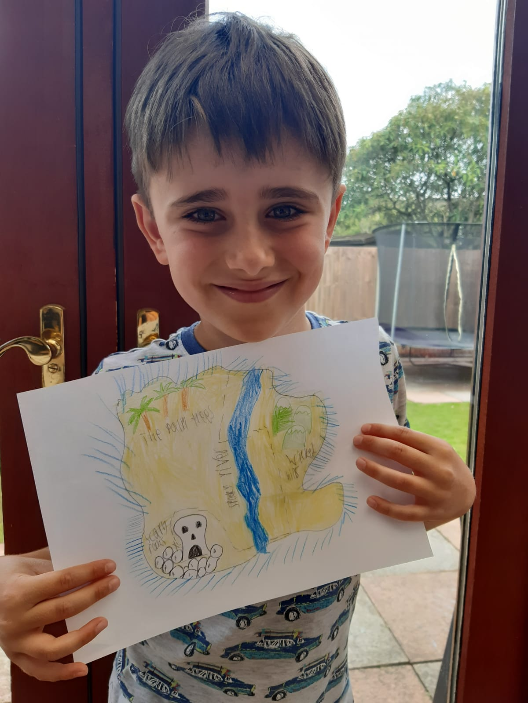 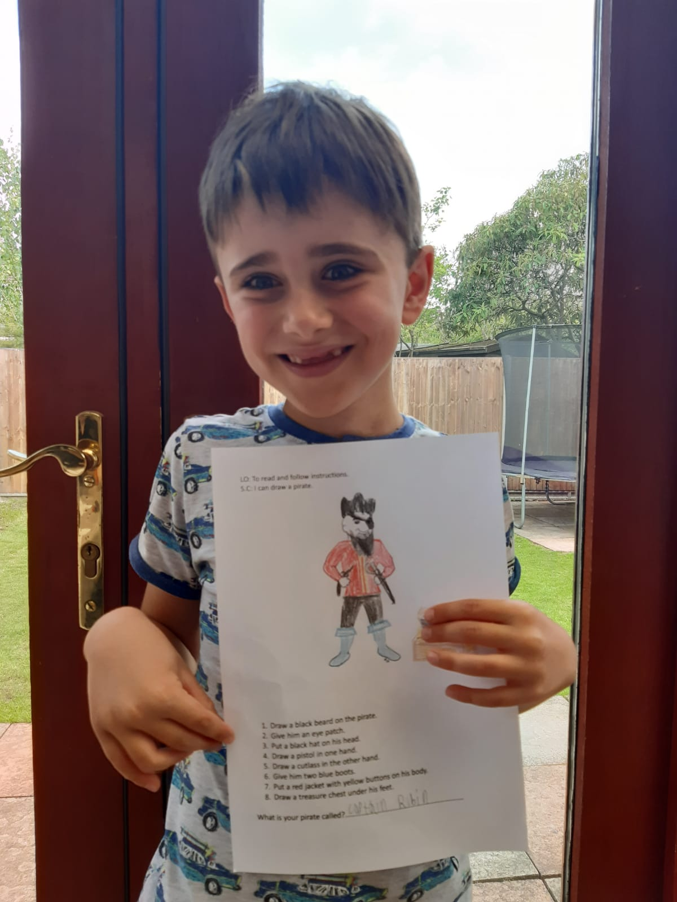

Alex with the treasure map and the pirate.  He named the pirate 'Captain Robin'.

😊

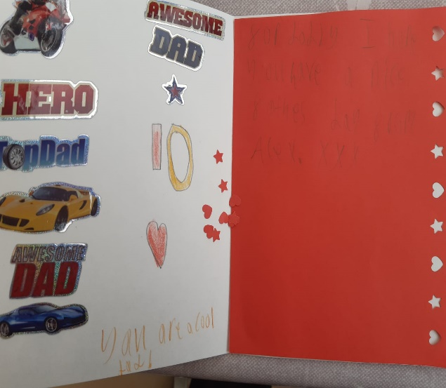 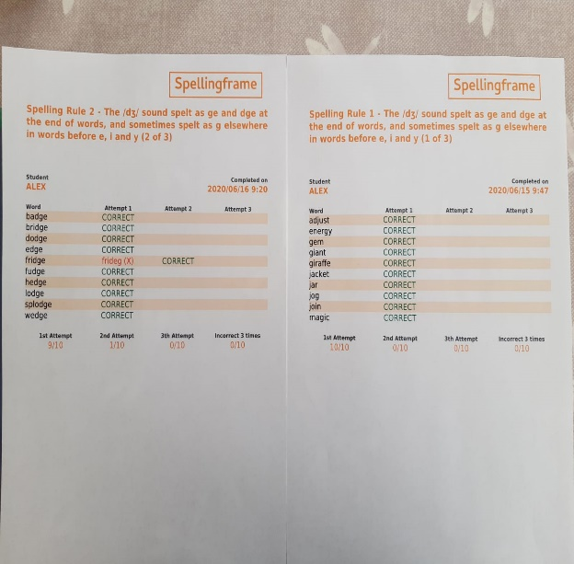 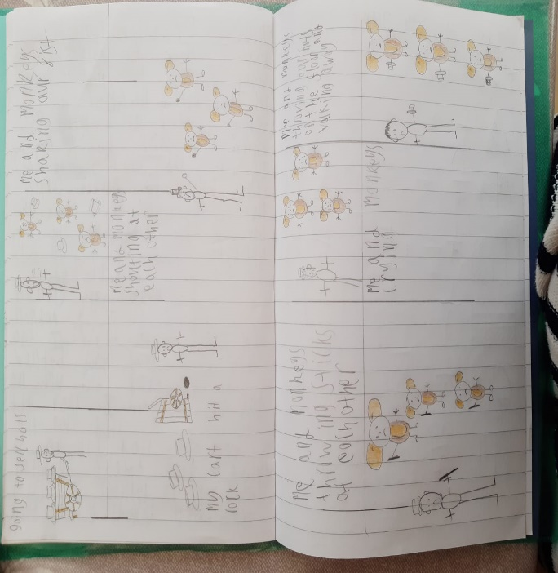

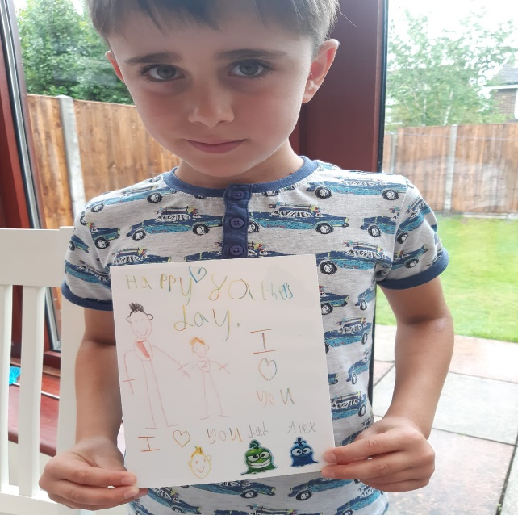 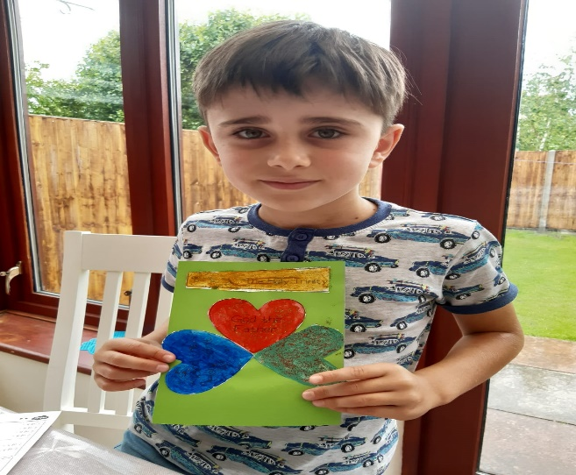 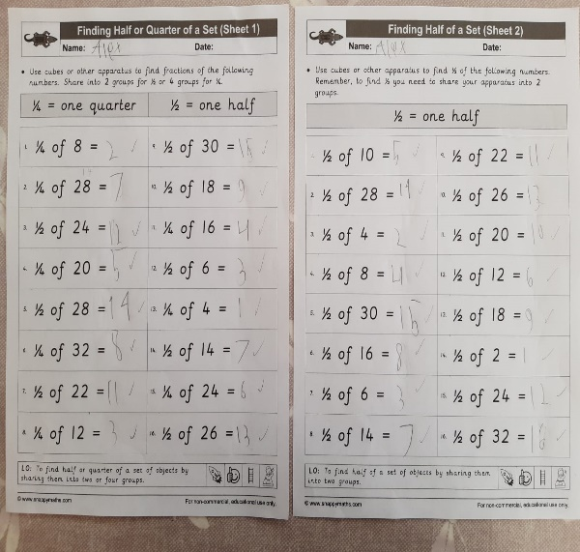

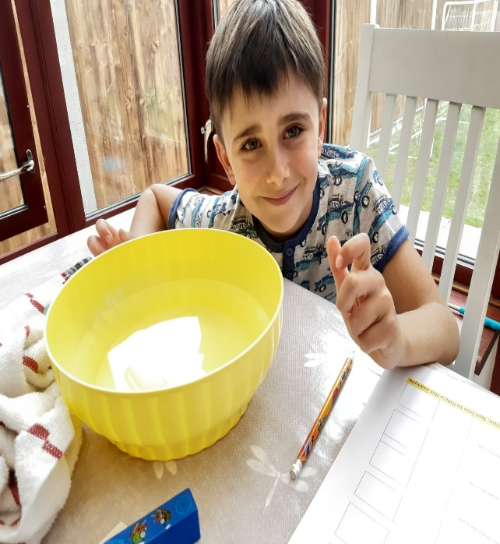 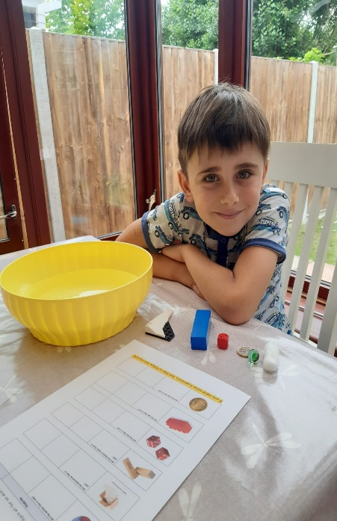 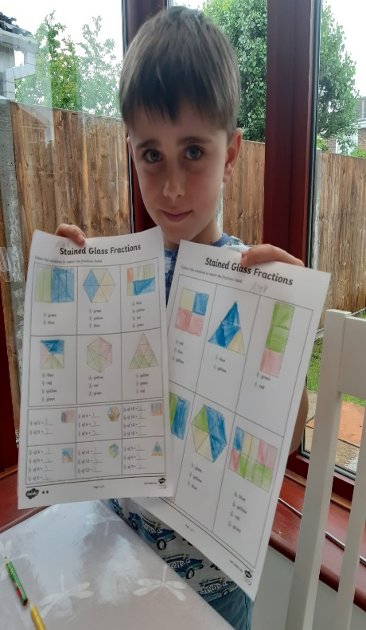

Alex worked really hard and he sent us pictures of his science experience (sink and float), some additional fractions work, spelling frame results and his home made Father’s Day card.

Did you know?

Alex is enjoying learning about fractions!