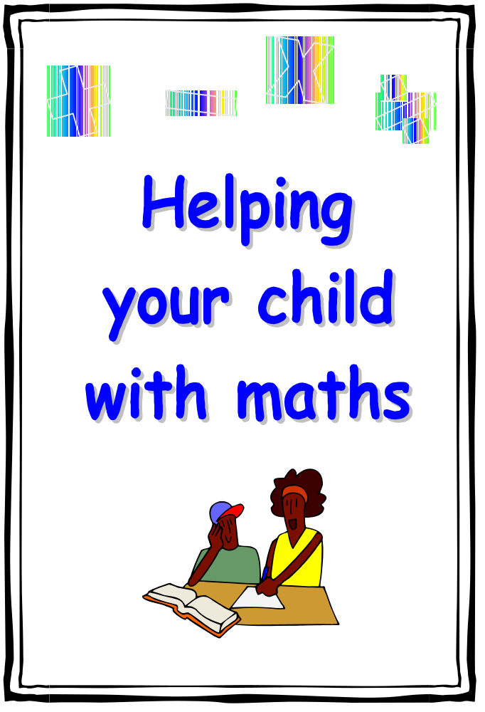
Leicestershire Numeracy Team 2003
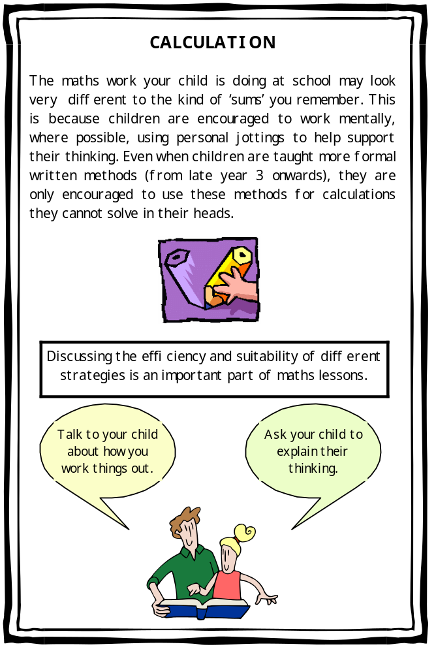
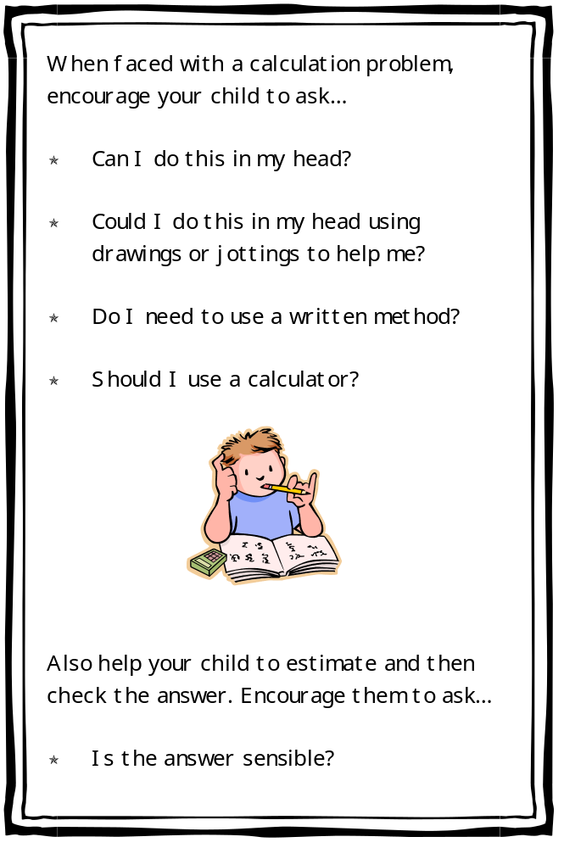
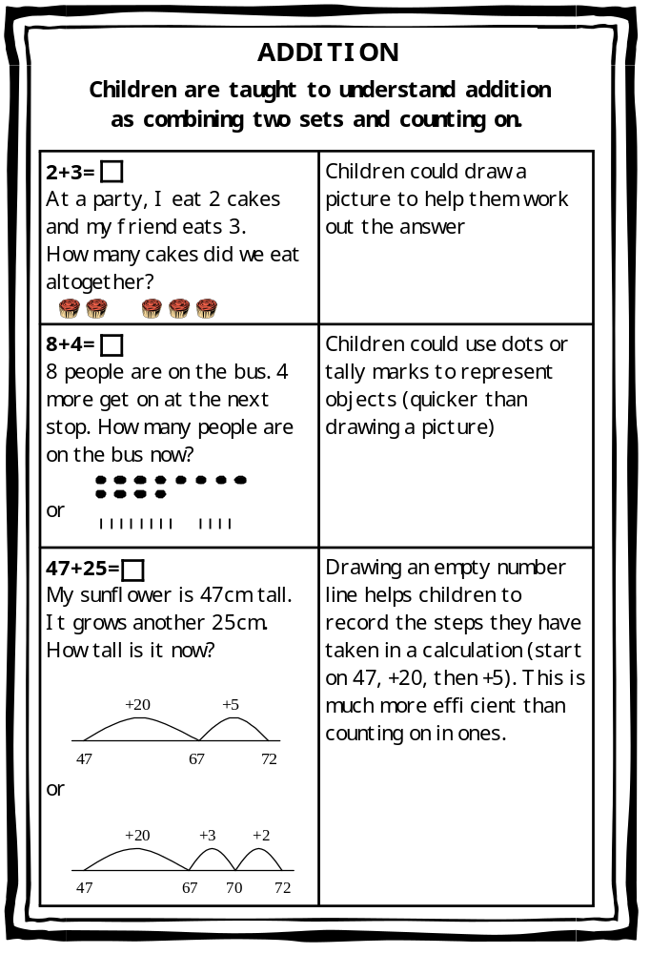

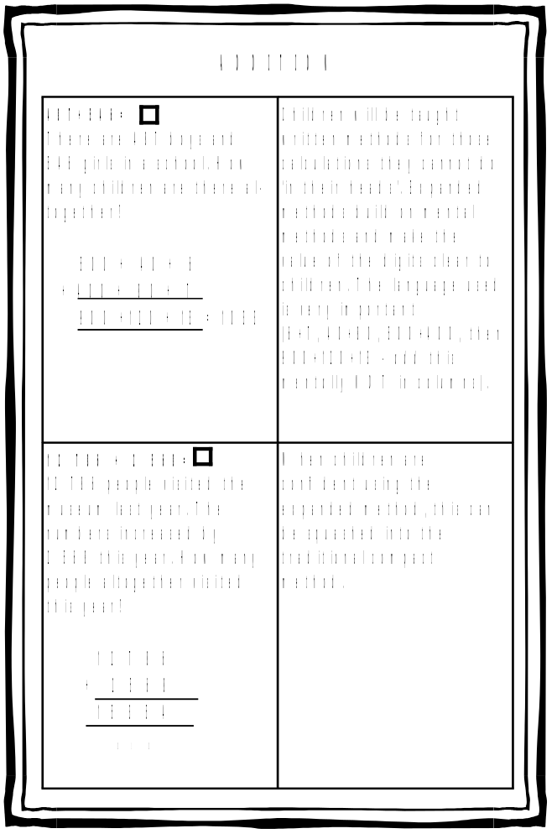
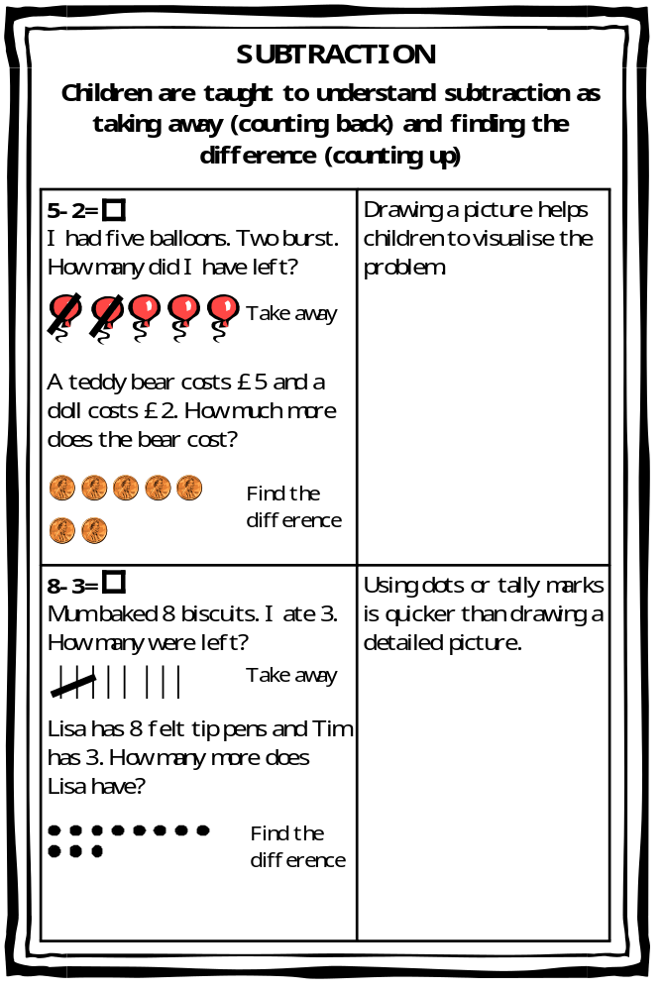

SUBTRACTION

84
-
27=

I cut 27cm off a ribbon
mea
s
uring 84cm. How much is
left?

or

Children could count
back using an empty
nu
m
ber line. This is a
really good way for them
to record the steps they
have taken (start on
84,
-
20, then
–
7).

834
-
378=

The library owns 834 books.
378 are out on loan. How many
are on the shelves?

2 2 (400)

4 0 0 (800)

3 4 (834)

4 5 6

Children could count up
(from the smallest
number to the biggest )
using an empty number
line. It is easiest to
count up to
a multiple of
10 or 100 (a friendly
nu
m
ber). The steps can
also be recorded
ve
r
tically. This method
works really well with
any numbers, including
decimals!

57 64 84
- 7 - 20

57 60 64 84
-3 -4 -20

+22 +400 +34

378 400 800 834



