1. Jack ate half the cherries on the plate.
These are the cherries that were left.
How many cherries were on Jack’s plate before he ate half of them?
cherries
1 mark
2. Tick () the two shapes that have three-quarters shaded.
1 mark
3. Here is part of a number line.
Write in the numbers missing from the two empty boxes.
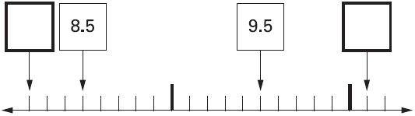
2 marks

4.
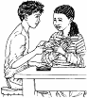
Tom and Nadia have 16 cards each.
Tom gives Nadia 12 of his cards.
How many cards do Tom and Nadia each have now?
Tom Nadia
1 mark
Lucy also has 16 cards.
She gives a quarter of her cards to Kiran.
How many cards does Lucy give to Kiran?
1 mark
5. Here are 21 apples.
Put a ring around one third of them.
1 mark
6. Here is part of a number line.
Write the missing number in the box.
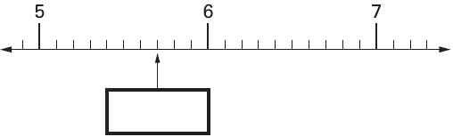
1 mark
7. Shade one third of this shape.
1 mark
Shade one quarter of this shape.
1 mark

8. Tick () two cards that give a total of 5
1 mark
9. Write the two missing numbers in this sequence.
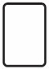 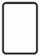 2
1 mark
10. Meg has 20 pet stickers to go on this page.
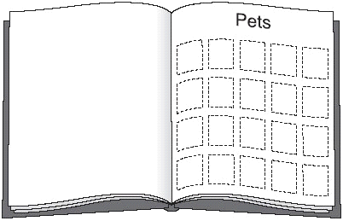

of them are dog stickers.
of them are cat stickers.
The rest are rabbit stickers.
How many rabbit stickers does she have?
stickers
1 mark
11. Circle the two fractions that are greater than
1 mark
12. Here is a square.
What fraction of the square is shaded?
1 mark
13. Circle the two fractions that have the same value.
1 mark
14. Draw an arrow () on the number line to show
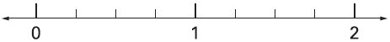
1 mark
15. Shade of this shape.
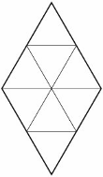
1 mark
16. John had £5
He gave 25% of it to charity.
How much did he give?
£
1 mark
17. Tick () the two numbers which have a total of 10
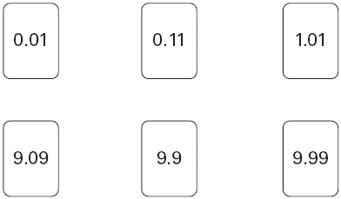
1 mark
18. Write in the missing number on this number line.
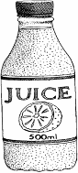
1 mark
19. A larger bottle of juice will hold 30% more than this bottle.

How much will the larger bottle hold?
ml
1 mark
20. Match each box to the number which has the same value.
One has been done for you.
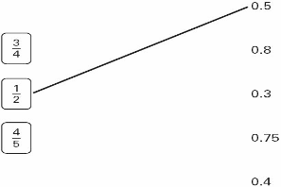 1 mark
21. Calculate 60% of 765.
1 mark
22. Draw one line to join two fractions which have the same value.
1 mark
23. Circle two numbers which add to make 0.12
0.1 0.5 0.05 0.7 0.07 0.2
1 mark
24. Write in the missing numbers.
One has been done for you.
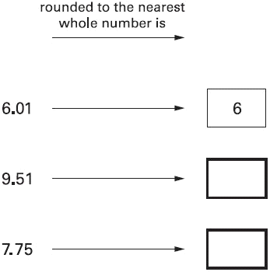
1 mark
25. Here is a grid made of squares.
Shade 10% of this grid.
1 mark
26. Write the same number in each box to make this correct.
+ + = 10.5
1 mark
27. Calculate of 840
1 mark
28. Circle the two fractions that are equivalent to 0.6
1 mark
29. Put a tick () in each row to complete this table.
One has been done for you.
 | greater than | less than
0.9
0.06
0.21
2 marks

30. Here is a chocolate bar.
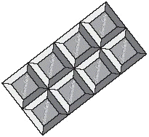
William eats 3 pieces and Amber eats 2 pieces.
What fraction of the chocolate bar remains?
1 mark
31. Match each box to the correct number.
One has been done for you.
1 mark
32. Karen makes a fraction using two number cards.
She says,
‘My fraction is equivalent to
One of the number cards is 6’
What could Karen’s fraction be?
Give both possible answers.
2 marks
33. Here is part of a number line.
Write in the two missing numbers.
2 marks
34. The diagram is made of squares.
What fraction of the diagram is shaded?
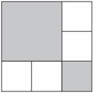
1 mark

35. Calculate of 325
1 mark
36. Write these fractions in order of size starting with the smallest.
smallest
1 mark

37. Write these numbers in order.
One has been done for you.
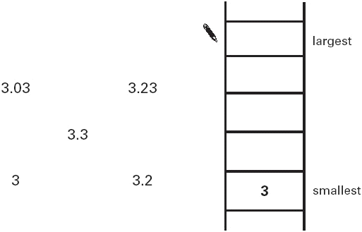 1 mark
38. Write in the missing numbers.3
30% of 60 is
1 mark
30% of is 60
1 mark
39. Calculate 31.6 × 7
1 mark
40. Here is a flag.
What is the area of this flag?
2 marks
20% of the flag is blue.
What area of the flag is blue?
2 marks
41. Complete these fractions to make each equivalent to
1 mark
42. Calculate 15% of 460
1 mark
43. Here are some number cards.
Use two of the cards to make a fraction which is less than .
1 mark
How much less than 1 is your fraction?
...............................
1 mark
44. Calculate 5% of £3600
£
1 mark
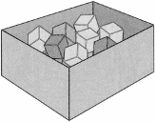
45. There are 24 coloured cubes in a box.
Three-quarters of the cubes are red,
four of the cubes are blue
and the rest are green.

How many green cubes are in the box?
2 marks
One more blue cube is put into the box.
What fraction of the cubes in the box are blue now?
1 mark

46. Which is larger, or ?
Explain how you know.
...............................................................................................................................
...............................................................................................................................
1 mark

47. The Year 6 children in a school were asked to choose a musical instrument. This is a pie chart of their choices.
Estimate what fraction of the children chose a drum.
1 mark
There are 80 children in Year 6.
Estimate the number of children who chose a violin.
1 mark
Explain how you decided.
..............................................................................................................................
...............................................................................................................................
1 mark
15% of the 80 children chose a guitar.
How many children is this?
2 marks
48. Calculate of 980
1 mark
49. Kelly chooses a section of a newspaper.
It has 50 words in it.
She draws a bar chart of the number of letters in each word.

What fraction of the 50 words have more than 6 letters?
1 mark
Kelly says,
23 of the 50 words have less than 5 letters.
This shows that nearly half of all the words used in the newspaper have less than 5 letters in them.
Explain why she could be wrong.
...............................................................................................................................
...............................................................................................................................
1 mark
50. Calculate of of 378
1 mark

51.
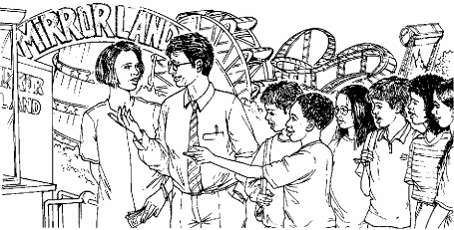
250 000 people visited a theme park in one year.
15% of the people visited in April and
40% of the people visited in August.
How many people visited the park in the rest of the year?
2 marks
52. Calculate 24% of 525
1 mark

