1.
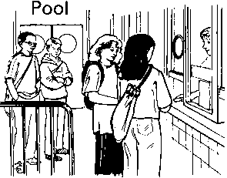
These are the opening times at a swimming pool.
How many hours is the pool open on a Sunday?
1 mark
Which day has the latest closing time?
..............................
1 mark
Habib arrives at the pool at 5:20pm on Saturday.
How many minutes is it before the pool closes?
1 mark

2. The time is
John has to be ready for school in half an hour.
Tick the time when he has to be ready.
1 mark

3. The clock shows the same time as one of the watches.
Draw a line to match the clock to a watch.
1 mark

4. An aeroplane takes off on Tuesday at 22:47
It lands on Wednesday at 07:05
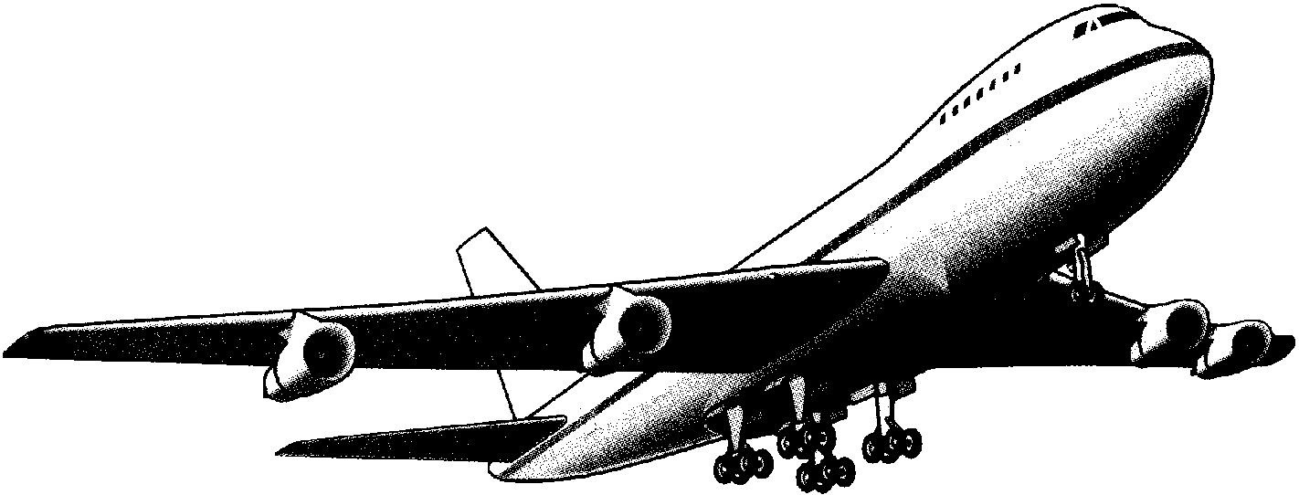
How long in hours and minutes is the flight?
1 mark

5. This was the time on Selin’s watch when she set off for a walk.
What time did the watch show 20 minutes before this?
1 mark
What time did it show an hour and a half after she set off for the walk?
1 mark
6. Here is a clock.
How many minutes is it until this clock shows 7:30?
1 mark

Here is another clock.
What time will the clock show in 20 minutes?
1 mark

7.
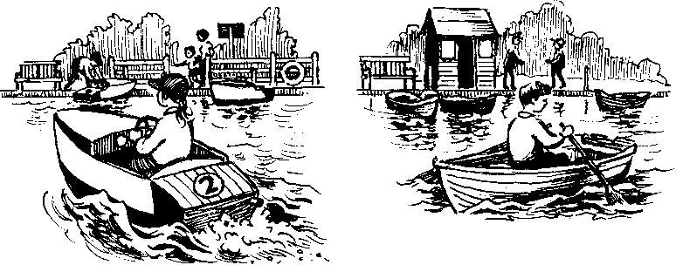
How much does it cost to hire a rowing boat for three hours?
1 mark
Sasha pays £3.00 to hire a motor boat.
She goes out at 3:20 pm.
By what time must she return?
1 mark

8. Here are three clock faces.
Match each clock face to the same time on a digital clock.
2 marks

9.
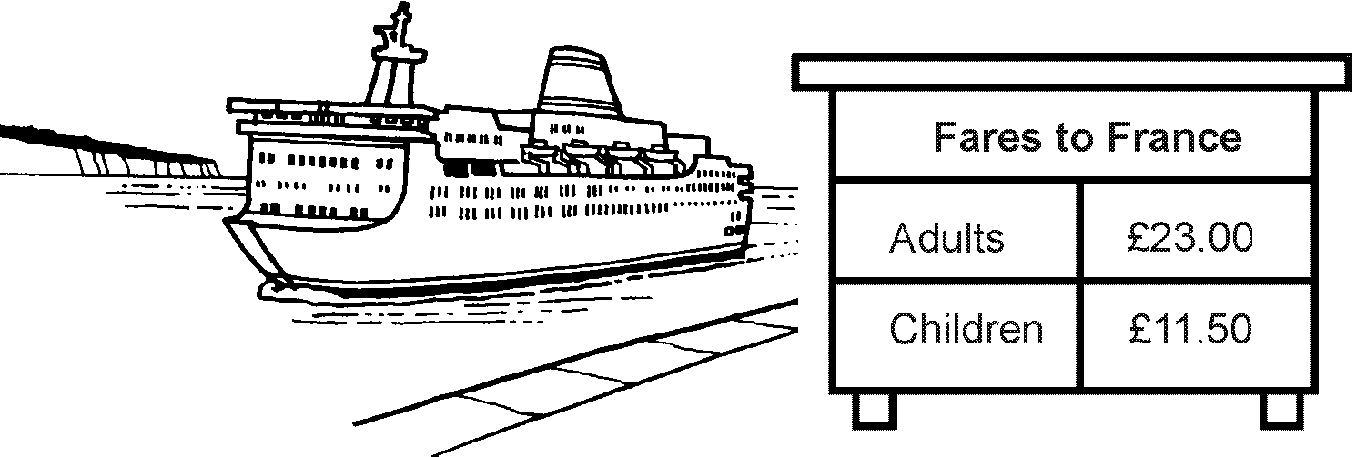
There are 2 adults and 3 children in a family.
How much does it cost the family to go on the ferry?
2 marks
On the ferry they change pounds for French francs.
For every £1 they get 7 francs.
How many francs do they get for £150?
1 mark

10. Here is the calendar for August 1998.
Simon's birthday is on August 20th.
In 1998 he had a party on the Sunday after his birthday.
What was the date of his party?
1 mark
Tina's birthday is on September 9th.
On what day of the week was her birthday in 1998? ……………………….
1 mark

11. This table shows the weight of some fruits and vegetables.
Complete the table.
2 marks
12.
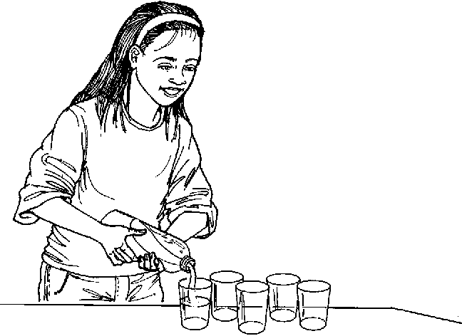
A bottle holds 1 litre of lemonade.
Rachel fills 5 glasses with lemonade.
She puts 150 millilitres in each glass.

How much lemonade is left in the bottle?
2 marks
13. One of these watches is 3 minutes fast.
The other watch is 4 minutes slow.
What is the correct time?
1 mark

14. Write the correct whole number in the box.

5 miles is approximately kilometres.
1 mark
15.
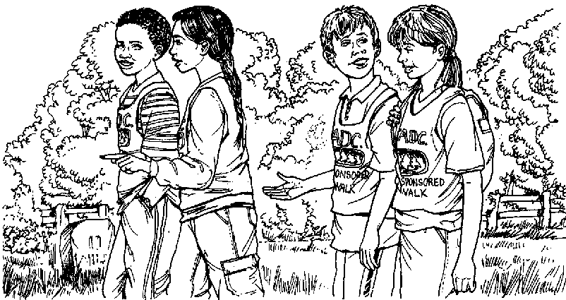
Here are the start and finish times of some children doing a sponsored walk.
How much longer did Claire take than Tim?
1 mark

16. This piece of cheese has a mass of 350 grams.
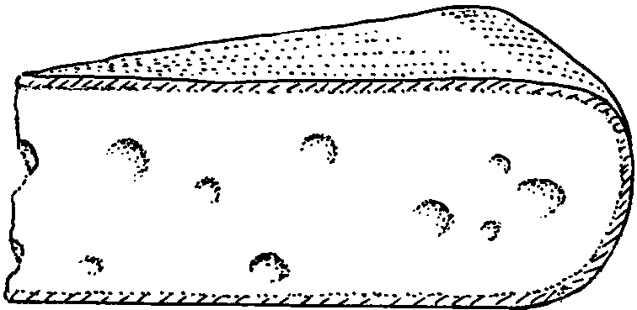
Mark an arrow (↓) on the scale to show the reading for 350 g.
1 mark
Here are some apples.
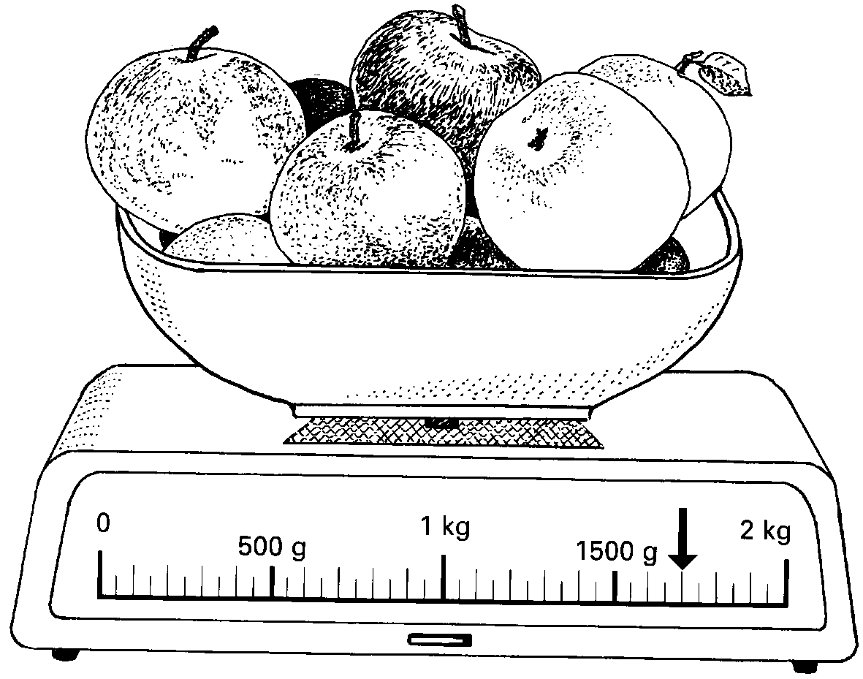
What is the total mass of these apples? 1 mark

17. These are the start and finish times on a video cassette recorder.
START 14:45
FINISH 17:25
For how long was the video recording?
1 mark
18.
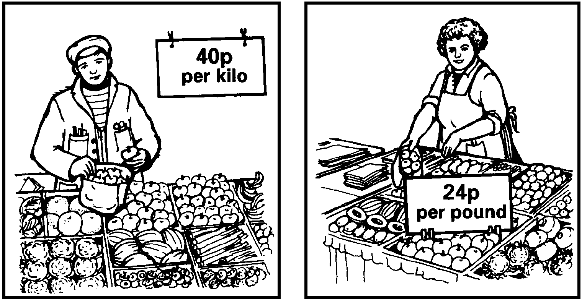
Mr Green sells apples Mrs Ball sells apples
at 40p per kilogram. at 24p per pound.
Work out who sells the cheaper apples.
Show how you worked it out.
................................
1 mark

19. This diagram shows the distances of different towns from Birmingham.
Write the name of a town which is between 30 and 50 miles from Birmingham.
…………………………..……..
1 mark
Use the diagram to estimate the distance in miles from Birmingham to Mansfield.
1 mark

21. Here is a recipe for raspberry ice cream.
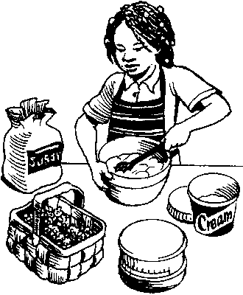
This recipe is for 8 people.
Josie makes enough raspberry ice cream for 12 people.
How much cream does she use?
1 mark
Fred makes raspberry ice cream in the same way.
He uses 2½ kg of raspberries.
How much sugar does he use?
2 marks

22. A packet contains 1.5 kilograms of guinea pig food.
Remi feeds her guinea pig 30 grams of food each day.
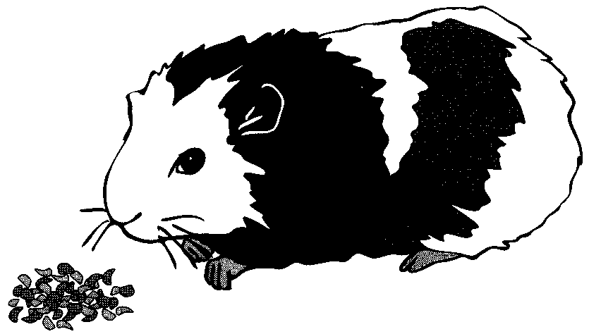
How many days does the packet of food last?
2 marks

23. This graph shows how the weight of a baby changed over twelve months.
From the graph, what was the weight of the baby at 10 months?
1 mark
How much more did the baby weigh at 5 months than at birth?
1 mark

24.
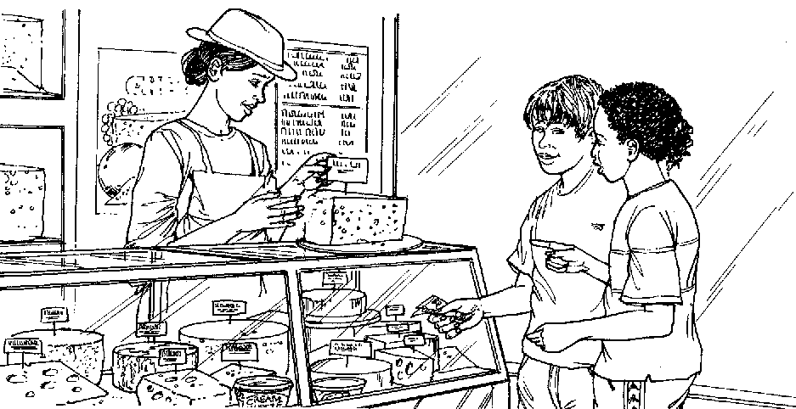
Cheddar cheese costs £7.50 for 1kg.
Marie buys 200 grams of cheddar cheese.
How much does she pay?
1 mark
Cream cheese costs £3.60 for 1kg.
Robbie buys a pot of cream cheese for 90p.
How many grams of cream cheese does he buy?

2 marks

25. On this scale, the arrow (↑) shows the weight of this pineapple.
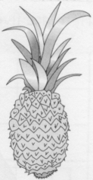
Here is a different scale.
Mark with an arrow (↑) the weight of the same pineapple.
1 mark

