4. Superheroes
THE earliest superheroes appeared in comic books in the 1930s. Some of them such as Captain Marvel are less well known today but others from that era, Superman for example, are still with us. They appear in feature films, cartoons, on television, as well as in comics and a new type of fiction called ‘graphic novels’. Such is their appeal that many of them – Batman, Superman and Wonder Woman, to name but three – are known throughout the world and their stories are told in many languages.
OF COURSE superheroes may be popular all over the world, but that does not mean that everybody likes them. Some people argue that their adventures are far-fetched and unrealistic. They are accused of having a harmful influence on children who put themselves in danger by copying their heroes’ impossible deeds. Others enjoy the stories for their excitement, suspense and escape from reality. Fans revel in knowing every detail about their superheroes: their individual powers, their intriguing costumes, their unique physical features – even their family backgrounds.
While fans may be interested in the detailed differences between these characters, there are certain features they have in common and which they have to possess in order to qualify as ‘superheroes’.

SUPERHEROES must have:
AND THEY ALWAYS TRIUMPH …
... in the end.

These questions are about the information Superheroes.
1. Where are the main places you can see superheroes now?
Tick three answers.
on television
in films
in museums
at the theatre
in graphic novels
1 mark
2. The writer has given reasons why some people like superhero adventures and others do not.
Write down one reason why people like them and another reason why they do not.
Like:
...............................................................................................................................
1 mark
Dislike:
...............................................................................................................................
1 mark
3. individual ... unique
What do these words tell you about superheroes?
...............................................................................................................................
...............................................................................................................................
...............................................................................................................................
1 mark

4. Eight features of a superhero are described.
Draw lines to show which one would be most useful in each of the following challenges.
One has been done for you.
2 marks
5. Ordinary people sometimes perform heroic deeds.
Which three of the eight superhero features could an ordinary person have?
• ............................................................................................................................
• ............................................................................................................................
• ............................................................................................................................
2 marks

6.
A huge meteor is sent hurtling out of control towards Earth by enemy aliens.  A superhero sets out to try to save the world.  Using the information you have read, explain which features the superhero will use to solve the problem and how they will be used. | 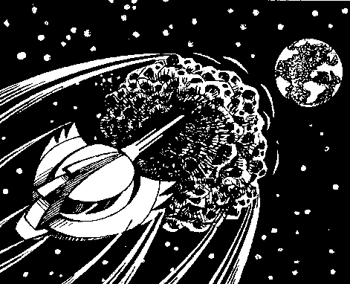
...............................................................................................................................
...............................................................................................................................
...............................................................................................................................
...............................................................................................................................
...............................................................................................................................
...............................................................................................................................
3 marks

