Homework:
Homework is always handed out on Friday’s and all tasks are expected back into school by Wednesday the latest. Homework consists of one piece of Literacy work, one piece of Numeracy. These are usually tasks that would consolidate what we have been learning about in class. In addition, RE homework is set every couple of week and there is also a Topic project every half term. The project homework has its own date that it is due in.
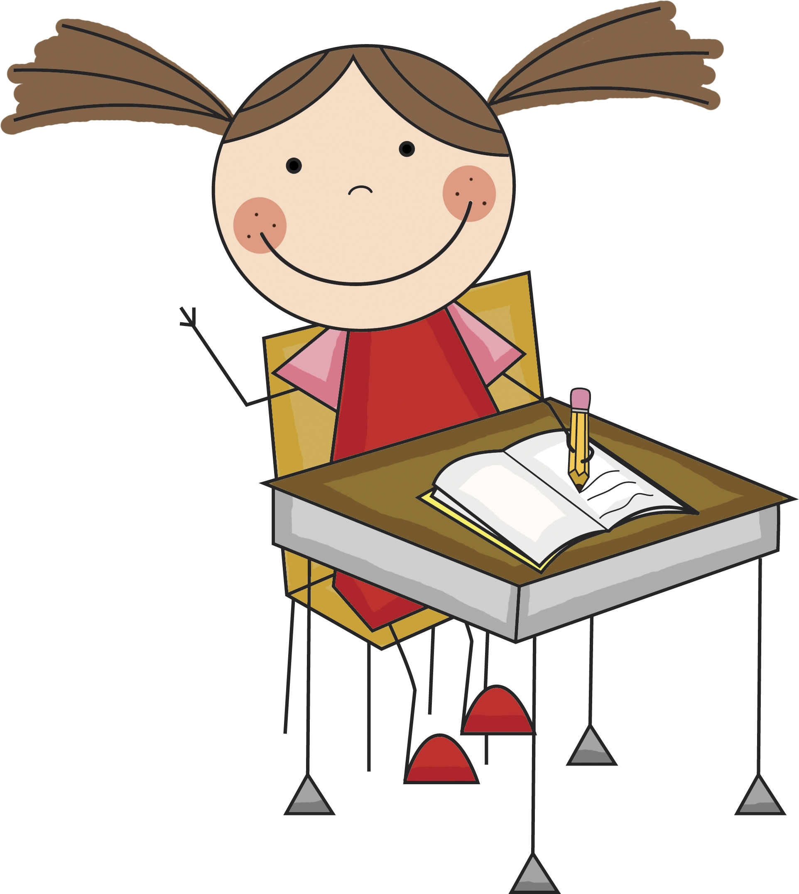
In addition to all of this, daily reading is also an expectation that we have as a school. This ensures that the children are continuously practicing and applying their phonics decoding skills.

Spellings:
Spellings are also part of the homework that is distributed on Friday’s. There will be 7-10 words a week and the test is always on the following Friday, allowing an entire week for your children to learn them. Spellings consist of high frequency words that are a requirement of Year 1. The children’s scores will be noted in your children’s reading records on the day of the test.
PLEASE SUPPORT US!

- Please ensure that reading is carried out daily at home and any reading is noted in your child’s reading record.
- Please ensure that your child learns their spellings as the words chosen are requirements of a Year 1 child.
- Please ensure that all homework is completed on time and presented nicely.
- Please support us in the behaviour code that we adopt as a school.
- Always inform us of any changes in address or contact details.
- The safety, welfare and happiness of each child is a key priority at St Bernadette School. If you have any problems, worries or concerns please do not hesitate to contact the school through your child’s class teacher.

YEAR 1
ST BERNADETTE CATHOLIC PRIMARY SCHOOL
CURRICULUM NEWSLETTER
AUTUMN 2019
MISS WEBB

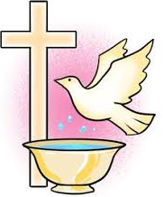
Religious Education:
The first topic of this term is called ‘In the Beginning’. Here we will be exploring our relationship with God and learning about different stories from the Bible such as the story of the Burning Bush. In the second half of the term we will be learning about Advent as well as looking into different versions of the Christmas Nativity.

Prayer is a very important focus in Year 1. We recite prayers three times a day and there are also additional opportunities for individual children to lead the class in their own prayers.

Literacy:
A great deal of this term will be revisiting the phonics phases 2, 3 and 4 which the children would have learnt in Reception. This is fundamental to aspects of the curriculum. In the first half term, we will be writing labels, lists and captions, linking this to our Topic theme of Travel and Transport. The second half of the term will be writing recounts about the Gunpowder Plot from Guy Fawkes’ perspective!

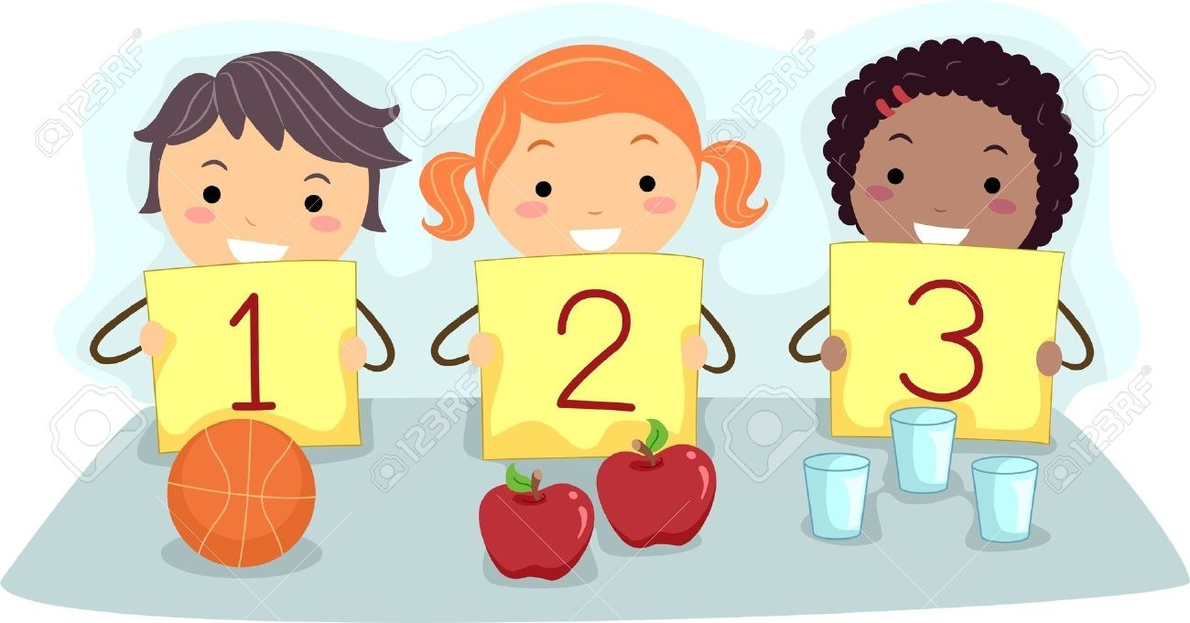
Numeracy:
Initially, the maths we tackle at the start of the term will focus on securing the children’s understanding of the number system (using numbers 1-10 at first). Once this is secure, we will move on to basic addition and subtraction- using the correct signs as symbols as well. Pattern and shape will also be explored this term. We follow a scheme called Maths No Problem, which maps out the individual maths requirements of Year 1 in a more realistic and gradual manner.
CREATIVE CURRICULUM-subject areas are highlighted in bold
Our first science topic for this term is ‘Everyday Materials’. Here we will be identifying the main materials that we see on a day-to-day basis whilst also looking at the properties of them. The second topic explores how the weather changes from Autumn to Winter. (Science)

Our first Topic theme is called ‘Travel and Transport’. Here we will be looking at how we are able to travel around on a daily basis as well as how this has changed and improved over 100 years. It will involve significant comparisons between then and now! In the second half of the term we will be looking at the Gunpowder Plot and Guy Fawkes. (History)

The creative curriculum is designed so that science, history and geography all contain area for creativity. Art and design and technology are intertwined within these subjects, meeting the needs and requirements for all types of learners. At St Bernadette, we aim to provide cross-curricular lessons, creating links between all subject areas where possible. You will notice links especially between our science, topic and literacy lessons.

HOW YOU CAN EXTEND YOUR CHILD’S LEARNING?

- Please encourage your children to take advantage of all learning opportunities that may arise at home. This year I have created an entire display board. I am eager to praise and display work from all subject areas and even any additional work that you may choose to do at home with your child.
- Year 1 is a very important year in terms of Phonics. The children have to sit a screening check that is required by the local authority. This test is either pass or fail. It consists of 40 words (both real and nonsense words) that the children must read correctly, using their phonics skills. It consists of Phase 2, 3, 4 and 5 sounds. It is therefore crucial that you are practicing these as often as possible at home. This can be easily achieved through reading on a daily basis.
Computing:
Over the summer holidays, we were very lucky to have received brand new Chromebooks. Therefore, this term we will spending most of our ICT lessons practicing logging into the computers and performing basic tasks. These lessons will be very practical and will consist of working independently or in partners on the Chromebooks. We still have access to the iPads that we have been using over the previous years and we will therefore be using these occasionally as well.

PSCHE:
Starting a new year group at school can sometimes be difficult. Therefore, PSCHE this term will consist of a number of circle times tackling key areas such as British Values, how to be good friends, worries, growth mind-set, dealing with friendship problems, identifying issues and many other areas. In addition, time in PSCHE will also be allocated to remind and reinforce behaviour expectations and acting kindly.

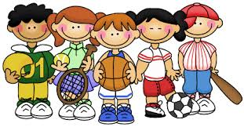
Physical Education:
In PE this term we will be looking at ball skills. This consists of throwing and catching a variety of different shape and sized balls. The children will be learning about different ways of passing such as bounce passes, underarm throws, overarm throws and so on. PE will consist of lots of games and activities that gets the children running around and exercising. For the second half of the term, we will be looking at creating our own ‘Winter Dance’. This half of the term will link nicely to our music lessons, in particular where we looked at rhythm and expressing the dynamic of music through movement.

Music:

