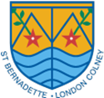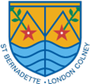**St Bernadette Catholic Primary School**

School has been closed for a long time.





Insert School/nursery logo here

It has been closed because of Coronavirus.

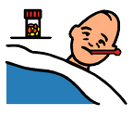

When School was closed I stayed at home.

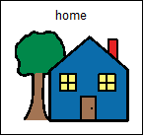

School is ready to open again soon.

[](https://www.google.com/url?sa=i&url=https://www.shutterstock.com/image-vector/sign-open-icon-simple-style-isolated-463102208&psig=AOvVaw3PyuzowhqUFOPj1s9nfVDg&ust=1588333419409000&source=images&cd=vfe&ved=0CAIQjRxqFwoTCJiB7K2JkOkCFQAAAAAdAAAAABAD)



I will go back to school on:

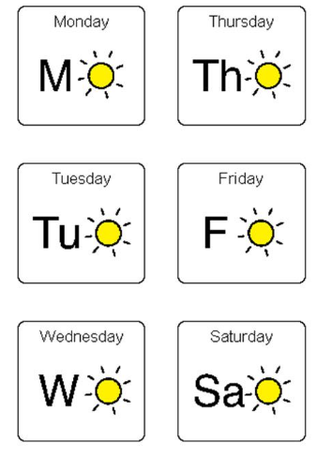

My classroom will be __________

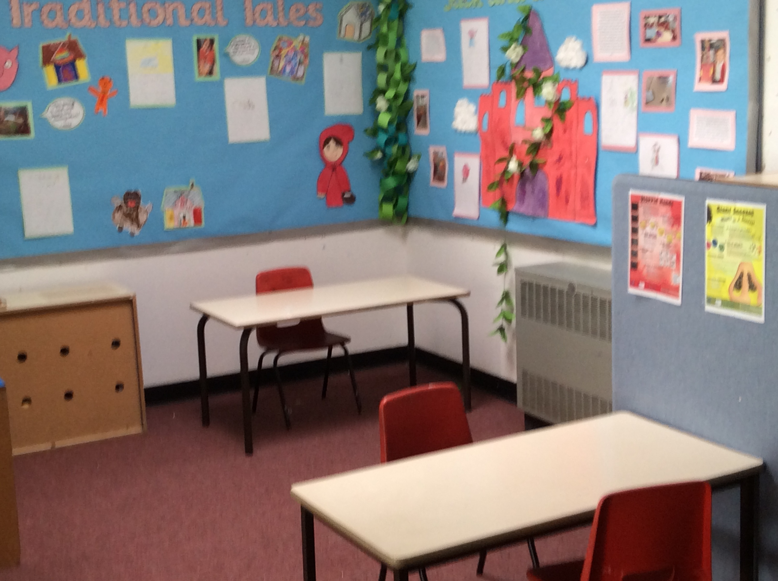

I will follow the arrows when walking around the school.

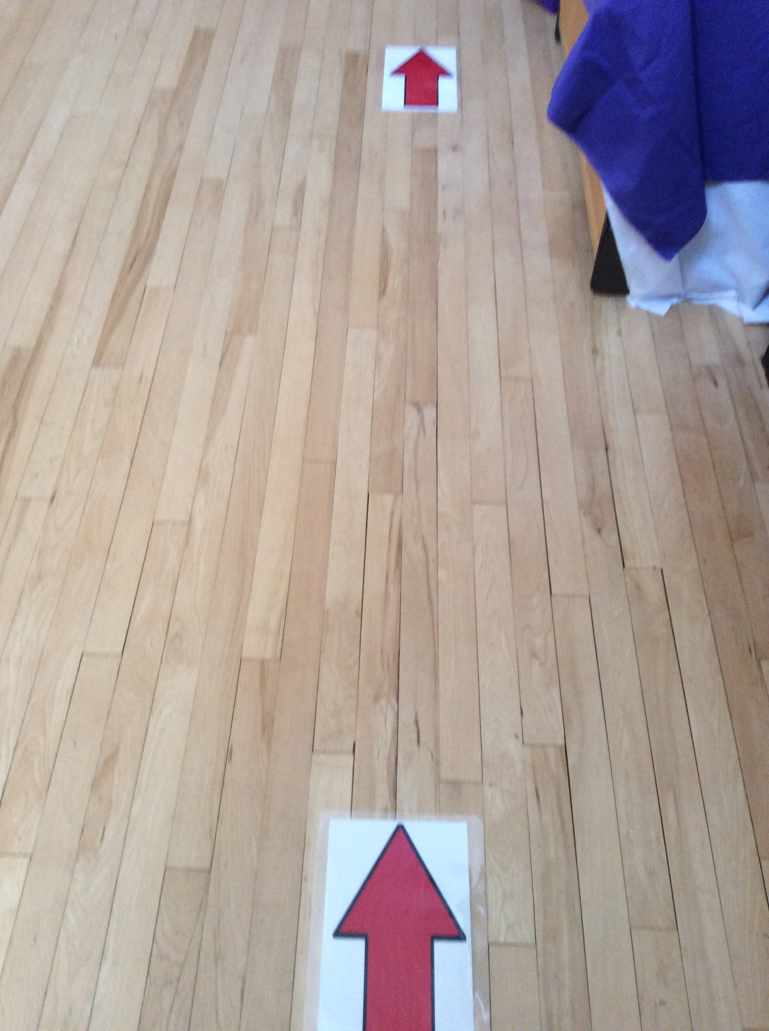

I will play outside here

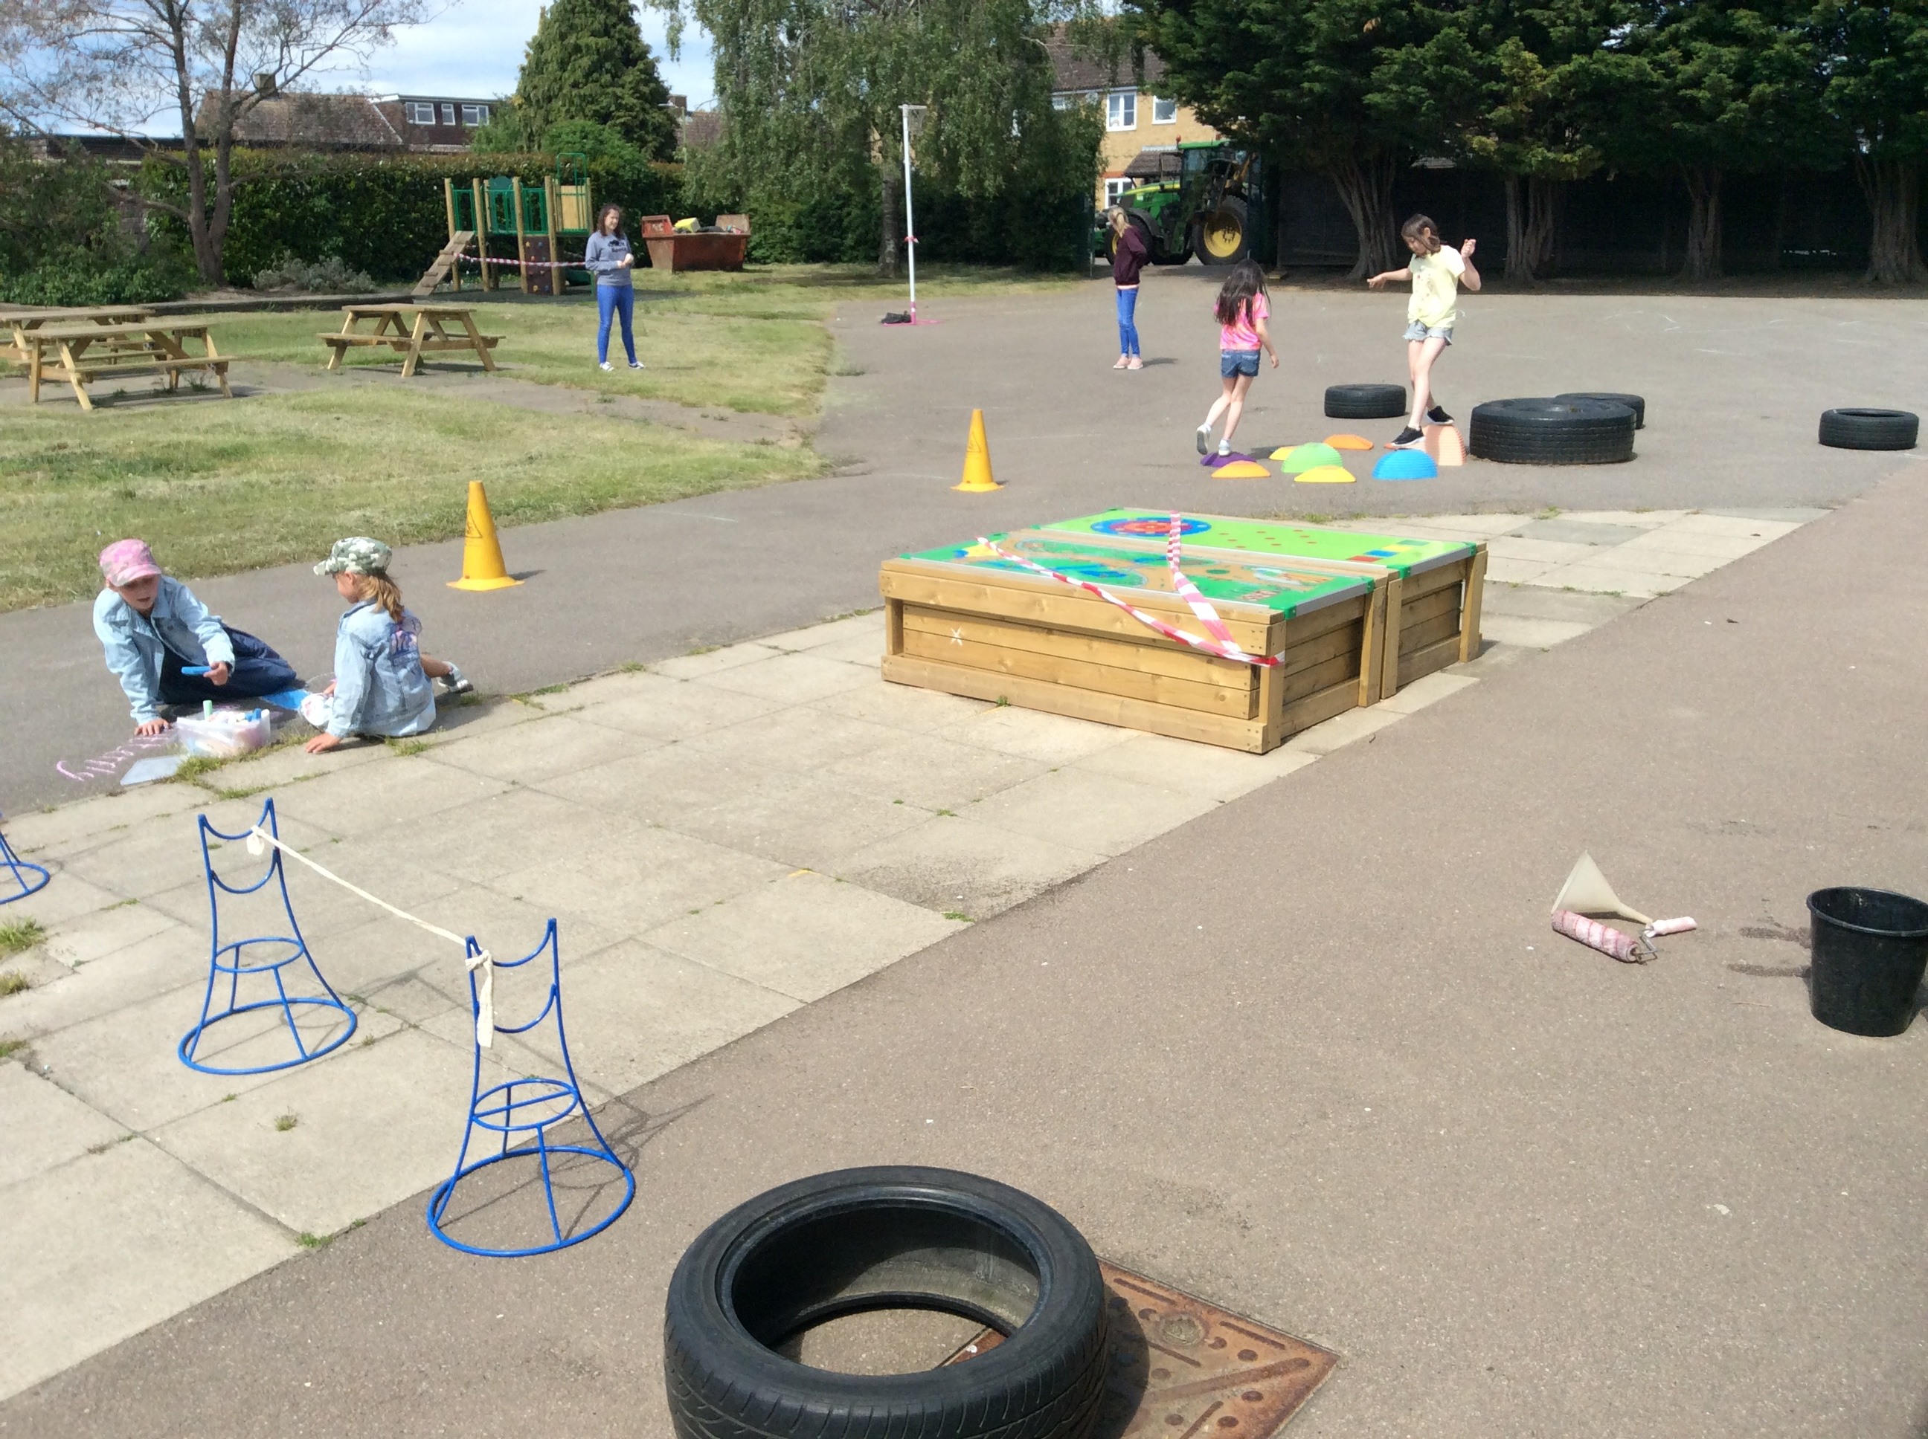

I will eat my lunch/snack here, in my classroom at my desk.

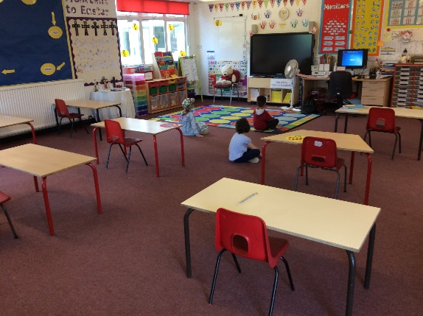

I will line up keeping social distancing.

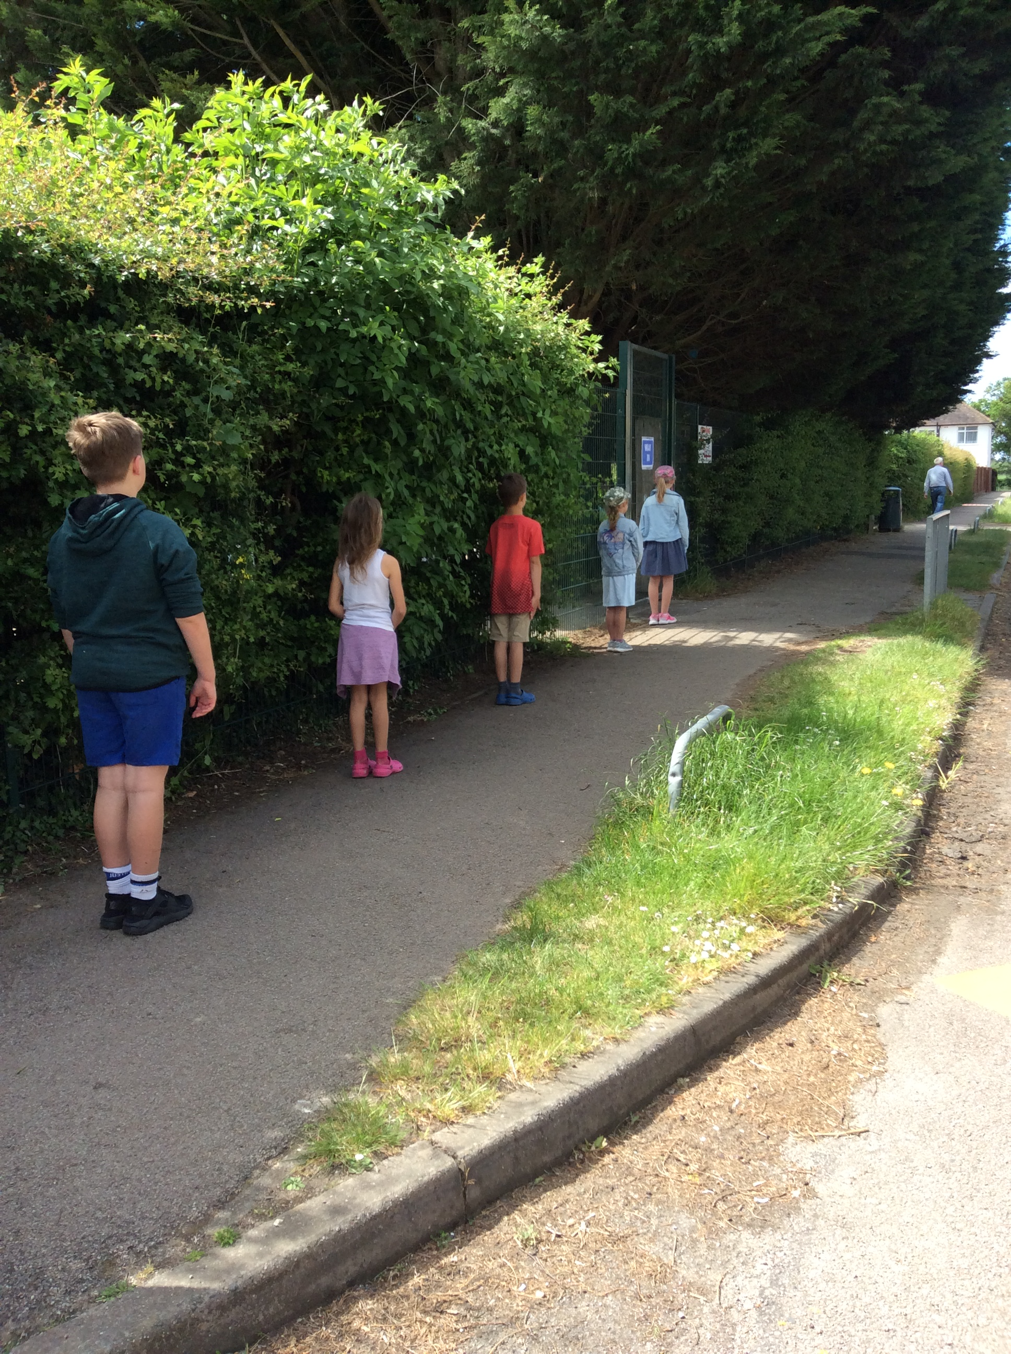

I might not have my own teacher but it will be a teacher I know and it will be OK.

Other adults will help me at in class and at lunchtimes .

I will be able to play with some familiar things and the adults will wash them to keep them clean.

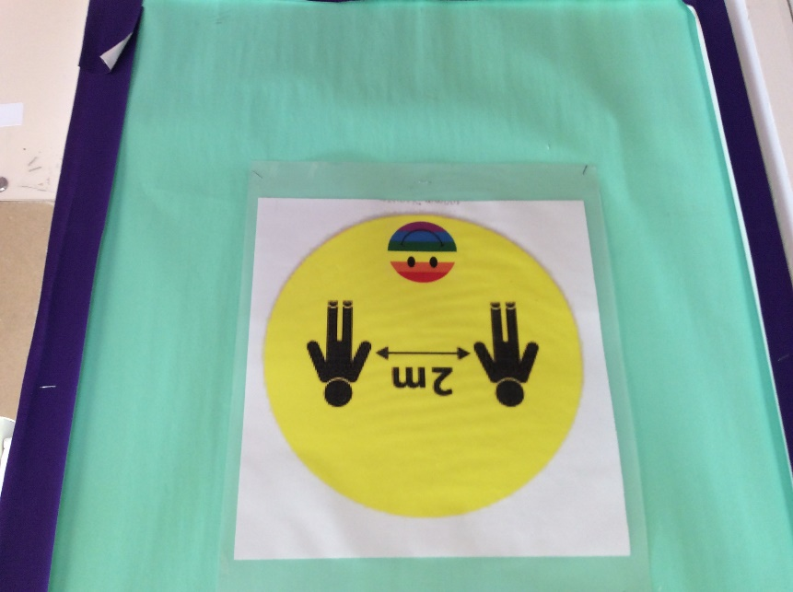 We will stay 2 metres apart but it will be ok because I can still talk to my friends.

We will wash our hands.

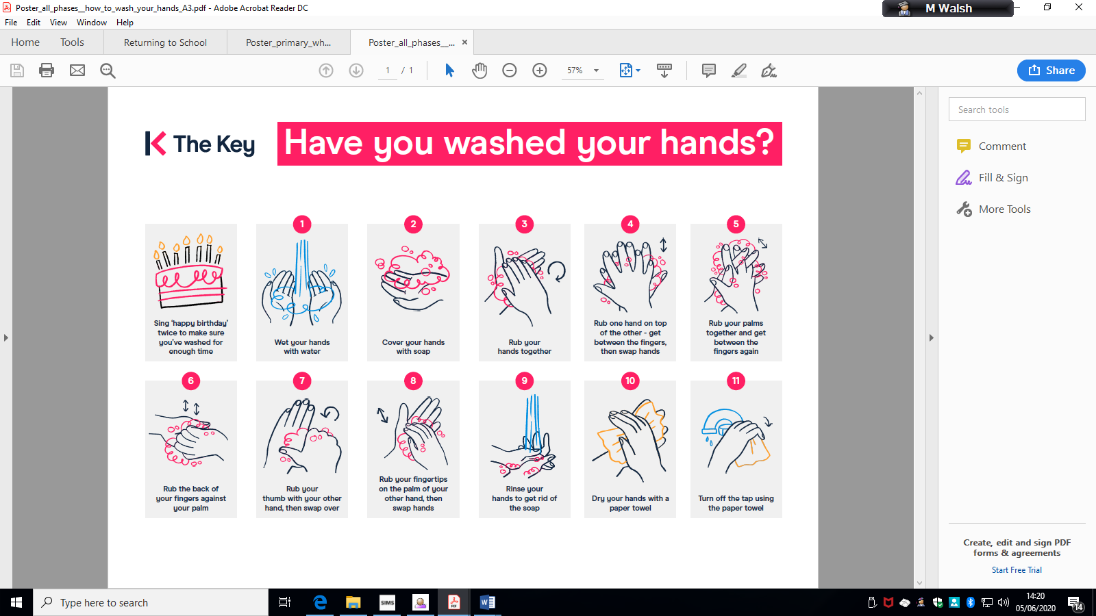

Going back to school will be OK!

Remember to look at the school website and watch the video <https://www.stbernadette.herts.sch.uk/>

Remember everyone will feel a little bit bumpy about coming back to school. This is fine. We are here to listen and talk about how we are all feeling.

