Parents Guide to Phonics

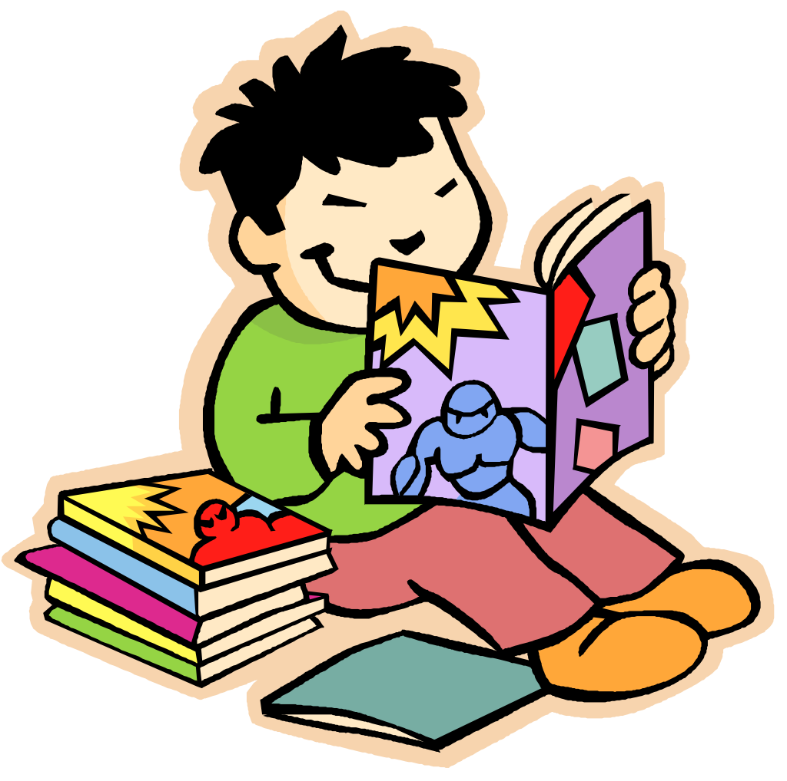

A guide to how phonics will help your child to read and spell.

First of all, what is synthetic phonics?
It is a technical name and nothing to do with being artificial. The synthetic part refers to synthesizing or blending sounds to make a word. Phonics is a method of teaching children how spoken words are composed of
sounds called phonemes and how the letters in words correspond to those phonemes. The process of reading involves decoding or ‘breaking’ words into separate phonemes, so that meaning can be gained. On the other hand, the process of spelling requires the writer to identify all the phonemes in a word and then use their knowledge of the phonemic code to write or ‘make’ the word.
English is essentially a code that can be encoded (written) and decoded (read). We need to teach children this code with as much emphasis as possible on the rules and regularities of the written language.
Children are taught that we can make a word from the sounds and then break it apart again when we want to
spell it. Spelling and reading are taught together but children’s may be better at reading before spelling or vice versa.
Written English is recognised as being a complex language. We have 26 letters but 44 phonemes in the spoken language. There are a huge number of letter combinations needed to make these 44 phonemes (a phoneme is the technical name for the smallest unit of sound).

Letters and Sounds
Letters and Sounds is a government produced synthetic phonic teaching programme. Throughout the six phases children will be taught the 44 phonmemes. It is important to remember that there are alternative spellings to these graphemes.
There are six phases in which the children are introduced to all 44 phonemes and corresponding graphemes starting with the most familiar grapheme for each phoneme first.
Synthetic phonics starts with ‘phonemic awareness” which is hearing the different sounds in a word and the matching of these phonemes to single letters. At the same time it shows how these phonemes (sounds) can be 'blended' to produce words and the words can be ‘segmented’ to write.. Your child will learn simple letter to sound correspondence. This is when a phoneme is represented by a single letter as in the word /c/ /a/ /t/. When that’s mastered your child will learn that sometimes one phoneme is represented by two letters (digraph); as in the word /ch/ /o/ /p/ ; where /ch/ is only one phoneme (sound).
Then after that, even though at first it may sound confusing, your child will learn that sometimes a single phoneme can be represented many different ways. Like the sound /ay/ in play.
Your child will eventually learn that this phoneme can be written;
/ay/ as in the word play
/a-e/ as in the word spade
/ea/ as in the word break
/ey/ as in the word hey
/eigh/ as in the word eight
/a/ as in the word later
/ei/ as in the word vein
Finally your child will learn that sometimes a single (or more) letter may represent more than one phoneme; for example, the ‘o’ in /most/ and the ‘o’ in /hot/ or the ‘ow’
in /wow/ and the ‘ow’ in /tow/.

This can be confusing but with the structure and regularity of letters and sounds almost all children will pick this up.

What do all these technical words mean?
What is a phoneme?
It is the smallest unit of sound and a piece of terminology that children like to use and should be taught. At first it will equate with a letter sound but later on will include the digraphs.

What is a digraph?
This is when two or more letters come together to make a phoneme. /oa/ makes the sound in boat.

What is blending?
Blending is the process that is involved in bringing the sounds together to make a word or a syllable and is how /c/ /a/ /t / becomes cat.
What is a consonant blend?
Previously, consonant blends were taught as if there was something special about them. Children were taught that /st/ was one phoneme, when actually it is two, /s/
and /t/. Think about it. Why teach /st/ when children already know /s/ and /t/, it just wastes time and clogs up children’s memory. But note that sh is a diagraph. It cannot be made by a process of blending the two letter sounds of /s/ and /h/ together.
We need to teach the digraphs not the blends.

At a glance:
• It is not important to know all the jargon. It is important to try to use the same words your child is being taught at school.
• It is important to know how to pronounce each of the phonemes correctly.
• Remember that teaching the old consonant blends just wastes time and energy with something your child already knows; it can also lead to confusion.

Phase 1
Phase One of Letters and Sounds concentrates on developing children's speaking and listening skills and lays the foundations for the phonic work which starts in Phase 2. The emphasis during Phase 1 is to get children attuned to the sounds around them and ready to begin developing oral blending and segmenting skills.
Phase 1 is divided into seven aspects. Each aspect contains three strands: Tuning in to sounds (auditory discrimination), Listening and remembering sounds (auditory memory and sequencing) and Talking about sounds (developing vocabulary and language comprehension).
Useful website for phase 1 games:
http://www.letters-and-sounds.com/phase-1-games.html

Phase 2
In Phase 2, letters and their sounds are introduced one at a time. A set of letters is taught each week, in the following sequence:
Set 1: s, a, t, p
Set 2: i, n, m, d
Set 3: g, o, c, k
Set 4: ck, e, u, r
Set 5: h, b, f, ff, l, ll, ss
The children will begin to learn to blend and segment to begin reading and spelling. This will begin with simple words.
Words using set 1
at | sat | pat | tap | sap

Words using set 1 and 2
(+i) | (+n) | (+m) | (+d)
it | an | am | dad
is | in | man | sad
sit | nip | mat | dim
sat | pan | map | din
pit | pin | Pam | did
pip | tan | Tim | Sid
sip | nap | Sam | and
tip | tin |  | dip

Words using sets 1-3
(+g) | (+o) | (+c) | (+k)
tag | got | can | kid
gag | on | cot | kit
gig | not | cop | Kim
gap | pot | cap | Ken
nag | top | cat
sag | dog | cod
gas | pop
pig | God
dig | Mog

Words using set 1-4
(+ck) | (+e) | (+u) | (+r)
kick | get | up | rim
sock | pet | mum | rip
sack | ten | run | ram
dock | net | mug | rat
pick | pen | cup | rag
sick | peg | sun | rug
pack | met | tuck | rot
ticket | men | mud | rocket
pocket | neck | sunset | carrot

Words using set 1-5
(+h) | (+b) | (+f and ff) | (+l and ll) | (+ss)
had | but | of | lap | ass
him | big | if | let | less
his | back | off | leg | hiss
hot | bet | fit | lot | mass
hut | bad | fin | lit | mess
hop | bag | fun | bell | boss
hum | bed | fig | fill | fuss
hit | bud | fog | doll | hiss
hat | beg | puff | tell | pass
has | bug | huff | sell | kiss
hack | bun | cuff | Bill | Tess
hug | bus | fan | Nell | fusspot
 | Ben | fat | dull
 | bat |  | laptop
 | bit
 | bucket
 | beckon
 | rabbit

Alongside this children are introduced to tricky words. These are the words that are irregular words. That means that phonics cannot be applied to the reading and spelling of these words.
The tricky words introduced in phase 2 are:
to | the | no | go | I

Useful websites for phase 2 onwards:
http://www.letters-and-sounds.com/phase-2.html
http://www.nessy.com/
http://www.bbc.co.uk/schools/wordsandpictures/
http://www.bugclub.co.uk/ (School id: cgla) Every child has a user name and password.
Useful app for phase 2:
http://www.nessy.com/hairyletters/

Phase 3

By the time they reach Phase 3, children will already be able to blend and segment words containing the 19 letters taught in Phase 2.
Over the twelve weeks which Phase 3 is expected to last, twenty-five new graphemes are introduced (one at a time).
Set 6: j, v, w, x
Set 7: y, z, zz, qu
Consonant digraphs: ch, sh, th, ng
Vowel digraphs: ai, ee, igh, oa, oo, ar, or, ur, ow, oi, ear, air, ure, er
Tricky words:
we | me | be | was | no | go
my | you | they | her | all | are

Phase 4
By Phase 4 children will be able to represent each of 42 phonemes with a grapheme. They will blend phonemes to read CVC words and segment CVC words for spelling. They will also be able to read two syllable words that are simple. They will be able to read all the tricky words learnt so far and will be able to spell some of them.
This phase consolidates all the children have learnt in the previous phases.
Tricky words:
said | so | she | he | have | like
some | come | were | there | little | one
they | all | are | do | when | out
what | my | her

By this point children would be expected to be reading CVC words at speed along with the tricky words from the previous phases. It is important that children are taught that blending is only used when a word is unfamiliar.
Phase 5
Children will be taught new graphemes and alternative pronunciations for these graphemes and graphemes they already know. They will begin to learn to choose the appropriate grapheme when spelling. The children will be automatically decoding a large number of words for reading by this point.

Tricky words:
oh | their | people | Mr | Mrs | looked
called | asked
water | where | who | again | thought | through
work | mouse | many | laughed | because | different
any | eyes | friends | once | please

New graphemes for reading:
ay day | oy boy | wh when | a-e make
ou out | ir girl | ph photo | e-e these
ie tie | ue blue | ew new | i-e like
ea eat | aw saw | oe toe | o-e home
 |  | au Paul | u-e rule

By this phase children should be reading words fluently and no longer be blending and segmenting familiar words.
The real focus throughout the phase is to not only learn the new graphemes for reading but also to learn to read words with alternative pronunciations. Children also will need to learn alternative spellings for each phoneme.

Phase 6
In phase 6 children will be reading longer and less familiar texts independently and fluently. It is crucial that at this point children are now reading to learn and reading for pleasure.
Children should be able to read the 300 high frequency words. At this point it is important that comprehension strategies are developed so that children clarify meaning, ask and answer questions about the texts they are reading, construct mental images during reading and summarise what they have read.
In spelling children are introduced to the adding of suffixes and how to spell longer words. Throughout the phase children are encouraged to develop strategies for learning spellings.

Strategy | Explanation
Syllables | To learn a word by listening to how many syllables there are so it can be broken into smaller bits. (e.g. Sep-tem-ber)
Base Words | To learn a word by finding its base word. (e.g. jumping- base word jump +ing
Analogy | To learn a word use a word that is already learnt. (e.g. could, would, should)
Mnemonics | To learn a word by making up a sentence to help remember them. (e.g. could – OU Lucky Duck; people eat orange peel like elephants

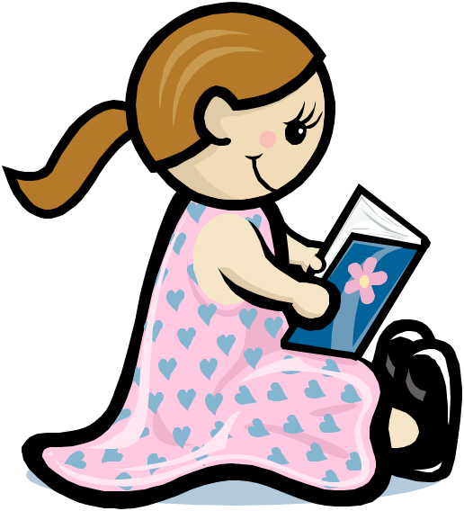
I am concerned about my child’s progress, what should I do?
Talk to your child’s teacher about your concerns.
If necessary we will do further assessments.
Not all children progress at the same rate some children may need to revisit some aspects that is why we ensure that each lesson begins with revision of previously learnt skills.
We may provide extra sessions for children who are not progressing. This may be ELS (early literacy support) for year 1 pupils which is a group session or FFT literacy intervention in shich the child works with an adult who has been trained everyday for 20 minutes.
It is important that children practice as much as possible however if a child is finding reading hard they may try to avoid this. Try to make it fun, play games and read to your child if they do not want to read to you.

