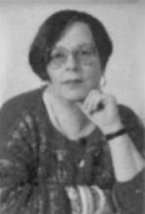
An Interview with Adèle Geras

Adèle Geras has been writing for young people for 20 years. She was born in Jerusalem, in Israel, and much of her childhood was spent in many different parts of the world. Before she started writing she worked as an actress, a singer and taught French in a girls' school. She has lived for the past 30 years in Manchester with her husband and two daughters, Sophie (25) and Jenny (19). In March, our reporter Jo Allen went there to interview her.
Jo Do you find it difficult when you start writing a new story?

Adèle Well, I like writing stories. I'm a little nervous of it on a Monday morning when a blank sheet of paper lies waiting for the words, but as soon as I get started, I enjoy it.
Jo What is it, then, that you most like about writing stories?
Adèle I like the power of writing things. I can do anything, be anyone, travel in time and space, describe a tiny corner of the real world or invent an entirely new one, simply by making marks on paper.
Jo Where do you get your ideas from for writing stories…do they all come from your own imagination?
Adèle Really, I use my memories of my own childhood. I've also travelled widely – that gives me lots of ideas too. And then there is my imagination, of course!
Jo Do you only write novels, or do you like writing other things as well?
Adèle Actually, I particularly like writing short stories. It is so challenging to try to be really creative in quite a short space. I really wish more short stories were written for young people.
Jo Do you have a picture of your readers when you are writing? Do you feel as if you are writing to someone in particular?
Adèle No, not really. It is as if I am sending out messages: this is what I think, this is how it is…listen to me while I tell you…come over here and meet these people…
Jo Do you enjoy meeting people who have read your novels?
Adèle When I meet someone who's read a book I've written, I feel as though my message-in-a-bottle has been discovered on a distant shore.

A bibliography is a list of books. Here is a bibliography of some of Adèle Geras's most popular short stories for children and young people:
Gilly the Kid
Fantora Family Photographs
The Fantora Family Files
Pictures of the Night
Golden Windows
A Lane to the Land of the Dead
1. This question is about the letters to the author.
1. Lee, Sam and Michel each wrote a ‘PS.’ at the end of their letters but these were not printed in your booklet.
Who wrote:
(a) P.S. I am going to look out for more of your short stories.
…………………………………………………..
1 mark
(b) P.S. It was interesting that there were refugees in your story, because things like that still happen today.
…………………………………………………..
1 mark
(c) P.S. Stories should make the world a happier place.
…………………………………………………..
1 mark

2. This question is about the interview with Adèle Geras.
Before becoming a full-time writer, Adèle did a number of other jobs. Find and write down three of them.
1. …………………………………………………………………………………..
2. …………………………………………………………………………………..
3. …………………………………………………………………………………..
1 mark

3. In her interview, Adèle says she is a little nervous on Monday mornings
Explain why you think she feels nervous.
………………………………………………………………………………………
………………………………………………………………………………………
………………………………………………………………………………………
2 marks
4. Why do you think Adèle compares reading a book with finding a
message-in-a-bottle?
………………………………………………………………………………………
………………………………………………………………………………………
………………………………………………………………………………………
1 mark

5. Fill in the table to show which statements about the Leaving Home booklet are fact and which are opinion.
The first one has been done for you.
 | Fact | Opinion
There should be more short stories  published for children. |  | √
Adèle Geras has two daughters.
The story is depressing.
All 11-year-olds worry too much
about what happens in the world.
The story is about leaving home.
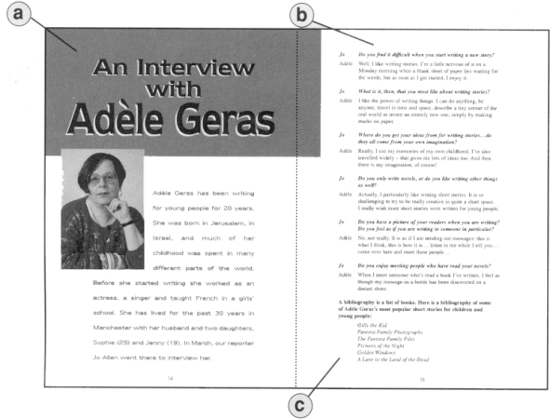
1 mark

6. For this question you need to look at these pages in your reading booklet.

The text on these pages is arranged in different ways, for different reasons.
For example,
points to the title - The text is in large print, in the centre, at the top of the page.

For and circle the best answer and explain the ways in which the text is arranged.
(i) points to
The text is …………………………………………………………………………
………………………………………………………………………………………
1 mark
(ii) points to
The text is …………………………………………………………………………
………………………………………………………………………………………
1 mark

