1. This table shows information about four solid shapes.
Complete the table.
One has been done for you.
 | number of  flat surfaces | number of  curved surfaces
sphere | 0 | 1
cone
cuboid
cylinder
2 marks
2. Put ticks () and crosses () on the chart to complete it correctly.
One has been done for you.
2 marks

3. Complete the table.
 | number  of faces | number  of edges
cuboid | 6 | 12
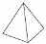  square-based  pyramid | 5

4. Two of these diagrams are nets for a triangular prism.
Put a tick () in them.
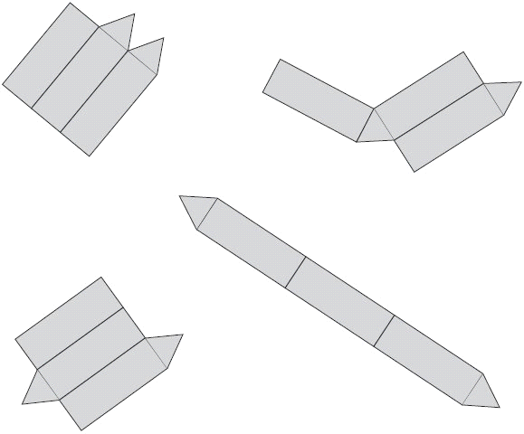
1 mark
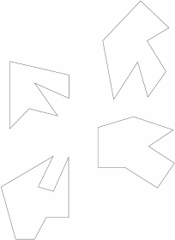
5. Here are some shapes.
Two of the shapes are octagons.
Put a tick () on them.

1 mark
6. The lines drawn on the grid are two sides of a pentagon.
Complete the pentagon.
Use a ruler.
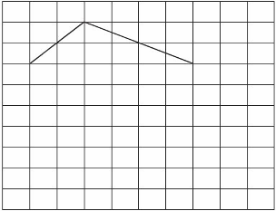 1 mark
7. Here are seven shapes.
Write the letters of the two shapes which are pentagons.
.............................. and ..............................
1 mark
8. Tom makes this shape from four cubes stuck together.
Two circles are drawn on the shape.
Tom moves the shape.
Draw the circles on the shape in its new position.
1 mark
9. Shade one third of this shape.
1 mark
Shade one quarter of this shape.
1 mark

10. Complete the table.
2 marks
11. Draw two more straight lines to make a rectangle.
Use a ruler.

1 mark

12. On the grid join dots to make a triangle which does not have a right angle.
Use a ruler.

1 mark

13. These nets will fold to make 3-D shapes.
Match each net to the name of its shape.
1 mark
14. Here are four shapes.
They each have a different number of right angles.
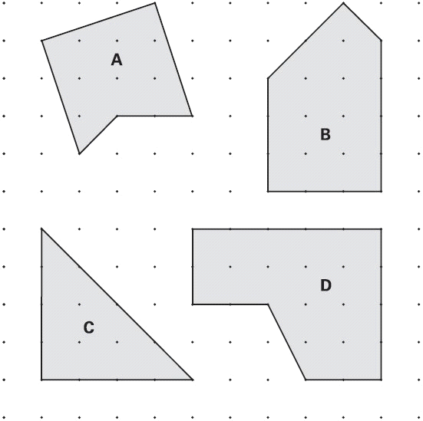
Write the letter for each shape in the correct order.
One has been done for you.
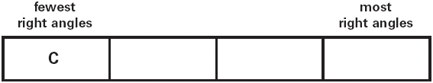
1 mark
15. Use a ruler to draw 2 more lines to make an isosceles triangle.
1 mark
16. Draw in lines where you would fold this shape to make a cube.
Use a ruler to measure where they would go.
1 mark

17. Here are some shapes.
Write the letters B and C in the sorting diagram below to show where shapes B and C should go.
Shape A is done for you.
2 marks
18. The line on the grid is one side of a square.
On the grid, draw the other three sides of the square.
Use a ruler.

1 mark
19.
1 mark
20. These two shaded triangles are each inside a regular hexagon.
Under each hexagon, put a ring around the correct name of the shaded triangle.
equilateral equilateral
isosceles isosceles
scalene scalene
1 mark
21. Here are 4 shapes.
Each shape has two parallel sides.
Write TWO other things which are the same about ALL the 4 shapes.
1 ........................................................................................................................
............................................................................................................................
2 ........................................................................................................................
............................................................................................................................
2 marks

22. This ring is made of regular pentagons, with sides of 5 centimetres.
What is the length of the outer edge of the ring?
cm
1 mark
Here is part of a new ring.
It is made of squares and triangles.

The pattern is continued to complete the ring.
What is the total number of squares used in the complete ring?
1 mark
23. Here are four diagrams.
On each one put a tick () if it is a net of a cube.
Put a cross () if it is not.
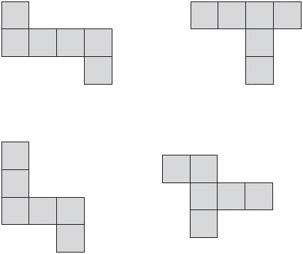
2 marks
24. Match each quadrilateral to the correct description.
One has been done for you.
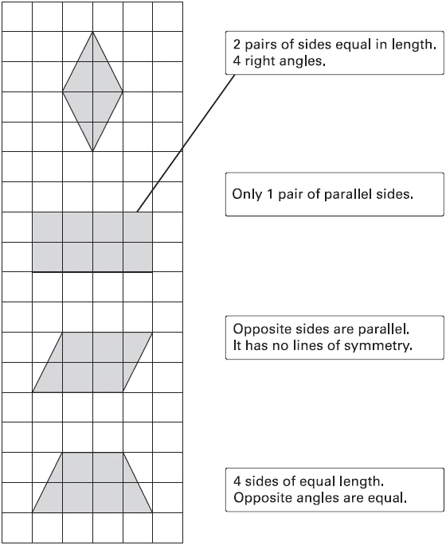
1 mark

25. Here are six triangles. One of them is an equilateral triangle.
Put a tick () in the equilateral triangle.
1 mark
Write one property which makes equilateral triangles different from all other triangles.
...............................................................................................................................
...............................................................................................................................
1 mark

26. Draw two straight lines from point A to divide the shaded shape into a square and two triangles.
1 mark

27. Here are five shapes on a square grid.
Which two shapes fit together to make a square?
...................... and ......................
1 mark
28. On the grid, draw a rectangle which has the same area as this shaded pentagon.
Use a ruler.
1 mark
29. Here is the net of a cube with no top.
The shaded square shows the bottom of the cube.
Draw an extra square to make the net of a cube which does have a top.
1 mark
30. This is a drawing of a pentagonal prism.
Tick () the one shape that is a net for the pentagonal prism.
1 mark
31. Here is an open top cube.
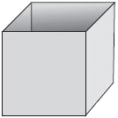
Here is the net from which it is made.
Put a tick () on the square which is its base.
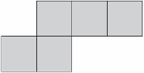
1 mark
32. Here is a triangular box.
Below is part of the net of the box, but two of its faces are missing.
Draw accurately, full size, ONE of the missing faces on the diagram below.

You can use a ruler and protractor (angle measurer).
2 marks
33. Here are four statements.
For each statement put a tick () if it is possible.
Put a cross () if it is impossible.
A triangle can have 2 acute angles.
A triangle can have 2 obtuse angles.
A triangle can have 2 parallel sides.
A triangle can have 2 perpendicular sides.
2 marks
22
34. Liam has two rectangular tiles like this.
He makes this L shape.
What is the perimeter of Liam’s L shape?
cm
1 mark

35. Look at this diagram.
Calculate the size of angle x and angle y.
Do not use a protractor (angle measurer).
x = 1 mark y = 1 mark

36. Here is an equilateral triangle inside a rectangle.
Calculate the value of angle x.
Do not use a protractor (angle measurer).
2 marks
37. How many edges has a triangular prism?

38. A cube has shaded triangles on three of its faces.
Here is the net of the cube.
Draw in the two missing shaded triangles.
1 mark
39. An isosceles triangle has a perimeter of 12cm.
One of its sides is 5cm. What could the length of each of the other two sides be?
Two different answers are possible. Give both answers.
cm | and | cm

cm | and | cm
2 marks

40. Triangle ABC is isosceles and has a perimeter of 20 centimetres.
Sides AB and AC are each twice as long as BC.
Calculate the length of the side BC.
Do not use a ruler.
2 marks

