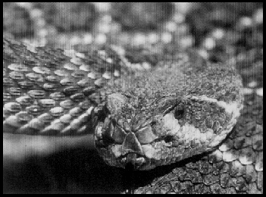

A snake came to my water-trough
On a hot, hot day, and I in pyjamas for the heat,
To drink there.
In the deep, strange-scented shade of the great dark carob-tree
I came down the steps with my pitcher
And must wait, must stand and wait, for there he was at the trough
before me.
He reached down from a fissure in the earth-wall in the gloom
And trailed his yellow-brown slackness soft-bellied down, over the edge
of the stone trough
And rested his throat upon the stone bottom,
And where the water had dripped from the tap, in a small clearness,
He sipped with his straight mouth,
Softly drank through his straight gums, into his slack long body,
Silently. . .
He drank enough
And lifted his head, dreamily, as one who has drunken,
And flickered his tongue like a forked night on the air, so black;
Seeming to lick his lips,
And looked around like a god, unseeing, into the air,
And slowly turned his head,
And slowly, very slowly, as if thrice a dream,
Proceeded to draw his slow length curving round
And climb again the bank of my wall-face.
© Snake by D.H. Lawrence from The Puffin Book of Classic Verse,
with kind permission of the Estate of Frieda Lawrence Ravagli and published by Laurence Pollinger Limited.

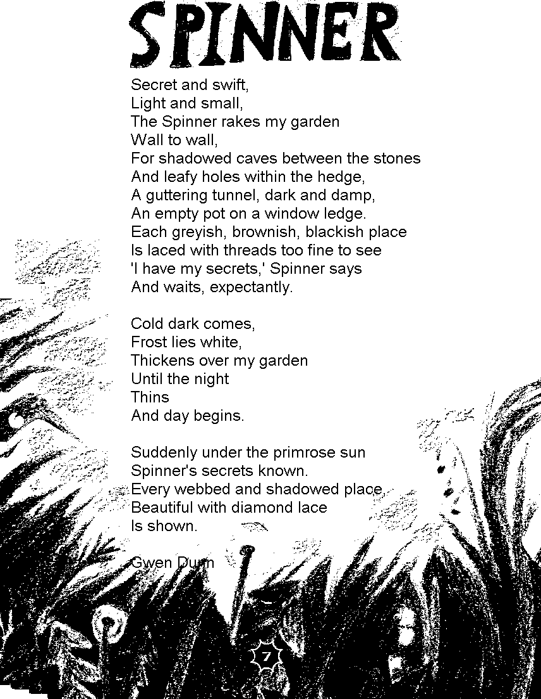
© Gwen Dunn
Questions on the poem Snake
1. In what kind of setting does this poem take place?
Use details from the poem to help explain your answer.
...........................................................................................................................................
...........................................................................................................................................
...........................................................................................................................................
...........................................................................................................................................
...........................................................................................................................................
...........................................................................................................................................
...........................................................................................................................................
...........................................................................................................................................
...........................................................................................................................................
2 marks

2. The poet looks at the snake with admiration and wonder.
Explain how he conveys these feelings.
In your answer you should comment on:
- how he describes the snake
- his reactions to it
- the movement and rhythm of the poem.
...........................................................................................................................................
...........................................................................................................................................
...........................................................................................................................................
...........................................................................................................................................
...........................................................................................................................................
...........................................................................................................................................
...........................................................................................................................................
...........................................................................................................................................
...........................................................................................................................................
3 marks
Questions on the poem Spinner
1. What creature is this poem about?
……………………………………………………………
1 mark
2. What sorts of places does the Spinner look for in the first part of the poem?
………………………………………………………………………………………
………………………………………………………………………………………
2 mark
3. What two changes take place in the second part of the poem that give the Spinner’s secrets away?
1. ……………………………………………………………………………………
2. ……………………………………………………………………………………
2 marks
4. The last line of the poem is: Is shown.
What would you see if you were there?
………………………………………………………………………………………
………………………………………………………………………………………
2 marks
5 Find five words to do with darkness in the first part of the poem.
Write one word next to each dot.
- …………………………………………………
- …………………………………………………
- …………………………………………………
- …………………………………………………
- …………………………………………………
2 marks
6. In the third part of the poem, the webs are described as:
diamond lace.
What does the word diamond tell you about the webs?
………………………………………………………………………………………
………………………………………………………………………………………
………………………………………………………………………………………
2 marks

7. The second part of the poem is different from the first and third parts.
Write down one main way in which it is different
………………………………………………………………………………………
………………………………………………………………………………………
………………………………………………………………………………………
1 mark

8. What are the main contrasts the poet makes in the first and third parts of the poem?
………………………………………………………………………………………
………………………………………………………………………………………
………………………………………………………………………………………
………………………………………………………………………………………
………………………………………………………………………………………
………………………………………………………………………………………
………………………………………………………………………………………
………………………………………………………………………………………
3 marks
9. In the second part of the poem we read:
… the night
Thins
Explain what these words mean and why you think the poet chose the word thins.
………………………………………………………………………………………
………………………………………………………………………………………
………………………………………………………………………………………
………………………………………………………………………………………
………………………………………………………………………………………
………………………………………………………………………………………
………………………………………………………………………………………
………………………………………………………………………………………
3 marks

